Russia’s presidency

Guess who!

The news that Vladimir Putin will return to the Kremlin ends a four-year charade. The real question is how he can stay in power
Oct 1st 2011 | MOSCOW | from the print edition
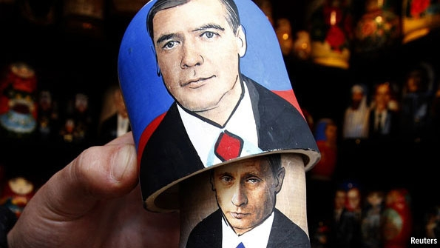
NIKOLAI GOGOL’S play “The Government Inspector” ends with a scene in which the bureaucrats who mistook a flimsy impostor for a high official from St Petersburg are dumbstruck when a messenger announces the arrival of the real inspector-general. This week Russia enacted a postmodern version of this scene: the arrival of the genuine official was announced by the pretender, and the pair hugged in front of duped bureaucrats who rewarded them with a standing ovation for their clever performance.
This is roughly what happened on September 24th when Dmitry Medvedev, Russia’s president, told a congress of the ruling United Russia party that Vladimir Putin would return to the Kremlin after a presidential election in March 2012, and Mr Putin informed them that Mr Medvedev would stay on as prime minister and leader of United Russia. The applause from bureaucrats whose only concern is to stay close to the rent-distributing centre grew louder when Mr Putin and Mr Medvedev told them that they had agreed this arrangement several years ago.
Mr Putin’s return to the office he vacated in 2008 was largely expected. The shameless admission of the stitch-up, however, should have been a humiliating slap in the face for any self-respecting audience. It makes a mockery of any notion of open politics, democratic elections and independent institutions. It exposes Mr Medvedev’s presidency as little more than a ploy used by Mr Putin to stay in power after his constitutionally mandated two-term presidential limit expired. It has made fools out of many of the 50m people who voted for Mr Medvedev in 2008, and those both in Russia and abroad who have cultivated him as some sort of liberal reformer since. Yet unlike the small number of high-minded citizens who protested, neither Mr Putin nor his bureaucrats saw anything shameful in the revelation that the job swap was pre-planned. In fact it was designed to explain why Mr Medvedev, a young politician in good health with apparent ambitions to stay on in the Kremlin, had stepped aside.
In Mr Putin’s Russia it is informal arrangements, rather than such formalities as elections, that carry weight. As in a mafia, the word is bond, and loyalty matters more than competence. When Alexei Kudrin, Russia’s long-serving and highly respected finance minister, objected to the choice of Mr Medvedev as prime minister, he was promptly dismissed (see article). According to a rumour that spread through Moscow’s chattering classes this week, to thank Mr Medvedev for sticking to the deal Mr Putin offered him any job he liked (bar one). Mr Medvedev plumped for the premiership. Whether or not this is true, it shows how cynically the political process is seen in Russia.
The news of Mr Putin’s return does at least put an end to the embarrassing spectacle in which Mr Medvedev was cast as a president with a supporting cast of liberal-sounding cheerleaders. After next March Mr Putin’s status as Russia’s most powerful man will chime with his title as president.
That Mr Putin, who enjoys approval ratings of nearly 50%, wants to stay in power is not surprising. (If he runs for two terms he could stay in office until 2024.) But it is the fatalistic acceptance of his decision by most of the country that makes it possible. Some Russians held their noses and turned the other way, others shrugged their shoulders, but few protested. In fact, the Kremlin often defends its actions, particularly to foreigners, by pointing to the “mindlessness” of Russians and the lack of a strong civil society. It is this, they say, rather than rulers who treat citizens like cattle and institutions with scorn, that lies at the heart of Russia’s problems. In the meantime, as a former Kremlin official puts it, Russia has to rely on the restraint of its leaders.
Confident in its right to rule, the Kremlin has banned opponents from television studios and electoral registers, put election commissions under its control and created political clowns and clones to create an appearance of democratic choice. Such machinations, although they can get electoral results, are losing legitimacy. Under Mr Medvedev United Russia, already widely thought of as a party of “thieves and crooks”, will lose more support. Even if the party finds a way to achieve 50% of the vote in parliamentary elections on December 4th, public irritation will grow.
Similarly, Mr Putin can make Mr Medvedev prime minister but he cannot make him respected by his colleagues, as the fallout from his row with Mr Kudrin shows. In the past month, the Kremlin has also alienated Mikhail Prokhorov, one of Russia’s richest tycoons, who threw in the towel after making an attempt to participate in public politics.
The legitimacy question will also be central for Mr Putin. When he first became president in 2000, his popularity was guaranteed by a growing economy, spurred by rising oil prices, a devalued currency, macroeconomic stability, spare capacity left after the end of the Soviet Union and, above all, entrepreneurial activity. These sources of growth are all now exhausted. Higher oil prices seem to lead only to expectations of more public spending.
Before the weekend’s announcement some observers argued that, once reinstalled in the Kremlin, Mr Putin would reinvent himself as an economic liberal with a repressive streak (a Russian Pinochet, in effect), and that he would appoint a prime minister who would bring public spending under control and find new sources of growth. Mr Medvedev’s looming premiership makes this less likely. Mr Putin has little faith in market forces. The Kremlin’s belief that the answer to Russia’s economic problems is more spending on the military-industrial complex will only exacerbate the country’s difficulties. Corruption is so deep, and the degradation of skills and education so acute, that most of the money will evaporate without trace.
The only way to promote growth is to foster competition, both economic and political, and the rule of law. But this is just what neither Mr Putin nor Mr Medvedev can deliver, as their job swap demonstrates. It is clear that Mr Putin wants to stay in power for the next 12 years. What is unclear is whether he can. His return is not a continuation of the past. It opens a new chapter in Russian history—one that may well end in crisis.

