Two articles look at China and religion. First, a war of attrition over Tibet; next, China vs. the Vatican
Aug 20th 2011 | BEIJING | from the print edition
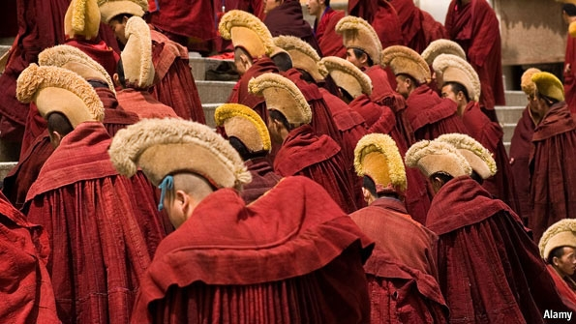
IT WAS never going to be easy. Installing the Chinese Communist Party’s chosen man as Tibet’s second-highest ranking religious leader has been an uphill struggle since 1995, when it declared him, at the ripe old age of six, to be the new Panchen Lama. But a recent attempt to introduce him to monastic life suggests that Tibetan resistance to China’s choice is still strong. Loyalty to the young man is brittle.
For China, this matters hugely. Tibetan Buddhism has a religious hierarchy with the Dalai Lama at the top, followed by the Panchen Lama. The Dalai Lama is traditionally involved in recognising the Panchen Lama, and the Panchen Lama is part of the process by which each new Dalai Lama is chosen. China has its eyes on a complex struggle that will play out after the death of the current 76-year-old Dalai Lama, who lives in exile in India. With the endorsement of its own Panchen Lama, China wants to choose a successor to the current Dalai Lama and seek to control him. Hence it is believed to be keeping another young man, who was the Dalai Lama’s choice as Panchen Lama 16 years ago, incommunicado in an unknown location. China fears that Tibetan exiles will appoint their own Dalai Lama and it does not want any authoritative Tibetan figure to show him support. Both China and the exiles have recently been stepping up preparations for a coming dispute.
On China’s side, this has involved an effort to burnish its Panchen Lama’s credentials by getting him some monastic training. Gyaltsen Norbu, as he is named, has spent most of his 21 years in Beijing. His outings have been few and secretive. Across Tibet, images of the Dalai Lama’s choice of Panchen Lama, Gedhun Choekyi Nyima, can sometimes be seen on furtive display in monasteries, his face frozen in time as a little boy. Chinese officials probably hoped that installing Gyaltsen Norbu in a big-name monastery might win him more supporters. With some parts of Tibet roiled by unrest—a protesting monk burned himself to death on August 15th in Daofu, a Tibetan-dominated county of Sichuan Province—this was always bound to be tricky.
The monastery they chose was Labrang in southern Gansu province, on the edge of the Tibetan plateau. It is not clear why. Historically, the Panchen Lama’s seat was Tashilhunpo Monastery in Shigatse in central Tibet. Robert Barnett of Columbia University in New York says it is possible that even at Tashilhunpo some lamas do not accept China’s choice. In 1997, Tashilhunpo’s then abbot, Chadrel Rinpoche, was sentenced to six years in prison (he has not resurfaced since) for helping the Dalai Lama make his choice of Panchen Lama. In 1998, Chinese officials tried to give their Panchen Lama a monastic start at Kumbum in Qinghai Province, a monastery that has usually acquiesced to Chinese rule. Its abbot, Arjia Rinpoche, fled to America to avoid the duty.
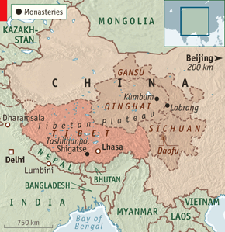
Labrang has no reputation for tameness. Its monks joined a wave of protests that swept Tibet and neighbouring Tibetan regions in 2008 after an outbreak of rioting in Lhasa, Tibet’s capital. In recent days, Labrang has again proved stubborn. Locals gave China’s Panchen Lama, who arrived on August 11th, nothing like the rapturous reception his predecessor, the tenth Panchen Lama, received during visits to Tibetan areas. Large numbers of police prevented any protests, and foreigners were ushered out of town. Tibetan exile groups quoted sources at Labrang saying that Gyaltsen Norbu was expected to stay for weeks or months. A local official, however, says he left on August 16th. His cool welcome, it seems, hastened him on his way.
In Dharamsala in India’s Himalayan foothills, Tibet’s government-in-exile has been busy manoeuvring, too. On August 8th it swore in a new prime minister, Lobsang Sangay. This is touted by the exiles as an historic event, with the new man taking over all the Dalai Lama’s political functions. Mr Sangay, who has never been to Tibet, struck an ambiguous tone in his inaugural speech, referring to Tibet as “occupied” but also expressing his wish for “genuine autonomy” under Chinese rule.
The Dalai Lama’s decision to give up his political role appears aimed at bolstering the post of prime minister before his death. A new Dalai Lama chosen by the exiles is likely to be a small boy who will need many years of tutelage before taking up his duties. It also presents a challenge to China, which has always refused to recognise the Dalai Lama’s political mantle. Now that he no longer has it, China has a face-saving opportunity to engage with him properly. Chinese officials have held several rounds of talks with the Dalai Lama’s representatives in recent years, the latest in January 2010, but have not moved beyond finger-wagging.
Few see any sign of change. The man likely to become China’s next president, Xi Jinping, visited Lhasa in July for official celebrations of the Communist Party’s takeover of the territory 60 years ago. He praised the fight against “separatist and sabotage activities staged by the Dalai group and foreign hostile forces”. But there have been some positive signals, too. A meeting between President Barack Obama and the Dalai Lama at the White House in July elicited the usual sharp criticism from China. But it did not derail subsequent exchanges between China and America, including a visit to Beijing this week by the vice-president, Joe Biden.
On August 13th the Dalai Lama told reporters in France that he would discuss the issue of his reincarnation at a meeting of Tibetan religious heads in September. He said that unlike China, he is in no hurry to make arrangements.

China and the Vatican: Your billion or ours?

An abrupt halt to rapprochement between two giant slices of humanity
Aug 20th 2011 | from the print edition
ONLY a year ago, a great diplomatic breakthrough—the exchange of ambassadors between the world’s largest church and the world’s most populous country—seemed to be in the offing. Now the mood between China and the Holy See is as bad as it has been for half a century.
On July 14th China’s state-backed Catholic hierarchy, which the Vatican does not recognise, held a three-hour ceremony to consecrate a bishop in the city of Shantou. This was the third time in eight months that a hierarch had been elevated in defiance of the pope. What gave the latest rite a nasty taste was the reported abduction by police of four Rome-aligned bishops who were then pressed to take part in the ceremony. One dissident bishop was “seen sobbing as he was dragged” from home, according to AsiaNews, a Vatican-linked news service.
Chinese Catholics, who may number up to 12m, are split between adherents of a state-run church and those loyal to the Holy See. The big dispute is over who can name bishops. Recently, a grey area between the camps had emerged, with many prelates recognised by both sides. In 2007 Pope Benedict XVI offered an olive branch by recognising the legitimacy of the Chinese state and stopping the unilateral naming of bishops.
But the Vatican has reacted to this summer’s events by declaring that the new bishop and another promoted in similar circumstances in June were ipso facto excommunicated. China’s religious-affairs agency called the Vatican’s move “unreasonable and rude” given the “ardent Catholic faith” of the new bishops.
To some people in, or close to, the Vatican, the mess will confirm reservations they already had about rushing into formal ties with China. George Weigel, an influential American Catholic, wants the pope to keep pressing for religious liberty, including the right to name bishops, before exchanging envoys with Beijing. In his view, cutting ties with democratic Taiwan could pose “grave questions” about the church’s stance on human rights. Among Vatican diplomats, too, there are hawks and doves on the China issue. What the church lacks, says Marco Ventura, an Italian writer on religion, is the strategic vision that guided its diplomacy in the cold war.

