United States History Klausur
The John F. Kennedy School
Friederike Glorius
Jonas Nelle
Benjamin Schloz
Stina Richter
Theme: Too much compromise?
Directions: Write one unified essay, which evaluates two opposing visions for America embodied in the first political parties. The documents provided must be integrated into the body of your essay. You may paraphrase or quote the documents, but in either case you must cite the source (document, line number). When analyzing the material, provide specific historical references—utilizing both the documents provided and previous historical knowledge—to support your thesis.
Provide an appropriate title for your essay. Write on both sides of the paper, number the pages, leave five lines between paragraphs and underline your thesis statement.

- Identify and carefully describe three significant compromises from 1820-1860 which effectively postponed the Civil War. Be sure to provide a clear historical context for each compromise discussed.
- Analyze the documents and explore to degree to which these compromises were fair and wise.
- Based on your assessment of the compromises, develop a well-constructed analytical essay which utilizes specific evidence to evaluate the following statement:
“The substantial compromises made by American political leaders in effect compromised the integrity and stability of the country. In effect, these compromises destabilized the United States and paved the way for sectional tension and Civil War.”

Source A: The Missouri Compromise (1820)
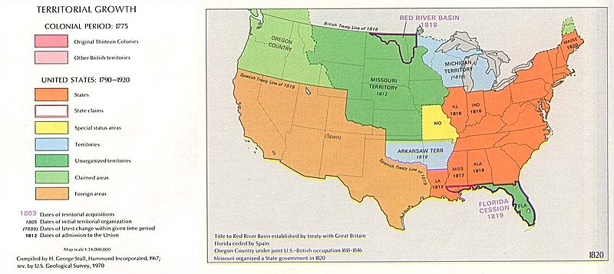
Source B: The Compromise of 1850

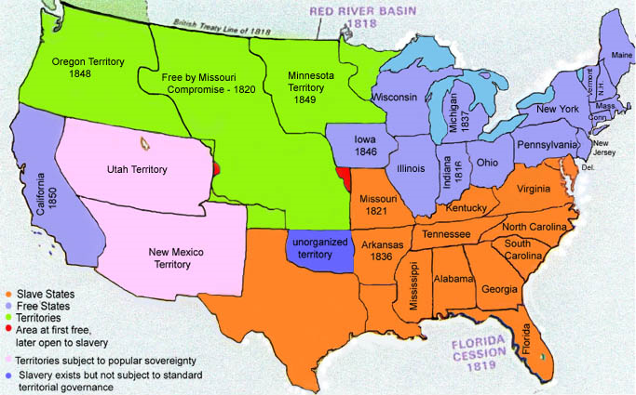
Source C: The Kansas Nebraska Act (1854)
