The Great Society at 50
Washington Post
Karen Tumulty
14 May 2014
Part 1: The Great Society at 50
Part 2: The legacy — and limits — of the Great Society in Prince George's County, Md.
Part 3: Job Corps is very popular. But does it work?
Part 4: Lyndon Johnson's lasting impact on the arts

One day shortly after starting his new job as presidential adviser and speechwriter, Richard N. Goodwin was summoned to see the boss. Not to the Oval Office, but to the White House swimming pool, where Lyndon B. Johnson often went to ruminate.
Goodwin found the leader of the free world naked, doing a languorous sidestroke. Johnson invited him and top aide Bill Moyers to doff their own clothes: “Come on in, boys. It’ll do you good.”
It was an unorthodox manner of conducting official business. As they bobbed in the tepid water, the president “began to talk as if he were addressing some larger, imagined audience of the mind,” Goodwin later wrote in his memoir.
The 32-year-old speechwriter forgot his chagrin as he was drawn by “the powerful flow of Johnson’s will, exhorting, explaining, trying to tell me something about himself, seeking not agreement — he knew he had that — but belief.”
This happened in early April 1964, just a little more than four months after a tragedy in Dallas had made Johnson the 36th president of the United States.
“I never thought I’d have the power,” Johnson told Goodwin and Moyers. “I wanted power to use it. And I’m going to use it.”
“We’ve got to use the Kennedy program as a springboard to take on the Congress, summon the states to new heights, create a Johnson program, different in tone, fighting and aggressive,” he said. “Hell, we’ve barely begun to solve our problems. And we can do it all.”
Johnson’s vision would come to be known as the Great Society — the most ambitious effort ever to test what American government is capable of achieving. And in doing so, to discover what it is not.
In laying it out, LBJ even set out a specific time frame for it to come to fruition — 50 years, a mark that will be reached on Thursday. Johnson launched his program with a University of Michigan commencement address, delivered on the clear, humid morning of May 22, 1964, in Ann Arbor.
Today, the laws enacted between 1964 and 1968 are woven into the fabric of American life, in ways big and small. They have knocked down racial barriers, provided health care for the elderly and food for the poor, sustained orchestras and museums in cities across the country, put seat belts and padded dashboards in every automobile, garnished Connecticut Avenue in Northwest Washington with red oaks.
“We are living in Lyndon Johnson’s America,” said Joseph A. Califano Jr., who was LBJ’s top domestic policy adviser from 1965 through the end of his presidency. “This country is more the country of Lyndon Johnson than any other president.”
The backlash against the Great Society has been as enduring as its successes.
Virtually every political battle that rages today has roots in the federal expansion and experimentation that began in the 1960s. It set terms of engagement for ideological warfare over how to grapple with income inequality, whether to encourage a common curriculum in schools, affirmative action, immigration, even whether to strip federal funding for National Public Radio. (Yes, the Corporation for Public Broadcasting is another Great Society program.)

Many Great Society programs are now so popular it is hard to imagine the country as we know it without them. Others — including some of its more grandiose urban renewal efforts — are generally regarded as failures. Poverty remains with us, with the two parties in deep disagreement over whether government has alleviated it or made it harder to escape.
When Johnson spoke that day in Michigan, before a crowd of 70,000, the country was enjoying unprecedented affluence.
So he beckoned Americans to consider what they could do with their riches, to imagine ahead — to today — a time that many who heard his words have lived to see.
“The challenge of the next half-century is whether we have the wisdom to use that wealth to enrich and elevate our national life and to advance the quality of our American civilization,” the president said. “Your imagination and your initiative and your indignation will determine whether we build a society where progress is the servant of our needs or a society where old values and new visions are buried under unbridled growth. For in your time, we have the opportunity to move not only toward the rich society and the powerful society but upward to the Great Society.”
The import of that pronouncement was lost on the graduates of the Michigan Class of 1964. Their college years had been framed by the thrill of John F. Kennedy’s election when they were freshman and the heartbreak of his death when they were seniors. They graduated six months to the day after his assassination; their speaker was a stand-in for the president they had originally invited.

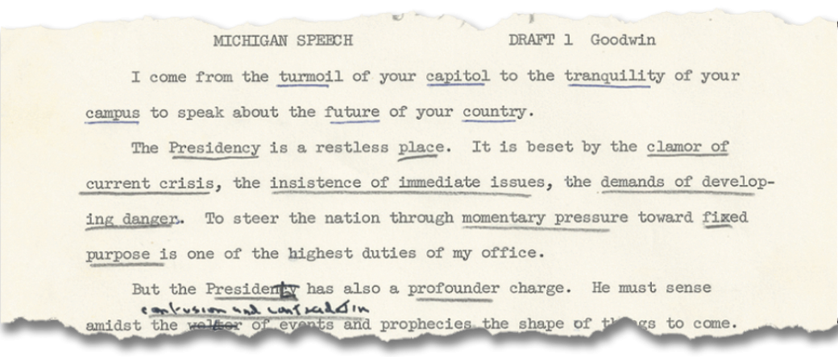

Undergraduate student-body president Roger Lowenstein sat onstage behind Johnson. When he saw the words “GREAT SOCIETY” roll by on the teleprompter — in his recollection, the phrase was underlined and written in big letters — Lowenstein snickered with Michigan Daily newspaper editor Ron Wilton, who was next to him.
“It did sound corny, and it wasn’t catchy,” said Lowenstein, who went on to become an attorney, then write for the hit TV show “L.A. Law,” and now runs a charter school in Los Angeles.
“We were just typical 21-year-old wise guys,” he said, “with complete ignorance that history was happening in front of us.”
Goodwin still has his first draft of the Great Society speech. For decades, it was boxed away in the Concord, Mass., home he shares with his wife, the historian and author Doris Kearns Goodwin.
Settled in a comfortable chair in his study, Dick Goodwin pulled eight typewritten pages from a folder. They show a work in progress: notes penciled in the margins, phrases underlined for emphasis, entire paragraphs scratched out.
“He knew his ambitions,” Goodwin said of Johnson. “When I first drafted that speech, somebody else on the staff took it upon himself to redo it so it became just another anti-poverty speech. In fact, it was rewritten. I went in to see Johnson. This was intended to be much more than anti-poverty. It was a grand master plan. Johnson had it changed back to what it had been.”

The transformation
LBJ’s brand of government activism was inspired by his idol, Franklin D. Roosevelt, and the New Deal of his Depression-era youth. (At 26, he had run FDR’s National Youth Administration work and training program in Texas.)
But the reach of Johnson’s Great Society was broader, its premise even more idealistic.
“Roosevelt did not set out to start a revolution in this country. He was trying to put out the fire” of an economic catastrophe, said political scientist Norman J. Ornstein, resident scholar at the American Enterprise Institute. “Coming at a time of prosperity, Johnson really was looking for a way to transform America.”
LBJ prodded the 89th Congress , which was seated from January 1965 to January 1967, to churn out nearly 200 major bills. It is regarded by many as the most productive legislative body in American history — and the starkest contrast imaginable to the Capitol Hill paralysis of today.
In the space of a few years came an avalanche of new laws, many of which were part of LBJ’s War on Poverty: Civil rights protections. Medicare and Medicaid. Food stamps. Urban renewal. The first broad federal investment in elementary and high school education. Head Start and college aid. An end to what was essentially a whites-only immigration policy. Landmark consumer safety and environmental regulations. Funding that gave voice to community action groups.
Before the 1965 passage of the Voting Rights Act, which sought to bring blacks to the polls, there were believed to be about 300 African American elected officials in this country. By 1970, there were 1,469. As of 2011, there were more than 10,500, according to the Joint Center for Political and Economic Studies.
One of them sits in the Oval Office.
Critics said some of the Great Society programs perpetuated the problems they aimed to solve, stirred social discontent and worked mostly to the benefit of the massive, intractable bureaucracies they created.
Enormous sums were spent on ideas that had never been tested outside of social-science theory, and some proved unworkable in the real world.
The Model Cities program, for instance, was shut down in 1974. Dick Lee, the slum-clearing mayor New Haven, Conn., who had overseen one of the most ambitious of the federally financed initiatives, once said, “If New Haven is a model city, God help America’s cities.”
The Office of Economic Opportunity, which ran the War on Poverty, was abolished in 1981.
“We were coming up with programs so fast, even Johnson could barely remember what he proposed,” Goodwin said.
Disillusionment gained force as the Vietnam War sapped Johnson of his political capital and his moral authority, and squeezed his budget.
In a 1978 book, Henry Aaron of the Brookings Institution wrote that the speed and intensity with which the country shifted gears “is unique in American political history.”
Johnson was acutely aware of that. “He was conscious of how limited time there was to get things done,” Califano said, “and how he was spending capital all the time.”
LBJ was elected in 1964 with what was then the biggest landslide in U.S. history. Just two years later in the midterm contests, his party lost three seats in the Senate, 47 in the House and eight governorships. Republicans would win five of the next six presidential elections.
Among those presidents was Ronald Reagan, who memorably said that the United States had waged a war on poverty and poverty won.
Reagan wrote in his diary on Jan. 28, 1982: “The press is dying to paint me as now trying to undo the New Deal. I remind them I voted for F.D.R. 4 times. I’m trying to undo the ‘Great Society.’ It was L.B.J.’s war on poverty that led to our present mess.”
The irony, of course, is that while Reagan and other presidents tried to eradicate Great Society programs, nearly all survived in some form, and spending on them continued to rise. The federal government has grown even larger — more than five times as big as it was in 1960, in real dollars — while public faith in it stands near all-time lows.
“That’s the paradox of the Great Society,” said Peter Berkowitz, a senior fellow at Stanford University’s conservative Hoover Institution. “It has never been more entrenched.”
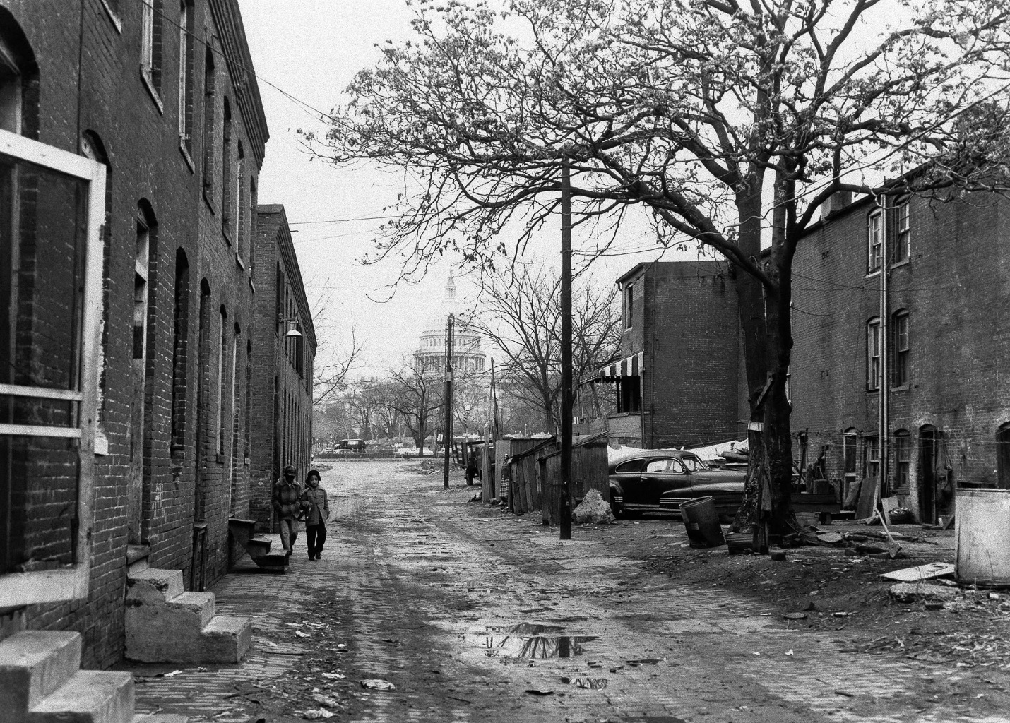
Above: An alleyway between Delaware Avenue and First Street in Southwest Washington, within sight of the Capitol, in January 1958. (Associated Press)

The right time
The debate over the proper size and role of the federal government is a distinctly American one. In no other country has that question been argued for so long and with such intensity, going all the way back to Alexander Hamilton (who wanted a powerful central authority) and Thomas Jefferson (who feared one).
But there have also been eras when the country has opened its arms to a more expansive, muscular Washington. Sometimes, it has been because of a thirst for reform, as happened during the progressive movement of the early 20th century. At others, because the problems are so dire, as was the case with the New Deal in the 1930s.
LBJ recognized that, in the early 1960s, another set of atmospheric forces was building a storm system for government activism.
The economy was booming, ginned up by a big tax cut. America was mourning a slain president who had ignited its idealism. The civil rights movement had awakened its conscience. The nation was led by a president of unmatched legislative skills. And confidence in Washington was as high as pollsters have ever seen it.
Back then, when Americans were asked how often they trusted the federal government to do what is right, nearly 80 percent said just about always or most of the time, according to data compiled by the Pew Research Center.
That confidence would begin to erode dramatically in the mid-1960s as Vietnam and social disruption surrounding the Great Society shook Americans’ faith in the government that had brought them through the Depression and World War II.
By the end of 1966, their favorable view of Washington had declined sharply, to 65 percent — and it had a lot farther to go. It stood at 19 percent after last year’s government shutdown.
Yale Law School emeritus professor Peter Schuck, who was an official at the Department of Health, Education and Welfare during the Jimmy Carter administration, argues that the extension of the government’s reach and ambitions has deepened public cynicism.
“In short, the public views the federal government as a chronically clumsy, ineffectual, bloated giant that cannot be counted upon to do the right thing, much less do it well,” Schuck wrote in his new book, “Why Government Fails So Often.” “It does not seem to matter much to them whether the government that fails them is liberal or conservative, or how earnestly our leaders promise to remedy these failures.”
The Great Society promised too much. Sargent Shriver, whom LBJ put in charge of the War on Poverty, said that “ending poverty in this land” was actually achievable by 1976.
Decades later, Shriver reflected on why such a righteous undertaking should have become so reviled. One reason was the explosion of disorder, even riots, that followed.
“We weren’t quite prepared for the bitterness and the antagonism and the violence — in some cases, the emotional outbursts — that accompanied an effort to alleviate poverty,” Shriver told Michael Gillette, director of the LBJ Presidential Library’s oral-history program.
“There were an awful lot of people, both white and black, who had generations of pent-up feelings,” Shriver said. “. . . The placid life of most middle-class Americans was stunned, shocked, by all this social explosion, and then a lot of fear came into the hearts and minds of a lot of middle-class people — not only fear, but then real hostility.”
Liberals and conservatives disagree on why the War on Poverty fell short — whether it was abandoned or was destined to fail from the start.
“Government has crowded out civil society in many ways, inadvertently,” said House Budget Committee Chairman Paul Ryan (R-Wis.). “. . . The federal government has a very important role to play here. I’m not suggesting they don’t. But it needs to be a supporting role, not a commanding role, not a displacing role.”
In the past few years, the plight of those on the bottom has gotten new attention as the country has struggled to reach escape velocity from its latest recession. The disparity between the rich and the poor has grown.
Ryan, who was on the 2012 GOP presidential ticket as Mitt Romney’s running mate, said his committee did a yearlong study of federal anti-poverty initiatives and discovered that Washington is spending $800 billion on nearly 100 programs, with no accountability for results.
In March, Ryan’s committee issued a report noting that the official poverty rate in 2012 was 15 percent, just a couple of points lower than where it stood in 1965.
But the president’s Council of Economic Advisers uses a broader measure — including tax credits and benefits such as food assistance — that estimates that poverty has dropped by more than a third, from more than 25 percent of the population in the mid-1960s to 16 percent in 2012.
So who is right?
“Economists always argue over the ‘counterfactual’ outcome,” said Austin Nichols, senior research associate at the Urban Institute’s Income and Benefits Policy Center. “You don’t know what things would have looked like if the programs hadn’t existed, and how many external factors there are, like economic growth.”
“It’s even harder with the Great Society programs, since a lot of them were constantly being modified,” he added.
For instance, Nichols noted in a recent blog post, federal spending on food stamps “mushroomed in size in the 2000s as it was called on to replace shrinking cash welfare programs.”
For some, the Great Society clearly made life better. In 1964, despite Social Security, more than one out of three Americans over 65 were living below the poverty line, in no small part because of their medical bills. (Forty-four percent had no coverage.) Today, with Medicare available, fewer than one out of seven do.
“These endeavors didn’t just make us a better country,” President Obama said earlier this year. “They reaffirmed that we are a great country.”

The shift
The Great Society did not just seek to redistribute wealth.
Johnson also set out to shift power in America — from states to Washington, from the legislative branch to the executive, from corporations to federal regulators, from big-city political machines to community groups.
That latter concept of “community action” — funding residents of poor communities so they could organize and mobilize — was one of the Great Society’s most controversial ideas. The concept was to put the poor in a position to help themselves, but it frequently played out in tense and even violent confrontations with the existing local power structure.
It also created a new generation of up-and-coming leaders, rising from the ranks of those who had previously been disenfranchised.
“My mother was clearly the person Lyndon Johnson had in mind with civic action, and she took full advantage of that,” said Ron Kirk, the former mayor of Dallas who served as U.S. trade representative in the Obama administration.
Willie Mae Kirk, who died in September, became a renowned community organizer whose victories included stopping the city of Austin from shutting down its only library branch in a black neighborhood. (One there now is named for her.)
“Part of President Johnson’s absolute genius was putting in place a mechanism that said: ‘You know what? You’re not going to have to be dependent on these, in many cases, biased political bodies,’ ” her son said. “They wouldn’t pay you lip service, give you an audience, much less put power in the hands of the people.”
For others, the Great Society opened up horizons, as well as opportunities.
When Rodney Ellis was 17, a Great Society program gave him a summer job in a hospital.
“It let me know I could do something other than what my dad did,” Ellis said. “My dad was a yard man.”
He became a slide-rule-team star as part of the Houston’s Inner-City Leadership Development Program — part of Model Cities. At 29, he was elected to the Houston City Council, taking a seat that was created because of the Voting Rights Act. Ellis is now a Texas state senator.
“All of the things that we aspire for in our country really ended up being implemented to some extent in the Great Society,” Ellis said.
Yet in his final years, Johnson mourned what was becoming of his domestic legacy.
“I figured when my legislative program passed the Congress that the Great Society had a real chance to grow into a beautiful woman,” Johnson told biographer Doris Kearns in 1971. “I figured she’d be so big and beautiful that the American people couldn’t help but fall in love with her, and once they did, they’d want to keep her around forever, making her a permanent part of American life, more permanent even than the New Deal.”
“It’s a terrible thing for me to sit by and watch someone else starve my Great Society to death,” Johnson said. “Soon she’ll be so ugly that the American people will refuse to look at her; they’ll stick her in a closet to hide her away and there she’ll die.”

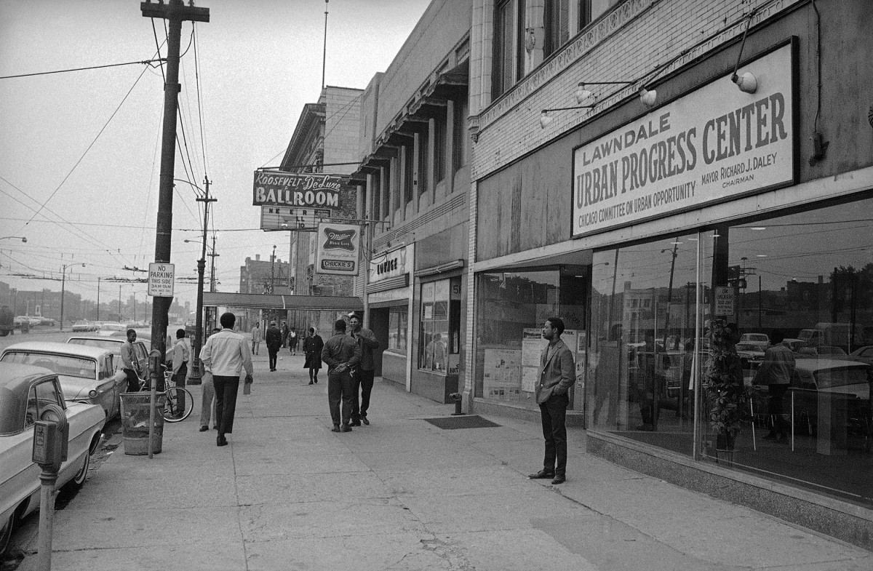

An urban renewal development office in Chicago on June 1969

The legacy
With 50 years’ perspective, there are things that liberals and conservatives agree the Great Society got right, including some that were politically costly in their day.
After signing the Civil Rights Act of 1964, Johnson gloomily observed to Moyers, “I think we just delivered the South to the Republican Party for a long time to come.”
Few now, however, would dispute that it was a good thing to remove barriers to racial equality — or that government dictate was the only way to do it.
“The anti-discrimination laws that were passed in the 1960s have probably done more to reduce economic inequality than have government programs,” said Diana Furchtgott-Roth, who was the Labor Department’s chief economist during the George W. Bush administration and who is now a senior fellow at the conservative Manhattan Institute for Policy Research.
In addition to tackling the oldest problems, the Great Society took the federal government into realms where it had never gone before.
Chief among them was education. Until the Elementary and Secondary Education Act of 1965, Washington had never provided comprehensive funding for education below the college level. Its aid to college students was largely limited to helping veterans through the GI Bill.
Where the federal government spent less than $150 per elementary and high school student in 1960, in inflation-adjusted dollars, the figure by 2011 had reached about $1,600. In 2008, more than 64 percent of undergraduates on college campuses were receiving federal financial assistance of some kind.
The federal role “has remained controversial to this day,” said Margaret Spellings, education secretary under Bush, whose No Child Left Behind initiative attempted to hold schools more accountable for student achievement.
In the Great Society, “what succeeded is resourcing around poor, minority and disadvantaged students, an acknowledgment that there was a role for the federal government to level the playing field,” Spellings said. “. . . What I think has not worked is thinking that that was enough, that just that input would do the job. That’s why things like accountability and No Child Left Behind — fast-forward 40 years — were important, to deliver on the promise.”
Yet the political battle over the Common Core — a set of achievement standards developed by governors and encouraged by the Obama administration — is the latest example of the tension that arises when the federal government puts its finger on the scale in education. Criticism of the Common Core has come from an diverse chorus that includes tea party activists and teachers unions.
Some of the Great Society’s biggest accomplishments are rarely acknowledged today. For instance, the Immigration and Nationality Act of 1965 scrapped a 1920s-era quota system that had effectively shut out most of the world, except for blond, blue-eyed Western Europe.
The 1965 law inviting in Africans, Latin Americans and Asians “was in some ways the most important determinant of our ethnic composition,” said Schuck, who taught immigration law and policy at Yale Law School.
Other Great Society initiatives are being whittled away. In 2013, the Supreme Court struck down a key part of the Voting Rights Act, saying that some of its restrictions are outdated, in light of the racial progress that has been made.
And last month, the court upheld Michigan’s constitutional amendment banning affirmative action in college admissions — a blow to another Great Society program that some believe has outlived its usefulness. (Johnson himself thought of affirmative action as a limited, temporary measure, necessary for only a generation or so, Califano said.) Since the ban passed in 2006, black enrollment at the University of Michigan has dropped by a third.
For Gwendolyn Calvert Baker, there was a poignancy in that court decision.
She had been sitting near the front of her 1964 University of Michigan graduating class when Johnson delivered his Great Society speech.
Baker would have been easy to spot in that sea of caps and gowns. She was older than most of the students, a mom who had returned to college on a Rotary Club scholarship. And she was one of only about 200 African Americans on Michigan’s campus of nearly 28,000 students.
Baker got her PhD in 1972, joined the Michigan faculty as an education professor, and went on to run the University of Michigan affirmative-action program that in more recent years came under court challenge.
“The content of that speech, I really can’t say I remember a lot of it,” said Baker, who is now retired and living in Florida. “But it had meaning. I was feeling good that he was at least thinking in some of the ways I had been thinking.”
A half-century later, Baker said, she is pretty sure she knows what LBJ would think of how it all turned out.
“He would say we’ve come a long way, but we’ve still got a long way to go.”

Great Society at 50: Prince George’s illustrates programs’ transformative legacy — and limits
Joseph M. Parker Sr. has lived in Prince George’s County all of his life, occupying a world that has always been pretty much all black — first by law, then by choice.
He grew up in Fairmount Heights, one of the earliest black towns in a county that was then overwhelmingly white. He graduated from all-black Fairmont Heights High School, then historically black Maryland State Teachers College at Bowie. His first teaching jobs were in the county’s segregated elementary schools.
After Parker married, he and his wife moved to the Addison Chapel Apartments in Capitol Heights. “That was the only place in all of P.G. where a black person could rent in an apartment complex,” Parker recalled.
Now 79, Parker is a retiree living a comfortable life in a spacious rancher in Mitchellville, but he recounts his history with more than a tinge of bitterness. The pattern of exclusion Parker experienced in Prince George’s held for decades, circumscribing his possibilities and those of most African Americans both in the county and across America.
The wall of discrimination stood solid until the mid-1960s, when the historic rush of legislation enacted to fulfill President Lyndon B. Johnson’s Great Society vision — launched 50 years ago this week — made it give way.
The legislation’s broad mix of anti-discrimination, social-investment and affirmative-action policies was pivotal in turning Prince George’s County from a mostly white, highly segregated and semi-rural backwater into the wealthiest majority-black county in the nation over the course of a single generation.
“I don’t think you could have the Prince George’s County of today without the Great Society,” said Bart Landry, a University of Maryland sociologist whose research has focused on the African American middle class.
The county became a premier example of a national migration of African Americans from central cities to the suburbs.
Since the 1970s, the African American population in Prince George’s has swelled from just under 15 percent to 65 percent. At the same time, the county’s median income increased, and it continues to far outpace the national average.
“This had been a horse-and-buggy county up until the late 1960s,” Parker said. “But things sure have changed.”
By 2010, just over half of African Americans in the nation’s 100 largest metropolitan areas lived in the suburbs, according to an analysis by Brookings Institution researcher William H. Frey. By then, nearly eight in 10 whites in the nation’s 100 largest metropolitan areas lived in the suburbs, Frey noted.
But if the shaping of modern-day Prince George’s — with its brick-front McMansions, its nearly 40,000 black-owned businesses, and its generally well-educated and upscale majority-black population — is testament to the transformative power of the federal government, it also offers glaring proof of its limits.
For all of the county’s successes, it remains the least-prosperous county in the Washington suburbs. Its student test scores and housing values are lower, and its crime and poverty rates are higher. Also, the county — where African Americans make up two-thirds of the population — remains largely segregated, with relatively few non-blacks choosing to move in, a pattern that lowers demand and holds housing prices down.
“While Prince George’s is in many ways a source of pride for middle- and upper-middle-class African Americans, it does not offer the same amenities, public or private, or the same wealth-building opportunities as do the other suburban communities in the Washington area,” said Margery Turner, an Urban Institute senior vice president who has studied the county’s housing patterns. “There is not enough demand pressure to push house prices up and create the kind of wealth from house-price appreciation that occurs in other parts of the metropolitan area.”
Black middle class grows
Some critics argue that the Great Society programs hastened urban decline by increasing government dependency and the family breakdown. And in many cases, the grim plight of the nation’s decaying central cities was largely unaltered by the programs launched by the Great Society. Anti-poverty programs could not overcome middle-class flight, and many of the nation’s cities — including Washington — continued a period of decline that has only recently reversed.
Across the D.C. line from Prince George’s County, urban- renewal programs later bolstered by the Great Society cleared out much of Southwest Washington’s working-class black community to build offices and apartments occupied by others. That kind of change became so common across the country that it prompted writer James Baldwin to dub the program “Negro removal.”
Still, longtime residents such as Parker say there is no denying the benefits the Great Society initiatives, including federal education aid and fair-housing legislation, brought to Prince George’s.
The Supreme Court’s 1954 Brown v. Board of Education decision outlawed the practice of “separate but equal” in the nation’s schools. But that barely made a difference in Parker’s world. White county officials slowed its implementation to a crawl, often leaving black teachers with inferior facilities, less pay and fewer career options than their white counterparts.
School officials in Prince George’s began feeling real heat to desegregate only when the large sums of money provided by Johnson’s education programs were threatened. The 1964 Civil Rights Act empowered federal education officials to withhold federal money from local school systems that were moving too slowly to integrate.
Around that time, large numbers of African Americans in the District began moving into Prince George’s. Most of them were funneled into neighborhoods inside the Beltway, largely because they were blocked from buying elsewhere.
Just as quickly, many whites abandoned those communities, often urged on by “blockbusting” real estate agents and speculators. Blockbusters would try to trigger the sale of white-owned homes by incessantly urging white owners to sell before their neighborhoods became predominantly black, lowering property values.
The 1968 Fair Housing Act outlawed blockbusting and other forms of housing discrimination, clearing the way for the mass suburbanization of African Americans in the decades to follow. Being able to buy homes in suburbs with newer homes and schools helped African Americans build wealth, scholars point out.
Mary Pattillo, a Northwestern University professor who has studied the growth of the black middle class, noted that for decades before the 1960s, federal policy often contributed to housing segregation in the country. Low-income public housing projects were largely packed into black neighborhoods. And the Federal Housing Administration, established in the aftermath of the Great Depression, offered guidelines that discouraged mortgage lending in black neighborhoods and communities that were turning black.
“The Fair Housing Act signaled that the federal government was, at the very least, going to be non-segregationist,” Pattillo said.
The Great Society’s impact did not stop there. The legislation providing federal aid for higher education included the nation’s federal college financial aid programs, which fueled a national boom in college attendance and completion. Between 1964 and 2013, the percentage of Americans over age 25 who graduated from college tripled to 33 percent. For African Americans the growth was even more dramatic, going from 5 percent to over 20 percent over that time period.
Meanwhile, the package’s anti-poverty legislation combined with a roaring economy to lift millions of Americans out of the ranks of the poor. Between 1964 and 1976, the African American poverty rate declined from more than 45 percent to 30 percent.
Johnson’s embrace of affirmative action helped lay the foundation for the explosive growth of the black middle class. Now, more than one in three black households have incomes at or above the national median of $51,000 a year, nearly double the percentage that earned that inflation-adjusted income in 1967, according to census statistics.
Affirmative action helped lift black workers — from police officers and firefighters to lawyers and other professionals — into jobs that were previously out of reach. The policies made it easier for African Americans to attend selective colleges and to win business from government, which created new firms and blazed new career paths for a growing black middle class that previously was confined largely to government work.
“There are more African Americans in the Washington area who are technology workers than there are African Americans who teach elementary and middle school or work for the Postal Service,” said William E. Spriggs, a Howard University professor and chief economist for the AFL-CIO.
There are more than 13,000 black technology workers in Prince George’s County alone. Many of them work for firms set up to take advantage of the Small Business Administration 8(a) program, which was established in 1968 to enhance federal purchases from small businesses owned by people from economically disadvantaged groups.
“That community grew as the government’s appetite for computing power grew,” Spriggs said. “This is a big part of what makes P.G. the place that it is.”
Changes in Prince George’s
Today’s Prince George’s County is a long way from the place where Parker came of age. As he grew up, his neighbors included some Howard University employees, federal workers and a fair number of people who worked for the Washington Suburban Sanitary Commission.
Parker’s parents were raised in Upper Marlboro, where just a few generations earlier the land was worked by slaves. They later moved to Fairmount Heights, then a thriving black town offering its own municipal services. His mother ran a family-owned tavern and delicatessen, and for years the family lived above the business before later moving to a two-story home on 60th Avenue.
“Living above the tavern, we heard and sometimes saw some things we shouldn’t have,” Parker said.
His father was a building engineer for the National Geographic Society before going on to a similar job at Fairmont Heights High School when it opened in 1950.
That put Parker and his family among the black elite in Prince George’s County. And he did what many in the nation’s tiny black middle class did back then: He earned his teaching credentials and began working in the county’s segregated schools.
As his early career unfolded in the 1950s and early 1960s, the nation was witness to historic civil rights breakthroughs in the courts, schools, bus stations and lunch counters. But it was Johnson’s raft of legislation that brought change home to Parker — even if it proved incomplete.
“Johnson’s Great Society speech absolutely made an impression on me,” Parker said. “I thought we had turned the corner.”
It wasn’t long before Parker was personally involved in — and protected by — the laws and programs set up by Johnson. By the mid-1960s, he was coordinator of a federally funded program that provided county youths with homework help, medical check-ups and cultural enrichment, including trips to restaurants and Broadway plays. The program proved to be short-lived when the county refused to pick up its funding after the federal money expired after five years. Parker went on to eventually be a principal in the county schools.
While driving home along Route 450 in 1974, Parker saw a sign advertising new homes in a Mitchellville neighborhood called Enterprise Estates. Curious, he followed the directions to the subdivision.
He stopped by the sales office, only to be ignored by the white real estate agent for 20 minutes. “I was treated like I was the invisible man,” Parker said. “The salesman was very cold, very distant, and obviously not interested in my investment plans.”
Parker finally got his attention but was told there were no houses available. He grabbed some literature and left.
Not long after, he returned with his wife. But they got the same treatment. They returned again and again — and each time they were given the same story. Parker later learned that nearly every black potential home buyer received the same treatment.
At the time, he was chairman of the county’s Human Relations Commission — the county’s vehicle for enforcing local anti-discrimination laws mirroring those passed by Johnson. On the commission, he paid particular attention to police abuses as well as the treatment of black prisoners in the county jail. But he refused to use his power to buy a house.
“If I did that, what happens when a black person who is not politically connected tries to buy a house?” he explained, a quaint view in a county now renowned as a center of black political power.
Parker kept visiting — he says more than dozen times over three months — before, finally, he had a confrontation with the sales agent. Looking up at a display of wall plaques recognizing sales goals met by the agent, Parker began: “Something doesn’t smell well here. You have been BS-ing somebody, and I am going to find out why.”
That evening, he got a call saying a house had suddenly become available. It is the same house where he raised his three sons — all of whom are college graduates, middle-class and living in Prince George’s — and where he still lives today.

Great Society at 50: LBJ’s Job Corps will cost taxpayers $1.7 billion this year. Does it work?
INDIAHOMA, Okla. — In the middle of an Oklahoma wildlife refuge — at a campus so remote that buffalo wander in — about 100 young people are taking classes in the hope that the U.S. government can turn their lives around.
Given the statistics, most of them will be disappointed.
This is the Treasure Lake Job Corps center, an outpost of a job-training program created as part of President Lyndon B. Johnson’s Great Society. The program began with a noble, untested idea: Government could save troubled youths one at a time, taking them in and teaching them a trade.
Today, students here learn subjects such as cooking, nursing and plumbing from employees of the U.S. Forest Service. A year of education and job placement costs taxpayers about $45,000, more than tuition at Georgia Tech.
But at last count, only about 49 percent of Treasure Lake’s students completed their job training.
And only 55 percent of those graduates found jobs in fields they were trained for.
“Is it worth it to the taxpayer? If functioning well, yes,” said Roger Hepburn, Treasure Lake’s new acting director.
But is Treasure Lake worth the cost given how it actually functions?
“I don’t know how to answer that,” Hepburn said. “So I’m just not going to.”
The struggles of this place — and of the Job Corps program as a whole — have come to illustrate two powerful legacies of the Great Society. The first is that the government has vastly expanded its ambition to improve individual lives.
Fifty years after Johnson laid out his ambitious agenda — which led to Medicare,Medicaid, food stamps and many other programs — Washington now does far more in an effort to lift ordinary Americans above their troubles.
The second is that government often fails to fulfill those broad ambitions.
And we’ve gotten used to it.
Job Corps will cost about $1.7 billion this year, making it the most expensive single job-training program at the Labor Department. It has about 37,000 training slots for young people every year, just a fraction of the country’s unemployed and underemployed.
But, at last count, less than half of Job Corps students were able to finish their job training and then find a job in the field they were trained for. And in 2008, a comprehensive studyfound that Job Corps’ benefits to society did not outweigh its costs.
But Job Corps is still very popular in Washington, among lawmakers of both parties.
It is still considered a success — at least as “success” is defined now, after a hard and disappointing 50-year war on poverty.
“The question is, do they work at all? Are the students better off not going to the center [at all] than going there?” said Anand Vimalassery, who represents an association of contractors that run federal Job Corps centers. “My guess is that they’re still probably a little better off going there.”
‘A fresh start’
The Job Corps program has 125 centers across the country. The students come as volunteers, some recruited by an online ad campaign: “Every day is a fresh start at Job Corps.” To enroll, they must be from low-income families and at least 16 years old. More than half lack a high school diploma.
Once accepted, nearly all students live at a center rent-free. Most stay there between nine and 11 months. In addition to academic and vocational classes, students also learn how to write a résumé and how to interview with an employer.
It is an expensive way to get somebody a job.
Federal officials say Job Corps costs more than other job-training programs because it does more. Instead of just teaching someone to weld, or how to search Monster.com, Job Corps is reorienting entire lives — lives that otherwise might drift away from the world of work.
“We think it’s clearly money well spent,” said Portia Wu, who oversees job-training programs at the Labor Department. “It’s a lot cheaper than some of the alternatives, like our juvenile- or criminal-justice systems.”
That is an argument nearly unchanged since 1964, when President Johnson’s advisers proposed the Job Corps program. Other Great Society programs offered a safety net to catch poor families — expanded food-stamp benefits, health care through Medicaid. Job Corps was intended to be something more aggressive, a way to help young people so they would never need that safety net.
“They are new educational institutions, comparable in innovation to the land-grant colleges,” Johnson told Congress in March 1964. “Those who enter them will emerge better qualified to play a productive role in American society.”
Congress signed on. The result was a series of centers that were a little like trade school and a little like charm school. Some of them were set in the remote countryside, and they operated a little like a Depression-era civilian work camp.
It was a program for the poor, created by bureaucrats and academics who knew little about them.
In fact, when the first Job Corps center opened in rural Maryland in 1965, its leaders weren’t even sure what the first students would want when they arrived. Would they want cigarettes, the bureaucrats wondered, according to a Washington Post history of the program written in 1980, or would they want milk and cookies?
Were these men, who needed a trade? Or children, who needed a parent?
In private, even Johnson seemed doubtful that this odd new experiment would succeed at getting its students jobs.
But, he told a friend, at least it might get them ready for another government institution — the U.S. Army.
“Scrub ’em up, get some tapeworms out of their bellies and get ’em to where they get up at 6 o’clock in the morning, work all day. And then we can get ’em to where they can serve,” Johnson told Dick West, an editor at the Dallas Morning News, explaining Job Corps in a taped conversation from August 1964. At the time, the Vietnam War was on and the Army was turning away many young draftees for a lack of physical or mental fitness.
“We think we can clean ’em up this way and shoot ’em on in there,” Johnson told his friend. “And maybe — maybe even teach ’em to be a truck driver or, uh, something.”
A heavyweight example
In the 50 years since, Job Corps has made a difference in many lives. George Foremanlearned to box at a Job Corps center and said later that it turned him from a street brawler into a heavyweight champ. Alumni include doctors, small-business owners and the chief judge of Idaho’s state court of appeals.
“If I could donate money to Job Corps, I would. It’s one of those programs that, I wish it would always be there,” said Antonio Alford, 33. Alford learned commercial painting at a Job Corps program in Massachusetts in 1999 and rose in that field to become the foreman in charge of repainting part of the U.S. Capitol’s roof in 2012.
“That’s all it takes sometimes, somebody to give you that first step,” Alford said.
But for many students, Job Corps was not enough.
Over the decades, auditors found that many students quit before they graduated — homesick, bored, or tired of conflicts with other students. Today, about 59 percent complete all of their training. The rest leave early, with no penalty or requirement to pay money back.
Many others students graduate to find that Job Corps did not prepare them for a job. The problem might be that a student is not advanced enough to be hired, or lacks the connections that help others in the field.
“I had a friend, he took culinary, and he ended up being a landscaper. . . . Had another friend, he was a plasterer, but now he cuts meat for a living,” said Adrian Puga, 18, of Amarillo, Tex. Puga graduated from the Treasure Lake Job Corps center in May 2013, trained in carpentry.
He became a success story — at least briefly. Puga got a job building fences, for six months, then left it. Now he works for a lawn-care business. “I only work on Fridays and Thursday, because we don’t have that much work going on,” he said.
In the past, auditors found that Job Corps officials had used accounting gimmicks to exaggerate their success at placing students in good jobs.
In 2011, for instance, auditors discovered a student who had been trained in cooking got a job as a funeral attendant. The loose rules used by Labor Department officials allowed them to count that as a “match” to the student's culinary training.
They also counted another culinary student who got a job in pest control. Labor Department officials say they no longer do things that way.
Critics of Job Corps, mainly conservatives, say the program’s success stories have kept politicians from asking hard questions about it.
“It’s really governance by anecdote,” said Mason Bishop, a former Labor Department official who oversaw Job Corps and other job-training programs under President George W. Bush. “We all want to believe that the worth of one soul is enough to justify millions and billions of dollars in spending. But the real question is, how many souls do we need to save to make the investment worth it?”
The broadest attempt to answer that question — “Does Job Corps Work?” — was made by researchers at a private firm in Princeton, N.J. Starting in 1995, they spent nine years studying 15,000 students who had applied for Job Corps, comparing the ones who attended with the ones who did not.
The results were mixed. The Job Corps participants showed greater educational gains and fewer arrests, and — four years after they attended Job Corps — they made more money, by 12 percent. That was the good news. This was the first time that any big federal employment and training program targeting at-risk youths had succeeded at increasing their earnings. The benefits were especially pronounced for students who entered the program when they were older than 20.
The bad news was that, after four years, the benefits disappeared. On average, the Job Corps students earned the same as the others.
And that wasn’t the only bad news. When the researchers tried to add up all the social benefits of Job Corps — including reduced crime and reduced use of welfare benefits — they found it still did not equal the cost of sending students to the program.
“What you find is that the program — from society’s perspective — does not pay for itself,” said Peter Schochet, a senior fellow at the policy research firm Mathematica who helped lead that study. “But it is a good deal for the enrollees themselves.”
In Washington today, that much good is good enough.
In past decades, Richard M. Nixon sought to shrink Job Corps. Ronald Reagan tried to eliminate it. Today, Washington is focusing on job-training programs again, with Vice President Biden leading a review of the government’s overcomplicated and undereffective set of 45-plus programs.
But, even amid all that, Job Corps seems to be safe. The program has support from House conservatives, although they have pressed to close a few low-performing centers.
“I think sometimes the value is, in one sense, immeasurable, because you have to see it almost kind of individual by individual,” said Sen. Robert P. Casey Jr. (D-Pa.), who chairs a Senate subcommittee that oversees employment programs. “You’re getting results that both parties can take a look at and make a determination that the program should be continued.”
Treasure Lake
Another way to measure the value of Job Corps’ work is to look at the place where it works the least. That would be Treasure Lake — the remote outpost in Oklahoma that ranks last in Job Corps’ own measurements of students’ academic progress and job-hunting success.
It began its life as a “civilian conservation center,” one of the subset of centers where students were supposed to be purified and edified through hard country labor. But today the center does most of its work indoors, teaching trades in construction, nursing and cooking.
Many former students say it was often chaotic and poorly managed.
“Reminded me of bein bk in jail lol,” one student wrote in a Facebook message.
Another said it reminded her of a homeless shelter, full of people hustling and fighting.
“As soon as I set foot in Job Corps, I was back on the streets,” she said. “The only difference was that my bed was a little nicer.”
Austin Brown, who came here when he was 16, recalled seeing other students at Treasure Lake make wine prison-style, using a trash bag full of fermenting cafeteria fruit and apple juice.
When it was ready, he said, “they strained all the apple peels and everything — all the mold and everything,” said Brown, now 18. “They would put it in the refrigerator and let it get cold” before drinking it, he said. Brown said he never drank it himself.
Turned off by the chaos, many students simply left before graduation. They called relatives or friends to pick them up and disappeared.
Today, the Forest Service is trying to turn the center around. Hepburn, the new director, arrived about three weeks ago — so recently that his walls are largely bare. But he already has tried to show there is a new order: When students returned from a recent field trip, he looked through photos and saw one flashing a gang sign.
“There he was, just big as day,” Hepburn recalled. “He’s gone.” The student was dismissed from the program.
It is too early to know if Hepburn’s approach is working, but he says he is regularly thanked by students and administrators for making the place feel safer and more productive.
But even when the place was at its worst, it still did some good. Former students praised their training in job skills, social skills and résumé writing, even while they criticized the living conditions. Brown — who watched his roommates make prison-style hooch — did get his training in culinary skills, and afterward he did get a job in his field. He is now a cook at Burger King.
“I hated it while I was there,” Brown said. “But I learned a lot.”

The Great Society at 50: Lyndon B. Johnson’s cultural vision mirrored his domestic one
On May 22, 1964, in a University of Michigan graduation speech filled with references to excellence, inspiration and enrichment, Lyndon B. Johnson interspersed the word “beauty” or “beautiful” five times. It was not the first mention of the term “Great Society” — the phrase had been used as the title of a commission report on the humanities five years earlier. But more powerfully than anything Johnson had said before, it connected the quality of American intellectual, aesthetic and artistic life with the basic aspirations of a prosperous, democratic nation.
Today, it’s easy to read the Great Society speech as generic political boilerplate. And most Americans, whether they admire or loathe Johnson, don’t remember him as a man preoccupied with art, culture or Aristotle’s ideal of man as a social being. He has come down to us as a collection of caricatures: the legislative sausage-maker, the men’s-room multi-tasker, the Rabelaisian figure delivered up by dozens of biographies and memoirs. His personal fund of metaphor and imagery came from the barnyard, not Parnassus, and so it’s a shock, 50 years later, to rediscover the halcyon Johnsonian rhetoric, so fresh, so idealistic, so impractical.
The trauma of Vietnam, images of the embittered and almost broken Johnson who dropped out of the political battle in 1968, and ongoing rancor about the economic and social costs of the Great Society have mostly erased memories of this lofty language. But it wasn’t uncharacteristic. During the 1964 election, which brought him an overwhelming congressional majority and legitimized his rise to the presidency after the assassination of John F. Kennedy, Johnson published a slim volume called “My Hope for America,” filled with similar inspirational nuggets. The Great Society, he averred, “serves not only the needs of the body and the demands of commerce, but the desire for beauty and the hunger for community.” It was a campaign document, and critics — especially those still mourning Camelot — savaged it. Murray Kempton thought it vulgar, false and badly written, sneering in the New York Review of Books, “To read him then is to pick through the racks of a dealer in second-hand national pieties.”
And yet, as we assess Johnson’s legacy, there is a surprising coherence to his cultural vision. He didn’t create the cultural infrastructure we know today, which is for the most part privately funded, intensely local and hugely diverse in ambition and resources. Nor did he initiate many of the ideas, programs and institutions that now define how Americans experience art and understand culture. But it was under his administration that the National Endowment for the Arts, the National Endowment for the Humanities, the Corporation for Public Broadcasting, the American Film Institute, the Hirshhorn and Renwick museums at the Smithsonian, and a host of other agencies and organizations were created or set on the path to fruition. The pieties may have been second-hand — Dwight Eisenhower and Kennedy laid much of the groundwork for the Great Society cultural program — but it was Johnson who helped realize them in legislation.
Equal access to excellence
There is still little agreement whether any or all of this was a good idea — whether the government should be involved in delivering ideas and beauty to the people, whether it is an effective system or a ridiculously cumbersome one. But in the extraordinarily active 89th Congress, which began in 1965, Johnson did something unprecedented in American history: He put art, culture and beauty on the same footing as roads, rights, commerce and security. If you want to understand Johnson’s cultural agenda, you have to see it not as an appendage but integrally related to the War on Poverty and the Civil Rights Act of 1964. The calculated brilliance of the Johnson cultural legacy is how closely it mirrors his other legislative priorities. The NEA, the NEH, the networks that bring us “Sesame Street” and “All Things Considered” were essentially a vast transportation bill meant to convey Americans through a moral, intellectual and aesthetic landscape.
“I think that President Johnson believed that the human experience needed to be nourished by face-to-face engagement and by bringing together people of different backgrounds and different races,” says Darren Walker, president of the Ford Foundation, which has played a major role in guiding and supporting the essential pieces of Johnson’s cultural program over the past half-century.
Johnson’s rhetoric affirms that. Again and again, the 36th president returned to a basic trope of encounter — that if Americans could see what was on the other side of the tracks or the other side of the country, once intractable problems would disappear. In Joseph A. Califano Jr.’s memoir of his time as Johnson’s top domestic aide, “The Triumph & Tragedy of Lyndon Johnson,” he remembers his boss saying: “You know the way to do something about Harlem? Make these rich Wall Street bankers drive through Harlem to and from work every day so they see the poverty instead of riding on an air-conditioned train drinking martinis and talking to each other about how much money they make.” Johnson offered the same solution to urban pollution: “Make the auto company executives and their wives ride around Detroit in non-air-conditioned cars during the summer,” Califano remembers him saying. “Then, they’ll damn well solve the problem.”
His ethical understanding of America was based on two essentially aesthetic, even artistic, ideas: discovery and epiphany. If Americans could be made to see the problems, they would by natural, reflexive impulse set out to solve them. But first, they had to see them firsthand. They needed knowledge of each other, and they needed equal access to the tools of encounter, whether that was art, music or documentary film.
“They are very much part of a related package,” says Paula Kerger, speaking of agencies such as the NEA and the one she runs as president and chief executive, PBS. “If you look at the NEA and PBS together for a second,” she says, one of the goals was “to bring art and knowledge into every corner of the country.”
Or as Califano said in a recent interview, Johnson’s cultural legislation “was kind of analogous to the Heart [Disease], Cancer and Stroke Act.” Like top-tier medicine, first-rate culture shouldn’t be limited to a handful of major metropolitan areas.
If access was essential, so was quality. “Johnson’s most famous legislative triumphs are about protecting and including people at the bottom of society,” says Dana Gioia, who became chairman of the NEA under George W. Bush in 2003. “But what people forget is that Johnson felt that you [also] had to invest in the ‘top’ of society, scientific research, medical research and, for the first time, cultural development.” In other words, equal access to excellence.
Which was, in turn, driven by deep concern about America’s place in the world. The cultural programs of the Great Society sprang from many sources, including Cold War competition and Johnson’s own sense of being a cultural outsider as a Texan in Washington.
“If the Soviet Union weren’t exporting art or the perception of superiority in the arts, would we have been as motivated?” asks Marc Scorca, head of Opera America. Just as Sputnik galvanized public funding for science, the Bolshoi Ballet’s international tours (beginning in 1959) helped build consensus for supporting the arts.
The need to represent American culture on the international stage helps explain one of the central contradictions of the cultural programs of the Great Society: In many ways, they weren’t really necessary. The situation for American culture in the mid-1960s was complex. There were deep worries that some older, “high culture” institutions, such as opera, might not be able to survive without government assistance. But there was also a boom in smaller cultural groups — theaters, dance companies, even regional opera companies — beginning in the 1950s. Johnson’s agenda wasn’t just to foment culture — it was meant to put a national stamp of approval on existing trends, an endorsement of the vibrant artistic and intellectual churn that preexisted his call “to advance the quality of our American civilization.”
“It is almost as if the growth in the field called for a federal agency,” Scorca says.
The culture business
Conservative critics saw little reason for government to get into the culture business, and great potential danger. Today we see Johnson’s arts and humanities programs through the lens of the culture wars, when the NEA was accused of blasphemy and obscenity, the NEH of academic insularity and historical revisionism, and PBS of political bias. Some critics argued that the agencies should be eliminated altogether, while others demanded stricter control over the art, academic research and public programming supported by taxpayers. That was a 180-degree reversal from the central conservative critique heard during the legislative debates in the 1960s — that government support of culture would lead to government control of culture. “The day will not be far off before we demand political allegiance of those who receive federal gifts, that we see the controversial ignored and the mediocre praised,” warned Rep. William S. Broomfield, a Michigan Republican.
The debate remains a perennial staple of congressional budget squabbles. But the history of these arguments confounds any easy sense of partisan division. When Johnson birthed the NEA and the NEH, the budgets were tiny. (The NEH began life in 1966 with an appropriation of $5.9 million, and the NEA $2.9 million.) Under Richard Nixon, both budgets increased exponentially, and two of the NEA’s strongest leaders were Republican appointees: Nancy Hanks, who served under Nixon and Gerald Ford, and Gioia, who served under George W. Bush.
Democratic administrations have often been uninterested in the agencies, or confused about their purpose. President Obama left the chairmanship of the NEA empty for more than a year, and the NEH is still without a chairman more than a year after the departure of Jim Leach. Such absences have weakened the cultural stamp of the administration and the effectiveness of both agencies. The commercialization of public television has continued steadily, regardless of the political climate or administration.
And over the past half-century, some of the Johnson cultural programs have essentially lost their Great Society stamp altogether. No one seems to care much that it was Johnson who brought Joseph Hirshhorn’s extraordinary modern art collection to Washington, despite ugly anti-Semitic debate during and after the museum’s creation about having a museum on the Mall named for a Jewish man born in Latvia (“I want the American people to see this stuff, I don’t care if they call it the horse---- museum,” Califano remembers Johnson saying). The American Film Institute, also born under Johnson and with a major outpost in Silver Spring, Md., is privately supported, its quasi-governmental origins largely forgotten.
Johnson’s cultural legacy is still contested, with strange contradiction on both sides. Some arts advocates view it as absolutely essential to the survival of culture yet bemoan budgets so small that the programs can never be effective. Some detractors seem almost as addicted to punching it as they are determined to eliminate it. The amount of energy spent criticizing a handful of controversial grants during the culture wars was strangely disproportionate to the simultaneous descent of popular culture into crudity, vulgarity and insipidity.
And yet, despite constantly attracting epithets such as “embattled” or “controversial,” most of what was established in 1965 has proved remarkably resilient. “The consensus about the value of the arts has always been a fragile ecosystem,” says Robert Lynch, head of Americans for the Arts. But it survives, he argues, because a lot of different constituencies “found a home in that legislation.”
Gioia argues that the decentralization of the cultural programs was part of its brilliance, making it more dynamic and creative than the centralized, top-down European systems of cultural funding. Kerger, of PBS, admits that “there is a part of me that wishes there had been more resources set aside” for public broadcasting, but adds that “on the other hand it has made us more entrepreneurial and more attuned to the needs of our communities.”
And one might argue that the darkest days of the Great Society cultural programs — when conservative critics angry about homoerotic photographs by Robert Mapplethorpe and a handful of other controversial grants — only proved how necessary Johnson’s vision of cultural encounter and epiphany was. The arts and humanities as a “transportation” project had been all too effective, bringing Americans too close, too quickly, to ideas that made them uncomfortable.
The Great Lady that wasn’t
In the end, after Johnson left the White House, when he seemed broken and bitter and his administration was defined by the failure and cynicism of the war in Vietnam, Johnson spoke to biographer Doris Kearns Goodwin about the Great Society. “I figured when my legislative program passed Congress,” he said, it “had a real chance to grow into a beautiful woman. And I figured her growth and development would be as natural and inevitable as any small child’s.”
There is a universe of megalomania and psychosexual weirdness in that image. But it is also one of the oldest metaphors of art, a reference to the statue of the beautiful woman who comes to life — Galatea, immortalized for 20th-century audiences in George Bernard Shaw’s “Pygmalion,” a satire on class and self-improvement. Johnson imagined his woman growing into a colossus: “I figured she’d be so big and beautiful that the American people couldn’t help but fall in love with her, and once they did, they’d want to keep her around forever.”
The cultural parts of Johnson’s Great Society never became the Great Lady he imagined, but Americans have so far been inclined to keep her around.
Curiously, in 1964, the Pygmalion and Galatea story was familiar to many Americans from the movie “My Fair Lady,” released that year and based loosely on the Shaw play.
Two people, from vastly different walks of life, were seen in Technicolor splendor, crossing cultural boundaries and having epiphanies about basic empathy. It was possible then, for many Americans, to imagine the whole world could be full of lots of chocolate for everyone to eat, and lots of coal making lots of heat.
One wonders whether Johnson, the cultural outsider, the foul-mouthed Texan taking up the Kennedy cultural mantle, knew the film. “Oh, wouldn’t it be loverly?”

