The Economist’s 2014 Special Report on Iran
Contents of this special report
- The revolution is over
- Religion: Take it or leave it
- Domestic politics: Rush to the centre
- The hardliners: Goon squad
- The economy: Melons for everyone
- The Neighbors: Moving targets
- Prospects: We shall overcome, maybe

“The revolution is over”

After decades of messianic fervour, Iran is becoming a more mature and modern country, says Oliver August
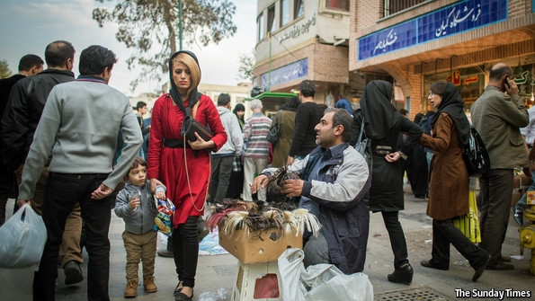
FROM THE MOUNTAINS of the Caucasus to the waters of the Indian Ocean, Iranians are watching intently as their government haggles with foreign powers over trade sanctions imposed to restrain its nuclear programme. Pointing to a corner of his office, the owner of a struggling cannery says: “See that television set? I watch it hour by hour, hoping for news that sanctions will be lifted.”
Iran says its nuclear programme is for peaceful purposes only. The West, not unreasonably, fears that Iran is building a bomb. In the hope of preventing a nuclear arms race in the Middle East, America and its allies have made it very difficult for Iran to engage in international commerce. The country’s oil exports have dwindled to half their former level. The Iranian government, for its part, has broken a habit of a lifetime and publicly held detailed discussions with countries it regards as hostile, including America. As this special report will explain, its motives are internal as much as external. All sides are keen to find a solution to this long-running stand-off. A deadline of November 24th has been set. An agreement to shackle the nuclear programme would have wide-ranging geopolitical consequences and could push Iran further towards modernity.
For now, Iran is disliked and mistrusted across much of the democratic world. Terrible things have been done in the name of its revolution. Some of its leaders have denied the Holocaust. They have locked up and tortured citizens who dared to challenge them openly. The country really could be set on having a bomb. But while the world has been cut off from Iran, it has failed to notice how much Iranians have changed. No longer is the country seething with hatred and bent on destruction. Instead, the revolution has sunk into the disillusion and distractions of middle age. This is not always a nice place, perhaps, but not a Satanic one, either.
To be sure, Iran is hard to fathom. It often makes visitors feel unwelcome. Journalists who have been able to obtain a precious visa still leave with a sense of uncertainty as few Iranians feel free to speak their mind. For years the government even refused to share information with the World Bank. John Limbert, an American diplomat held hostage in Tehran in 1979 who served his country until 2010, points out that “almost nobody in Washington has been to Iran in decades.”
Yet the country has unmistakably changed. The regime may remain suspicious of the West, and drone on about seeding revolutions in oppressor countries, but the revolutionary fervour and drab conformism have gone. Iran is desperate to trade with whomever will buy its oil. Globalisation trumps puritanism even here.
Revolution as a political lodestar has a limited shelf life. Adam Michnik, a historian who helped to overthrow the Soviets in Poland, once said: “Revolutions have two phases: first comes a struggle for freedom, then a struggle for power. The first makes the human spirit soar and brings out the best in people. The second unleashes the worst: envy, intrigue, greed, suspicion and the urge for revenge.” Iran followed this pattern. First came courageous street protests during the 1979 revolution, then the infighting started. Thousands were executed, properties were seized, bread was short.
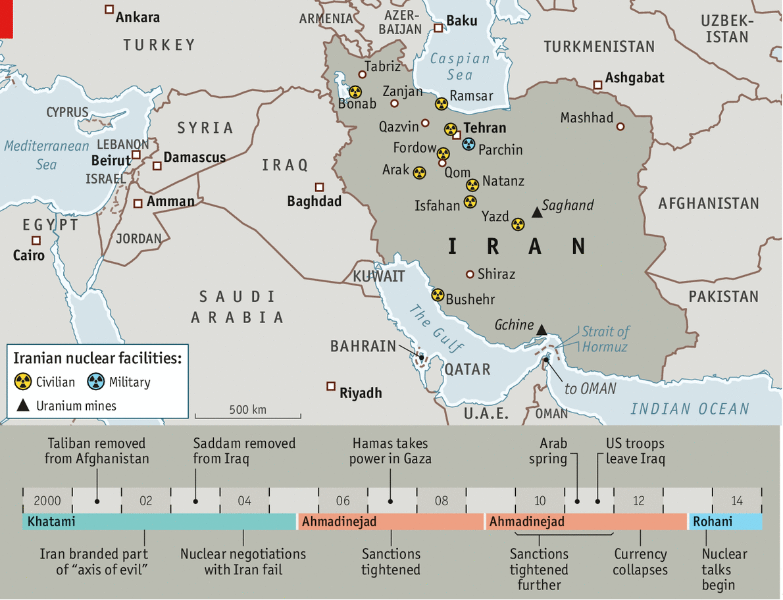
Colour me mellow
Arguably, there is a third phase to a revolution: the struggle for acceptance. Once power is secure, revolutionaries often seek recognition by strong outsiders. In a globalised world, that means engaging with the great trading countries. Children of Iranian revolutionaries have long followed this path. Privilege for them equals access to Western education and Asian consumer markets. Even hardliners allow their children to jet around the world. The offspring of Ayatollah Ruhollah Khomeini, who led the revolution, have flocked to Instagram and embrace Western mores. Seven of his 15 grandchildren have openly criticised the regime. Many of the students who took American diplomats hostage 35 years ago have become reformists and wish to see closer ties with the West. Ebrahim Asgharzadeh, who was one of their spokesmen and then served on Tehran’s city council, now says: “I no longer take radical actions and I believe gradual reforms last longer than radical change.”
The appetite for revolution has waned on all sides. Reformists are tired after their failed attempt in 2009 to push aside a government they considered illegitimate because the vote was rigged. Protests were put down bloodily, reminding many of the unhappy years after the revolution. Since then, reformists have recoiled at political bloodshed in neighbouring countries. Conservatives, for their part, have come to see revolution as a threat to their interests abroad; regimes they fostered in Iraq and Syria are fighting rebellions not unlike Iran’s home-grown one in 1979. “The Arab spring fallout has scared everyone,” says a Western diplomat in Tehran. “Iran is now a bastion of stability. The question of the validity of the regime has been settled.”
Many regard the nuclear programme as a symbol of national strength at a time of perplexing social changes
Yet although revolutionary fervour has waned, Iran’s 1979 revolution itself remains a source of legitimacy for the regime. Many Iranians, or at least the ethnic Persian majority among them, continue to associate it with national liberation from foreign oppression. Not being Arab, Turkic or South Asian, they feel friendless among their neighbours. This is vital to understanding Iranian foreign policy and helps explain why the nuclear programme enjoys widespread popular support despite the pain that the sanctions have inflicted. Many regard it as a symbol of national strength at a time of perplexing social changes. This special report will examine the effect of those changes on Iran’s politics, its economy and its place in the world.
Hardliners have long railed against “Westoxification” (the title of a book by Jalal Al-e Ahmad, published in 1962), yet in their daily lives they are now surrounded by Western consumer goods, computer games, beauty ideals, gender roles and many other influences. Iranian culture has not disappeared, but the traditional society envisaged by the fathers of the revolution is receding ever further.
The most visible shift is in public infrastructure. Tehran, the capital, is a tangle of new tunnels, bridges, overpasses, elevated roads and pedestrian walkways. Shiny towers rise in large numbers, despite the sanctions. Screens at bus stops display schedules in real time. Jack Straw, a former British foreign minister and a regular visitor, says that “Tehran looks and feels these days more like Madrid and Athens than Mumbai or Cairo.”
Smaller Iranian cities have changed even more. Tabriz, Shiraz and Isfahan are working on underground railways. Half the traditional bathhouses in Qazvin, an industrial town west of Tehran, have closed in recent years. In a basement with a domed ceiling built 350 years ago, the forlorn manager sweeps around two kittens and bemoans the loss of a 700-year-old competitor, musing that “people now have bathrooms with hot running water.” In Yalayesh, a remote village near the Caspian sea, entertainment remains old-fashioned: a Kurdish strongman, Ismail the Hero, shows off a lion in a cage on the back of his blue truck. Still, two years ago the government finished piping natural gas into every house, making winters with temperatures of -20ºC “tolerable for the first time”, says a spectator.
During the eight-year presidency of Mahmoud Ahmadinejad, which ended in 2013, prosperity spread rapidly. Loans, handouts and social-housing programmes, however corrupt and ineptly run, showered billions of oil dollars on the poor. Many found white-collar jobs in government agencies. The middle class ballooned. Villagers streamed into Tehran to buy property as GDP per person rose from $4,400 in 1993 to $13,200 last year (at purchasing-power parity). Despite the sanctions, Iran does not look like beleaguered Cuba; people drive new sedans made locally, not 1950s Chevrolets. Life became harder when sanctions were tightened in 2011, but even now Iranians live much better than most of their neighbours.
Prosperity has inspired an obsession with technology that restrictions on internet access cannot dampen. Facebook is the primary medium for half the country’s youth and Twitter is used by officials to put out statements—never mind that both are banned. Freedom House, an American human-rights lobby, ranks Iran last in the world in terms of internet freedom, but in reality access is cheap and fast. (The fastest speeds are achieved near seminaries, since clerics preach online and get priority on fibre-optic cables.)
Although the media are controlled by the state, uncensored news is easily available. Foreign websites like Tehran Bureau, based in London, fill the gaps. Iranians access them using virtual private networks (VPN). Almost everybody has one. Sitting under a tree in the Alborz mountains, a group of farmers nod cautiously when asked about internet access. One of them explains later that most download “sexy films”, hence the shy response. Pornography, although strictly banned, blazes a trail for freedom.
“The government tries to put up controls, but people are well versed in evading them,” says one of Iran’s first bloggers. A lot of effort has gone into trying to mimic China’s strategy of nurturing local websites that can be controlled, such as salam.ir, a search engine. But most of these have failed spectacularly because access to superior foreign competitors is easy. So-called VPNtrepreneurs sell the software and access codes to bypass controls. A 21-year-old wearing cordless headphones says he charges a dollar a month or $10 a year and has 80,000 clients. His day job at an IT company is a cover. Occasionally he pays the cyber-police a few hundred dollars in bribes.
The hunger for free information is fuelled by rising education levels, which are now comparable to those in Western countries. In 2009, 34% of Iranians in the relevant age group went to university. Three years later the number had gone up to 55% and is said to have climbed further since then, mostly thanks to the huge expansion of Azad University, which now has over 100 campuses and 1.5m students. Iran’s cabinet has more members with PhDs from American universities than that of America itself; the president, Hassan Rohani, got his in Scotland. According to SCImago, a Spanish firm that monitors academic journals, Iran’s scientific output has increased by 575% in the past decade. The country also publishes three times more books than all Arab nations combined.
The vastly expanded education system, which makes particular efforts to reach poor and rural families, has acted as a catalyst for independent thinking. The art world has opened up. Film scripts still require approval, but religious themes have faded. Culture is no longer a mere propaganda tool.
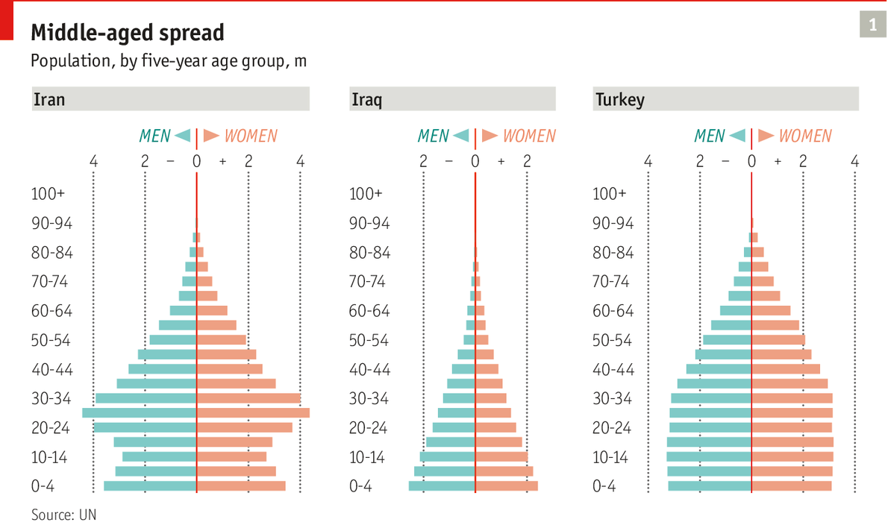
One of the knock-on effects of these social changes has been a demographic shift. Iran is fast becoming a middle-aged country (see chart 1). After the revolution the birth rate soared, but as Iranians became more prosperous and educated it started falling and eventually dropped below pre-revolution levels. The size of the population has doubled since the 1980s but the number of births has halved. There are no reliable figures, but experts put it at 1.6-1.9 children per woman, broadly in line with European rates. In neighbouring Iraq it is 3.5. The calming impact on politics is unmistakable. The largest age bracket now is 25- to 29-year-olds. Soon most of them will be married and lose interest in street protests.
Nor are they much interested in religion (see article). The majority of Iranians are Shia Muslims; they generally put less emphasis on public worship than Sunnis, but that alone cannot explain the many empty mosques. Friday prayers at Tehran University—often the place for ideological pontificating by clerical leaders—are well attended, but in the provinces it is different. Few believers turn up in the main mosque in Zanjan, a soaring concrete structure with double-glazed windows and powerful air-conditioning near the Azeri border.
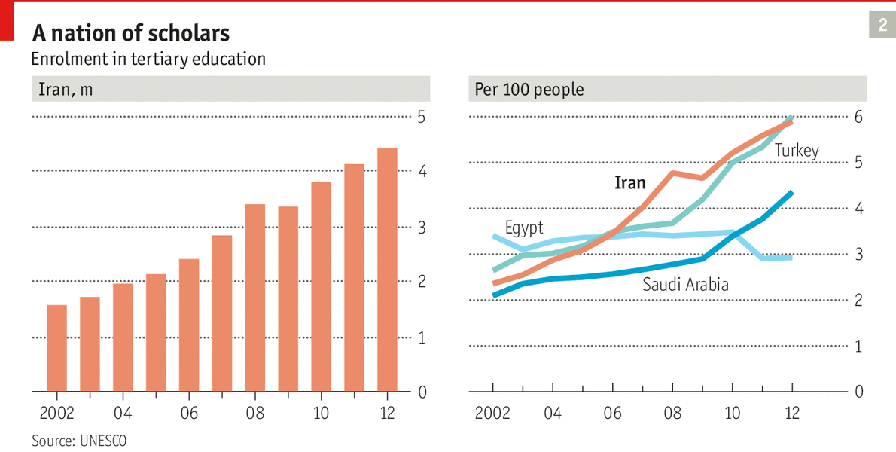
All these social changes have had a palpable effect on Iranian politics. In the presidential election last year most of the debate was focused on which candidate was the better manager, even among conservatives. Few tried to bring in religion, which was seen as a vote-loser. Nasser Hadian, an academic and government adviser, says that “ideology has been losing its potency in domestic politics.” Ten-storey-high murals showing martyred fighters still stare down from the façades of prominent buildings, but Iranians are generally fed up with mass mobilisation and indoctrination, and most of them prize individualism above public duty. The death-loving idealism of the past has become a minority interest.
The winner of last year’s election, Mr Rohani, is pursuing a moderate agenda. His government is staffed by pragmatic technocrats rather than messianic nationalists. It has allowed Iran’s people more freedom, though many restrictions remain. As one local journalist puts it, “We can now print things that were off-limits last year, but of course not everything.” Headscarves have crept backwards, yet women who discard them altogether may still be detained by the “morality police”.
Mr Rohani seems to recognise that past belligerence has hurt Iran. In an article in the Washington Post last year he wrote: “We must work together to end the unhealthy rivalries and interferences that fuel violence and drive us apart.” But does he mean it, and if so, will the rest of the political establishment support him?

Religion: Take it or leave it

Ordinary Iranians are losing interest in the mosque

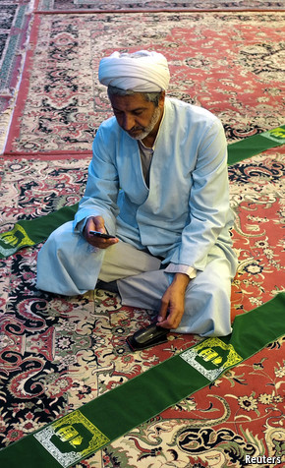
BY LAW, ALL public buildings in Iran must have prayer rooms. But travelling around the country you will find few shoes at prayer time outside these rooms in bus stations, office buildings and shopping centres. “We nap in ours after lunch,” says an office manager. Calls to prayer have become rare, too. Officials have silenced muezzins to appease citizens angered by the noise. The state broadcaster used to interrupt football matches with live sermons at prayer time; now only a small prayer symbol appears in a corner of the screen.
Iran is the modern world’s first and only constitutional theocracy. It is also one of the least religious countries in the Middle East. Islam plays a smaller role in public life today than it did a decade ago. The daughter of a high cleric contends that “religious belief is mostly gone. Faith has been replaced by disgust.” Whereas secular Arab leaders suppressed Islam for decades and thus created a rallying point for political grievances, in Iran the opposite happened.
The transformation of Shia Islam into an ideology undermined both the state and the mosque. The great irony of the Islamic revolution is that inadvertently it did more to secularise the country than the tyrannical shah, who ruled Iran after a coup in 1953 and persecuted clerics. By forcing religion on people it poisoned worship for many. They are sick of being preached at and have stopped listening.
Some have found salvation in materialism. Ever more shops and malls have sprung up. In the words of Saeed Laylaz, a noted economist, “You can’t shower a trillion dollars in oil money on a society in a decade and expect it to stay pious and revolutionary. People get comfortable.” This is not unique to Iran. “The country is Islamic in much the same way that Italy is Catholic,” says a southern European diplomat. “Everyone professes to believe, but in private we cheat on our taxes and our wives.”
The clerics’ power has waned and is mostly indirect. Many of them have withdrawn to seminaries and retain little say in the day-to-day management of the economy and foreign affairs, though they are still consulted on matters of principle. Western negotiators in the nuclear talks report that their Iranian counterparts often shift positions after trips to Qom, the cradle of the Islamic revolution. The clergy also has vast financial resources and thus economic influence. And Iranians remain a spiritual people who see Islam as part of their identity.
What many have moved away from is institutionalised religion—as far as they can. Women still have to cover their hair in public. They are banned from sports stadiums, and buses are segregated, with women sitting in the back behind a barrier. Yet female Arab visitors say they feel freer in Iran than at home, where misogyny is “less organised but more ingrained”, as one puts it. Female students outnumber men by 2:1 at many Iranian universities, leading to calls for male quotas. A recent survey of young adults by Iran’s parliament suggests that 80% of unmarried women have boyfriends.
Nowhere is change more apparent than in Qom, the religious capital. Pilgrims throng the shrines and listen to anti-Western sermons given by turbaned ayatollahs. But this is mostly a veneer. Government offices and seminaries on Martyr Street, which the locals call Time To Have Fun Street, are dwarfed by the multi-storey Pearl shopping mall, where the female mannequins wear tight jeans. In the past 15 years Qom’s population has risen tenfold, to 1.5m. Tidy suburbs line new ring roads and an elevated monorail.
The city has grown rich on the pilgrims, as have the clerics. Restricted in their choice of robes and obliged to spend many hours studying every day, they splash out on expensive glasses, says the owner of an eyewear shop. Some sport bright yellow slippers, a sign of virility, according to an obscure religious text. “Relations between the unmarried are tumultuous,” ventures a former seminary student. “Private lives are full of vice. We have the highest rate of alcohol consumption in the country.”
Men and women mix openly in cafés that once closed early but now stay open into the night. Face veils used to be common among women but were banned after three men wearing them entered a local school and groped the girls.

Domestic politics: Rush to the centre

Iran’s political elite maintains a delicate balance

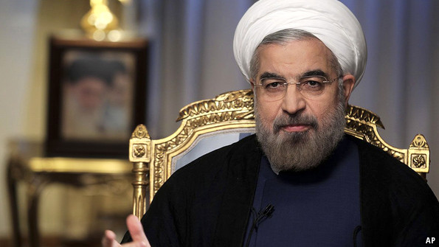

Rohani, the face of moderation
AYATOLLAH KHOMEINI, THE founder of the Islamic Republic, was essentially an anarchist. Having been persecuted by the shah’s secret police, he despised state structures. Yet after grabbing power he quickly realised that the gains of the revolution could be cemented only with the help of permanent institutions. So he set out to build them, lots of them, sometimes with the explicit intention that they should keep an eye on each other: the army held in check by the revolutionary guard, justice dispensed by clerics as well as by civilian judges in separate courts, militias performing some of the same functions as the police, an elected president facing an appointed supreme leader. Khomeini mimicked America’s Founding Fathers, creating checks and balances and occasional gridlock.
Three and a half decades later, Iran’s political system is neither a free-flowing democracy nor a monolithic dictatorship. As one dissident says, “We have freedom of expression, just not freedom after expression.” Public debates are fierce, but often amount to little more than shadow-boxing by an elite that makes decisions behind closed doors. What is remarkable is the size of this elite. Thousands of politicians, clerics, generals, judges, journalists, academics, businessmen and others participate in decision-making in one way or another, shaping government policy in endless and overlapping private meetings, conversations and conclaves, listening to and lobbying each other.
Often described as a constitutional theocracy, Iran also resembles a democratic oligarchy. No one man or group within the semi-representative elite holds anything more than a sliver of power. A coalition of naysayers can usually stop the executive from moving too far ahead. Big decisions require if not consensus then at least sizeable majorities. Assembling them takes time and stand-offs are common. But once made, decisions have a good chance of holding.
All this is achieved in the near-absence of political parties. Groupings and factions form for a time, but few have formal hierarchies and most fail to impose discipline. Compromise for the sake of a common agenda is rare.
This anarchic system just about works because at its centre sits a supreme leader (always a high cleric) who draws his authority from the revolution. Ali Khamenei, who was appointed for life in 1989, is only the second person to hold the job. His way of operating is to wait for consensus to form in debates and step in only when he has to in order to break a deadlock. He sees himself less as a decider than a referee. “He listens to his advisers and opponents, constantly weaving and tacking to stay in the mainstream,” says Gary Sick, an academic at New York’s Columbia University and doyen of America’s Iran-watchers.
Who might succeed the 75-year-old Mr Khamenei is the subject of endless speculation. No heir apparent has emerged, and some observers worry that when he dies a destructive power struggle could ensue. But the Islamic Republic’s system of governance, or nezam in Farsi, has a strong collective identity and seems quite capable of coming up with a successor. Even though members compete fiercely with one another, they acknowledge that without a supreme leader who is acceptable to all sides the nezam cannot survive.
Still, competition can get out of hand. In the late 1990s, after Mohammad Khatami, the first true reformist, was elected president, tensions rose to the point where competing power centres were in open revolt. Conservatives more or less declared war on their own government. The supreme leader feared the system might crash unless he curbed reformist ambitions. In 2005 Mr Ahmadinejad, a conservative provincial politician thought to be a loyal standard-bearer, succeeded to the presidency.
But the new president turned out to be very much his own man. He had no interest in unifying the system and instead built a separate power base for himself. He took on vested interests in much the same way his predecessor had done but offended reformists as well as conservatives. He won re-election in 2009 by rigging the vote. The supreme leader and other conservatives supported him in this, given that the likely winner was another reformist. The subsequent revolt by millions on the street, though quickly put down, again threatened the system’s survival. The plan to achieve greater coherence had failed.
A semi-democratic legitimacy
So for last year’s presidential election the system reverted to its old ways. Four conservatives and two moderate candidates, all carefully vetted, were given a more or less equal chance to win power. Before the vote the supreme leader said publicly that he was not supporting any one candidate, and that “all votes will be counted.”
That Mr Rohani won the election was part accident and part fallout from the previous election. In the complicated taxonomy of Iranian politics he might best be described as a centrist. During the campaign the reformist camp stood squarely behind one of their own, Mohammad Reza Aref, a former vice-president under Mr Khatami. But shortly before the vote Mr Aref’s supporters persuaded him to stand aside in favour of Mr Rohani, believing that only he had a chance of defeating the conservative candidates. Mr Rohani would probably have won in any case, but he also benefited from the conservatives’ failure to agree on a unity candidate.
Given the reformists’ previous intransigence, it was an extraordinary decision for them to unite behind Mr Rohani. One of the senior people involved in making it explains: “We went through a lengthy and painful process, but ultimately it led to a sort of success.” From wanting to challenge the system, the reformists moved towards working within it. Before the election their leaders had hotly debated whether to take part in it at all. Pragmatists led by Mr Khatami won. According to the senior reformist, “The hot-headed young learnt to play politics during the Ahmadinejad years. They saw that fielding candidates who are diehard reformists does not get results. They had to be more moderate, less ambitious. That’s the lesson from the many defeats of the past.”
Pick your battles
Many reformists had been broken by the protests in 2009. Given the size of the demonstrations, the number of people killed was not huge, perhaps a few hundred. But thousands endured periods of detention and abuse, saw their friends suffer and were harassed once released.
This seemed to work well for the regime. Many former protesters withdrew to protective cocoons from which they have still not emerged. They avoid the streets and take hashish at home. Others have left the country or thrown themselves into non-political careers. Those who remain active in the public sphere have become more pragmatic and cautious, picking battles carefully and advocating patience. As Mr Hadian, the academic and government adviser, puts it: “As a reformist I now know the limits of power. We know the other side much better and we know how to deal with them.”
Attitudes in the conservative camp have changed, too, although less conspicuously. The crackdown in 2009 was risky. Faced with a possible loss of power, the generals and clerics did what they thought was necessary to retain it. But many realised afterwards that they could not go back to the status quo. In a highly educated and well-informed society, only so much can be imposed from above. Quite a few conservatives supported Mr Rohani, seen as the candidate best placed to win popular support.
After the election the supreme leader made it clear that he stood behind the new president. His backing is not indefinite or unconditional, but it created enough breathing space for Mr Rohani to launch controversial initiatives such as engaging the West in nuclear talks. The hardliners are showing some restraint. Both sides unenthusiastically support a “central solution” (which generally means a political compromise) to relieve economic pressure and improve Iran’s international position. Kevan Harris, an academic at Princeton, reckons that “radicals on both sides are exhausted. They have run out of ideas. Neither ambitious reforms under Khatami nor hardline isolation under Ahmadinejad proved successful.”
This does not quite amount to a new equilibrium in Iranian politics. In the past year conservatives have impeached one of Mr Rohani’s ministers, dragged an adviser into court, tried to keep the president himself off state television and frustrated his attempts to free up the internet. And the conservatives retain plenty of power through the revolutionary guards.

The hardliners: Goon squad

Will the conservative camp sink a nuclear deal?

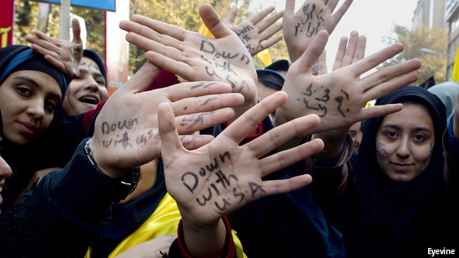
AT THE CENTRE of Iran’s establishment sits a shadowy organisation responsible for defending the ideals of the revolution. The Islamic Revolutionary Guard Corps (IRGC) is a paramilitary force rolled into an intelligence agency wrapped in a giant business conglomerate with security-related interests. It is directly controlled by the country’s supreme leader, Mr Khamenei, who is chosen by regime insiders for life and outranks the elected president.
Many guard commanders eventually end up in senior government posts, but they exert political influence long before then. Their baseej militia, made up of tens of thousands of youth volunteers, helps to keep domestic order. Baton-wielding militiamen dispersed protesters in 2009. In social clubs across the country they are moulded into conservative storm troopers. Their national snooping hotline is advertised on billboards: call 114.
The guards are dedicated to a strong Iran, both at home and abroad. The means by which they pursue their goals are often unconventional, including the funding of terror groups and the exploitation of sectarian tensions, all in the name of revolutionary change for the benefit of the downtrodden. The real aim, though, is to ensure stability at home and win greater influence vis-à-vis America and its allies abroad. The Quds Force, a special-operations unit, fights on Iran’s behalf outside the country. Aiding the government of Syria, a long-time client, it is taking part in a civil war that has so far killed 200,000 people. The guards also sponsor Hamas and Hizbullah, the missile-toting tormentors of Israel. A decade ago the Quds Force supplied weapons to Iraqi insurgents bent on killing American soldiers. More recently it has allegedly nurtured rebels in Bahrain and Yemen.
Last but not least the guards oversee the nuclear-weapons programme. Iran has officially denied trying to build a bomb, but almost all Western analysts believe that to be its aim.
Money talks
The guards preside over a vast business empire that generates a substantial income. They own mobile-phone networks, oil firms, carmakers and construction companies, mostly acquired in a $120-billion privatisation bonanza over the past decade. Many of the firms they own refuse to pay tax or open their books to government inspectors. The guards also control smuggling networks set up to bypass sanctions.
Mr Rohani, the president, is not close to the guards and has reduced their influence in government. His relationship with them has always been difficult. Hashemi Rafsanjani, a former president, writes in his memoirs that during the Iran-Iraq war, when Mr Rohani was a presidential aide, guard commanders constantly complained about him. Under Mr Ahmadinejad about half the cabinet posts went to senior guards officers. That number has now dropped to four out of 18, of whom only the defence minister is an important figure. The share of provincial governors supplied by the guards has dropped from half to a tenth.
Yet Mr Rohani is still surrounded by security folk. Five of his cabinet ministers come from the ministry of internal security, the successor to the shah’s secret police. The police can still be heavy-handed and wilful, and many dissidents remain in prison. Critics can question the competence or honesty of officials but are never allowed to challenge the legitimacy of the Islamic Republic itself. When the justification for many policies amounts to “because we are an Islamic Republic”, political freedom is bound to remain circumscribed.
Since Mr Rohani’s election the power structure has remained unchanged and he has given few jobs to reformists. Conservative judges still hand out harsh sentences for trivial offences. Liberals who voted for Mr Rohani seem disappointed. They describe him as a pragmatic insider who lacks ideals. A joke making the rounds in Tehran this summer draws a parallel between the reign of his underwhelming predecessor but one, the moderate Mr Khatami, and the succession by the hardline Mr Ahmadinejad, who in turn has now been succeeded by the more centrist Mr Rohani:
An old man seeks out a mullah to complain about his life. “I have only one room and no food,” he says. “My women and children are crying. What can I do?” The mullah tells him to buy a goat. The next day he comes back and says things are even worse now. “The women and children are crying and the goat is defecating everywhere. What can I do?” The mullah tells him to sell the goat. The man returns the following day, embraces the mullah and thanks him profusely. “Everything is so wonderful now that the goat is gone,” he says.
Moderates like Mr Rohani are allowed to tinker at the margins, but the hardliners will not let them stray far from traditional policies. Many still view the West with contempt and blame America for the wrongs of the world. Sermons authorised by the supreme leader are regularly filled with bitter accusations, such as that America created the extremist groups terrorising Iraq and Syria. Israel is openly despised, and Mr Ahmadinejad is not alone in questioning the Holocaust.
Many still view the West with contempt and blame America for the wrongs of the world
Arguably the regime needs external enemies to justify its repressive stance. Modern-day America is depicted as the latest iteration of the colonial powers with which Iran has grappled for centuries, thus justifying “internal vigilance”. But suspicion of all things Western is real enough. Repeated clashes with America, not least in Iraq, have shaped the views of many. The push to acquire nuclear weapons is mostly defensive: they would be an insurance policy. Some mention North Korea and Pakistan, whose security seems to have benefited from building a bomb.
Some Western observers fear that Iran is following a strategy which Mao Zedong called “fight-fight, talk-talk” during the Chinese civil war in the late 1940s: negotiate with your adversary to weaken his resolve and put off outside intervention by holding out the prospect of a compromise solution, but fight to win. In essence, they say, Iran is negotiating in bad faith, hiding materials and technicians at secret facilities to produce a nuclear arsenal even as the talks are in progress. Besides, they continue, dragging out negotiations and hence keeping sanctions in place serves the guards’ economic interests, since they control smuggling networks earning billions of dollars.
This argument suffers from several problems. First, cheating will be difficult. If the West signs a deal, it will insist on intrusive inspections. If Iran tries to drag out the talks, Congress is likely to impose more sanctions. And though some guard commanders may benefit from smuggling, the colonels and majors involved have no political influence. Senior generals, on the other hand, are linked to large companies whose business has been hit by sanctions like everyone else’s. An opening of trade would allow them to woo foreign investors and expand abroad.
The guards’ business interests are important, but they do not dominate the economy. A Western-educated banker in Tehran estimates that they cover just 5-10% of GDP, mostly in telecoms, energy and transport. He points out that “building a pipeline to Pakistan has national-security implications, so one of their firms gets the contract.” But the guards do not preside over a military-industrial monolith. Many enterprises are remarkably inefficient, often relying on personal favours from former officers, of whom there are many. During the Iran-Iraq war an estimated 2m Iranians served in the revolutionary guards.
Foreign and Iranian academics have described a “subcontractor state” made up of hundreds of privatised firms with vague links to the guards but little co-ordination among themselves. This can lead to large-scale embezzlement, which can be risky. Last year Reza Zarrab, a businessman with close links to guard commanders, was arrested in Turkey on corruption charges. Mr Rohani has cancelled several government contracts in response to public outrage over corruption, and has refused to pay up for failed projects.
State within a state
The hardliners are a diverse and internally divided bunch. A former guard commander who fought in the Iran-Iraq war explains: “There are many differences of opinion. It is a vast organisation. There is not one single voice. That’s not how it works.” Voting records in districts with guard barracks show that many support moderate candidates, including Mr Rohani.
For the most part, senior guard commanders have refrained from criticising the nuclear talks. Qassem Suleimani, the commander of the Quds Force and bête noire of the American armed forces, last year defended the doveish foreign minister and chief interlocutor of the Americans, Mohammad Javad Zarif, against radicals in parliament. Muhammad Qalibaf, the mayor of Tehran and former head of the guard air force, has championed a diplomatic solution. He takes holidays in London and occasionally flies an Iran Air jet to Paris to keep his civilian pilot’s licence up to date. In official media he is quoted as lauding “the culture of martyrdom and culture of jihad”. But privately the trained engineer talks admiringly of the co-operation between military and civilian manufacturers in Israel.
According to an academic close to the guards, “There is very little opposition in principle to a nuclear deal. General Suleimani is prepared to accept a decent deal. Iran does not want to confront America and lose. That’s not useful in terms of grand strategy. The revolutionary guards’ role after all is to stop America from feeling comfortable here.” This sentiment is echoed by other insiders. A former commander who survived a gas attack in the Iran-Iraq war says: “I don’t believe there are many hardliners who are against a deal with America in principle. A deal that preserves our dignity will encounter little opposition.” It is not clear what sort of deal would be acceptable to these kinds of Iranians, but it would certainly involve keeping thousands of centrifuges.
Hardliners have supped with the devil on past occasions, most notably in 1988, when Iran made peace with Saddam after eight years of terrible war, and in 2001, when it co-operated with America following the overthrow of the Taliban in Afghanistan. Last year the supreme leader advocated “heroic flexibility” in affairs of state, an allusion to the controversial peace made by the second Shia imam, Hassan, with the Sunni Omayad caliphate in the 7th century. His conduct is often compared unfavourably with that of his brother Hussein, the third imam, who died fighting against overwhelming odds.
How far might Iran’s flexibility stretch? Its anti-Israel rhetoric has always sounded somewhat hollow. Yasser Arafat sided with Saddam in the Iran-Iraq war in the 1980s, for which many Iranians never forgave the Palestinians. Mr Ahmadinejad’s Holocaust-denying was mostly for foreign consumption. An Iranian attack on Israel would be devastating, but is highly unlikely to happen. The revolutionary guards are good at fighting guerrilla wars, but Iran’s conventional forces are in poor shape and most of their equipment is ancient. In its latest assessment, the Pentagon notes that “Iran’s military strategy is defensive.”

The economy: Melons for everyone

A mixture of Western sanctions and bad economic management has hit prosperity
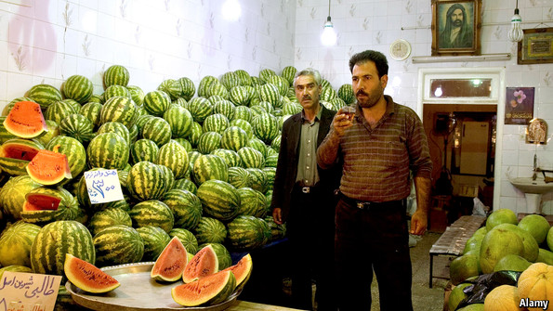
ECONOMIC CONSIDERATIONS USED to play a vanishingly small role in Iranian politics. As Ayatollah Khomeini, who led the 1979 revolution, famously said: “We did not rise up to get cheaper melons.” For decades conservative ideologues chased Utopian visions, whatever the cost, while liberals hungered for political reforms.
That has changed in recent years. Debate in last year’s election focused on boosting the economy. Mr Rohani won because he was seen as the candidate most likely to achieve that. Conservatives used to be anti-trade, in keeping with the autarkic and socialist sentiment of the revolution. Now even the supreme leader endorses globalised capitalism. Asked why, a senior official laughs and says, “My son is in grade two and was recently standing for election as class president. I had high hopes. He is a popular guy and articulate, too, and yet he lost. I couldn’t believe it. I asked him, ‘what did you campaign for?’ ‘Justice and dignity’, he said. ‘And your opponent?’ ‘He promised the class better lunch and longer breaks between lessons.’”
Iranians today live much more comfortably than they did a generation ago, but the past three years have been tough. Businesses and consumers are suffering from the effects of much tighter sanctions imposed in 2011. “You literally see fewer people with shopping bags on the streets,” says a banker in Tehran. “My normally busy plumber tells me he often doesn’t get his first client until mid-week.” The merchants in the bazaar in Qazvin report a drop in revenues of between 50% and 75%. A tomato-seller reckons these are the worst times he has seen in 25 years. Merchants open later or stack and restack shelves. “The bazaar is ruined,” says one shopper. “And I feel ashamed that I can no longer afford the same food. I cannot invite anyone to my home.”
Iran’s economy is the third-biggest and most mature in the Middle East. It has a large industrial base, an educated workforce and a service sector which in 2012 accounted for 52% of the economy. That year, though, GDP fell by 5.8%, according to the central bank, and last year it dropped by another 2%. Unofficial figures are even worse.
“The bazaar is ruined,” says one shopper. “And I feel ashamed that I can no longer afford the same food. I cannot invite anyone to my home”
Over the previous decade the economy had been growing at an average rate of 5.1% a year. When it keeled over, inflation at one point shot up to over 50%, and salaries failed to keep pace. In real terms, private pay dropped by 35-40%, and government employees lost up to 50%. At least half the population suffered a dramatic loss of income. In one week in October 2012 the currency plunged by 40% against the dollar in the black market, creating panic. At its lowest point the rial was down 75%. Unemployment has rocketed. Car production, which used to account for 10% of GDP and employ 1m people, fell by about 70%, according to industry sources. A Mercedes factory in Tabriz that a few years ago was making 80 engines a day now produces just two.
All this has caused a surge of popular discontent. As former revolutionaries, the country’s leaders are aware of the dangers, yet they struggle to respond because the state has no money. In the past, thanks to free-flowing oil revenues, governments had always been able to create jobs, feed the poor, rescue banks, subsidise industry and buy off critics. But now, for the first time in a decade, the coffers are empty and the budget is in deficit. According to American government estimates, the Iranian economy is 25% smaller today than its pre-2012 growth trajectory indicated.
The proximate cause of this dramatic plunge was the launch by Western governments of one of the most stringent sanctions regimes ever, designed to force an end to Iran’s nuclear-weapons programme. Iran’s main oil customers in Europe stopped buying almost overnight. America’s government banned the clearing of dollar payments, most of which go through the American financial system, by Iran’s central bank and anyone dealing with it. Iran’s government assets abroad were frozen and hundreds of state-linked firms targeted directly. Oil exports, which in 2011 had been running at about 2.5m barrels a day, declined by at least half. Imported industrial components became impossible to get hold of, fuelling unemployment and inflation.
Some non-Western states ignore the sanctions and continue to trade with Iran. The Iranian government tries to pay them in gold and turns a blind eye to smuggling, profits from which have set off a construction boom. It is hard to know how much trade still gets through, but sanctions have certainly made a serious impact.
The debate on their effectiveness has created some strange bedfellows. Western and Iranian hardliners both argue that the country’s falling living standards are solely due to sanctions—the Westerners to claim a political victory, the Iranians to blame their enemies for an ill that is partly self-inflicted.
A black hole filled with oil
Iran’s economy is so inefficient, corrupt and bloated that it was heading for a fall even before sanctions. Almost all Iranians receive cash transfers meant for the poor. Last year the state spent $100 billion on subsidies, a quarter of GDP. Until recently diesel cost the equivalent of two American cents per litre. Turkey, which has a population much the same size as Iran’s and is more industrialised, consumes about 60% less fuel. Iranian government offices are vastly overstaffed. The oil ministry has expanded from 100,000 employees in 2005 to 260,000 today. Many abuse their position. Transparency International, a Berlin-based lobby, classes Iran as “highly corrupt”. Officials routinely use public funds to invest in foreign property deals. According to one well-placed observer, “politics is a distraction from making money.” Parliamentary investigators have given warning that if the full extent of political corruption were revealed, it could cause “social shock”. Imports of luxury cars increased fivefold between 2011 and 2013, whereas sales of modest Iranian-made cars halved.
The misallocation of funds on a gargantuan scale has hurt the private sector. It accounts for only about a quarter of corporate revenues, and many firms are teetering on the verge of bankruptcy. The official figure for non-performing loans, at 18%, may be far too low. “The lack of investment capital is the country’s biggest problem. We’re $300-400 billion short every year,” says Mr Laylaz, the economist. Since 2006 investment in industry has fallen by 10-15% a year.
The banking sector is dysfunctional. Banks lend almost exclusively to state-affiliated firms. Small and medium-sized enterprises cannot get loans. The dearth of finance has spawned some ingenious solutions. For example, private landlords use apartments as collateral to borrow from tenants in lieu of rent.
Management of the Iranian economy had been poor since the revolution, but under Mr Rohani’s predecessor, Mr Ahmadinejad, it got even worse. During his eight-year tenure oil revenues more than tripled, thanks to steep price increases, and more money flooded into government coffers than in the preceding century, $800 billion in total. He spent all of it, shovelling vast sums into construction projects. Provincial towns are littered with unnecessary bridges and bypasses. His prestigious Mehr housing project created 200,000 apartments throughout the country without access to water, gas or sewerage, most of which now stand empty.
In theory some of Mr Ahmadinejad’s policies were sound. He tried to boost the private sector by selling state assets. Nine of the ten biggest companies on the Tehran stock exchange were listed in the past decade. Boards and shareholders are no longer toothless. Directors increasingly demand proper accounts, and annual general meetings can be contentious. The boss of the Asia Insurance Company was recently told by a shareholder: “A donkey could run this company better.”
But the privatisation programme still leaves much to be desired. Majority stakes were regularly sold to entities close to the state, including public pension funds, which in some cases received their stakes in lieu of money owed to them by the government. Although asset sales were open to anyone, private investors at home lacked the capital to buy large stakes and foreigners were put off by sanctions. Analysts speak of the rise of a semi-private sector.
Devaluations have made some parts of the economy more competitive. For years, Iranian goods were expensive in Iraq because of Iran’s overvalued currency. When sanctions caused the currency to slide, Iranian products almost overnight became cheaper than those from neighbouring industrial countries such as Turkey. At home, sanctions have also kept foreign competitors out; Iranian boutiques and supermarkets are full of domestic products for the first time in a decade.
The charms of self-sufficiency
Bad economic management apart, Iran’s government also inadvertently boosted the effectiveness of sanctions in two other ways. First, it had been keeping taxes too low for decades, allowing the country to become too dependent on oil revenues. Now it has to cut spending and raise taxes at the same time. Second, when Mr Ahmadinejad came to power a decade ago he abandoned the country’s long-standing policy of economic autarky. At the time Iran was almost self-sufficient. Seeing an opportunity to boost growth, the new president brought down tariffs and struck up new trade relations. The policy was a great success, but it made Iran much more vulnerable when sanctions hit home.
The government might have foreseen this. As Mr Zarif, the country’s foreign minister, wrote in an article in a Western policy journal a few months ago, “The ongoing process of globalisation, however conceived and defined, whether lauded or despised, has brought inescapable weight to bear on the foreign policies of all states, whether large or small, developed or developing…Today most nation states, regardless of their size, power, influence or other attributes, have come to realise that isolationism, whether voluntary or imposed, is neither a virtue nor an advantage.” It is the source of the article rather than the sentiment expressed in it that is remarkable. Iran has realised it has been hit by a triple whammy of oil dependency, sanctions and inefficiencies covered up by years of reckless state spending.
In his first year in office Mr Rohani has managed to stabilise the economy. The currency has levelled out and the trade surplus has gone up. Inflation is down from 45% to 15%. The president’s team of capable technocrats expects the economy to start growing again this year, perhaps by 1.5%. Cuts in subsidies have improved government finances, though they pushed up fuel prices by 75% overnight.
Yet there is a long way to go. Most energy prices continue to be subsidised by the state; petrol still costs only 28 cents a litre. Unemployment remains stubbornly high. Further reforms are needed to accelerate growth. Experts say these should include reducing cash transfers to the poor, reining in the generous welfare state, cutting industrial subsidies and firing hundreds of thousands of government employees.
Iranians have endured greater hardships in the past. American sanctions in the 1980s caused fuel and food shortages. For now, Iranians are not going hungry and the economy is nowhere near collapse. But in the longer run something will have to give. Reforms will become inevitable, but if Mr Rohani can cut a deal with the West to ease sanctions, they could be introduced more gradually and less painfully.

The neighbours: Moving targets

Iran’s position in its region, increasingly influential until recently, is becoming more precarious
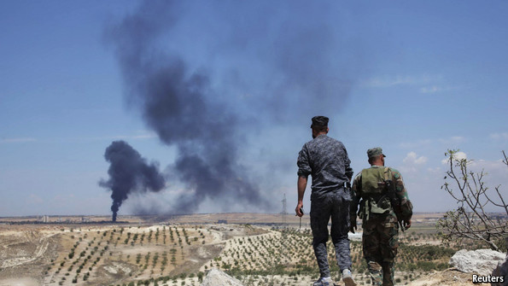
IRAN’S LEADERS HAVE long had immodest ambitions in the Middle East, pining for the respect of the neighbours who once conquered and converted them and even dreaming of leading a pan-Islamic alliance, however unlikely. In recent decades they have been exporting their revolution, propelled by national pride and an urge to pass on lessons from the long road to independence, but also driven by a deep fear that they—Shia Persians facing mostly Sunni Arabs—are not so much independent as alone in a hostile region.
In the 1980s the Islamic Republic set out to cultivate friends in Arab countries after bloodily thwarting an invasion by Iraq. In Syria (pictured above) it became the main sponsor of the Assad regime after the collapse of the country’s traditional patron, the Soviet Union. In Lebanon the Islamic Republic nurtured the Hizbullah militia which became the dominant political force there and, with support from Tehran, repeatedly gave Israel a bloody nose. Iran also sponsored Hamas, the most successful of the Palestinian groups warring with Israel. Support for the fight against the Jewish state won Iran plaudits in the wider Arab world.
In the aftermath of 9/11, America, Iran’s arch enemy, presented it with two gifts by removing regimes in Iraq and Afghanistan that were hostile to both of them. Revolutionary guards made sure that Saddam and the Taliban were succeeded by Iranian allies. They also acquired friends in places like Sudan and elsewhere in Africa. Iran’s influence grew steadily.
Sunni neighbours worried about a “Shia crescent” stretching from Tehran via Baghdad and Damascus to Beirut. Long-standing rivals, especially Saudi Arabia and Israel, drew attention to Iran’s nuclear programme and suggested military action to destroy it. But after getting mired in Iraq, America lost interest and eventually pulled out in 2011. The Islamic Republic never looked mightier.
Spring’s false promise
When the Arab spring began in December 2010, it seemed like a boon at first. Arab youths appeared to be following Iran’s script, rising up against secular rulers. The Muslim Brothers that were gaining ground across the region were quasi-allies of Iran. The country’s Sunni rivals became alarmed. But before long the Arab spring went as wrong for Iran as it did for almost everyone else. The protesting youths had no interest in backward-looking Islamism and anti-Western sloganeering. The Iranian protests of 2009 were among their models and Facebook was their friend. The Muslim Brothers were soon outgunned by harder sorts who target Shias as unbelievers.
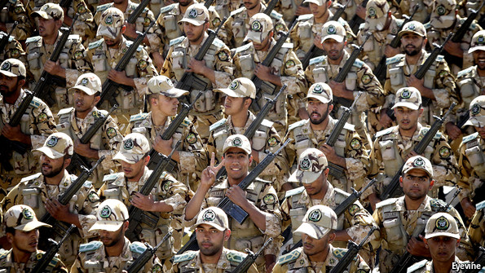
The greatest calamity awaited Iran in Syria. Thanks in part to Iranian aid the regime there did not fall, but Bashar Assad, the president, did not regain his footing either. Vicious fighting destroyed the country, and the Islamic Republic’s stature arguably suffered more damage than if he had fallen swiftly.
Support for the slaughter of Syrian rebels destroyed much of the goodwill Iran had painstakingly garnered among ordinary Arabs over decades. By drafting in Hizbullah to fight for the Assad regime, Iran also damaged the Shia militia’s popularity. And Iran lost its close relationship with Hamas, which had been headquartered in Syria but refused to support its hosts. In evident disgust, and perhaps sensing Iranian weakness, Hamas moved to Qatar, into the arms of a new sponsor.
All the while Iran spent billions of dollars propping up the Assad regime, turning public opinion at home against the war. University students openly grumble about the waste of money as tuition fees rise. “How do you say ‘quagmire’ in Farsi?” asked an American website last year, suggesting that Syria could be “Iran’s Vietnam”.
After three years of trying and failing to defeat the insurgency in Syria, another Iranian ally has now fallen victim to it. Hardline Salafi rebels who have made a habit of beheading Western hostages this year swept across the border into parts of Iraq and declared a Sunni “Islamic State” (IS). This damaged the Iran-friendly government in Baghdad and once again brought hostile forces close to Iran’s borders—both Salafists and Americans.
After decades of exporting revolution, Iranian generals are learning a new term: “blowback”. If Iran had aided rather than hindered America’s campaign against al-Qaeda insurgents in Iraq a decade ago, it would not have to worry about those same militants occupying the country’s north-west now. It had originally handed weapons to some of them to kill Americans.
Gone is the talk of a Shia crescent. Now Iranians worry about being surrounded by a “Salafi circle”, bearing in mind the Taliban’s resurgence in Afghanistan. The growing Shia-Sunni divide in the region, fuelled in part by Iran’s paramilitary efforts, is a greater threat to it in the long run than to the Sunni majority.
Once again Iran is almost friendless. Even China, Iran’s biggest oil customer but no fan of separatist insurgencies, voted for sanctions against Iran at the UN. In August Sudan expelled an Iranian diplomat and closed a cultural centre. An Iranian agent in Nigeria, where a Sunni insurgency rages in the north-east, has been jailed for arms-smuggling.
Ayatollah Khomeini’s vision of Iran as leading Muslims against the West is out of date. Since Saudi Arabia and Egypt have become noticeably less friendly with America, they can no longer be depicted as stooges. An ideological construct is crumbling. As the Iranian scholar Mohammad Tabaar put it, “There was a time when Iran would rely on its revolutionary ideology to project power. Today, Iran uses its power to project ideology.”
Iran must now co-operate with powers in the region that are interested in preserving the status quo, as it itself has become
Even more worryingly for Iran, it is not immune to the extremist bug that has befallen its Sunni neighbours. Independent Shia extremism, once unknown, is on the rise. Based outside Iran, radical Shia satellite TV channels such as Fadak preach war against the Islamic Republic, which they regard as insufficiently fervent. Hizbullah in Lebanon, increasingly enmeshed in the compromise-laden business of government, faces similar attacks. Intra-sect fighting could undermine Iran’s historic claim to be the Shias’ leader.
Iran must now co-operate with powers in the region that are interested in preserving the status quo, as it itself has become, despite the revolutionary rhetoric. Overstretched and broke, it can no longer handle its commitments. Engagement with rivals would suit its interests, now more closely aligned with theirs.
The Rohani government has taken first tentative steps to reach out to neighbours, not least following the rise of IS, which has altered the geopolitical calculus for everyone. Officials have held talks with the Gulf states, including Saudi Arabia. Joint military operations may be some way off, but informal co-ordination between once hostile forces is already in progress in Iraq. In the country’s north, American jets have cleared the way for Iranian-controlled militias. America and Iran are also accommodating each other in Baghdad’s corridors of power. At American insistence, Nouri al-Maliki, Iraq’s highly divisive prime minister, was forced to step down this summer by his patron, Iran, and replaced by someone less sectarian.
International relations in the Middle East still involve fierce competition for influence. Deep chasms remain. But the big powers know that the most likely solution to their multiple conflicts is a brokered peace, along the lines of the one that ended the Lebanese civil war in 1990. Iran has already published a plan for a “political solution” in Syria. It is not especially attractive, yet it points the way forward.
In the end, the likelihood of detente hinges on what happens in the nuclear negotiations. A deal with the West on its own would not calm the region down. Saudi Arabia and Iran will continue to view each other with mutual suspicion. But a deal would remove the threat of a military attack by Israel and America on Iran’s nuclear infrastructure, and of the inevitable retaliation, which has hung over the region for years.
If such a deal can be reached, Iran stands to regain stature over time. America would draw down troops in the Gulf in due course—one of the prizes that is rarely acknowledged. Until 1986 America had almost no presence along the Iranian shore. Today 35,000 troops sit on Gulf bases. It is conceivable—even likely—that the majority of them will leave if the situation stabilises, given defence cuts in Washington, America’s “pivot to Asia” and the shale-gas boom which makes the country less dependent on energy from the Middle East.
The American government has already begun to move away from unquestioningly backing traditional Arab allies and is shifting towards a balance-of-power policy. If Iran can lure America farther down this path, it stands to reap big benefits.

Prospects: We shall overcome, maybe

The chances of a deal with the West
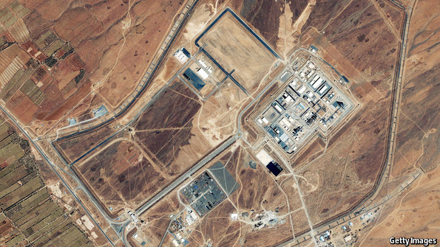
MILLIONS OF EDUCATED and prosperous Iranians resent being isolated from the rest of the world. Until sanctions started to emasculate trade, life had been gradually improving. Now many people have lost their jobs or seen their pay and savings eroded by inflation. The government, too, is having a difficult time. Oil revenues have dwindled and allies around the region are wobbling. Is relief in sight?
After nine months of nuclear talks in Geneva, the broad outlines of a possible deal with the West are becoming clear. The aim is to ensure that Iran would need about a year to build a bomb, giving the West plenty of advance warning. To achieve that, the two sides are talking about limiting Iran’s enrichment of uranium to 5% for the next decade or so, and putting the plutonium programme at Arak to irreversibly civilian use. All this would be monitored closely by international inspectors, but without forcing Iran to acknowledge past weapons tests in any detail. In return, Iran could expect a rolling (though reversible) lifting of sanctions over several years.
According to one Western official involved in the negotiations, “technical issues are not the main problem.” The tough part is convincing the respective elites back home to accept the deal that is on the table. The real negotiations arguably take place in Tehran and Washington, not Geneva. A majority of American congressmen seem reluctant to approve anything negotiated by the White House, even if their own generals say it is in America’s national interest. Mr Rohani, for his part, faces pushback from conservatives, even though a deal promises to relieve economic and regional pressures.
Opposition is driven by each side’s suspicion of the other. Some of that may be justified. Iran has repeatedly lied about and cheated over its nuclear programme. Equally, many of the Washington-based architects of the sanctions would like to see regime change in Tehran. Both sides have covertly and overtly harmed each other in recent years, compounding distrust.
However, mutual suspicion is also driven by pride, ignorance, historical grievances and partisan self-interest. American suggestions in the past that the Islamic Republic might be close to collapse still rankle in Tehran. One academic close to the revolutionary guards says testily, “America keeps thinking we are about to sink, that we’ll implode. I say, just come to terms with reality. We have figured out a stable path.”
Iranians complain that America is being hypocritical, supporting autocratic Saudi Arabia while denouncing more democratic Iran. Americans retort that the Saudis have not tried to kill or kidnap them, and point out that Iran has its own double standards, supporting the crushing of a revolution in Syria that is similar to its own in 1979. Iranian students at Tehran University are particularly aggrieved by what they see as American hypocrisy in foreign military missions, asking why Americans supplied weapons to rebels in Soviet-occupied Afghanistan in the 1980s. The students quote from a Hollywood film on the subject, “Charlie Wilson’s War”, in which American officials intone, “Let’s go kill some Russians.” So why, they ask, were Americans so offended when Iran used similar tactics against them in Iraq?
Historical grievances lurk everywhere. Three decades ago America shot down a civilian Iranian airliner, and Iran helped to bomb America’s embassy in Beirut. Hardliners on both sides are still looking for revenge. In April Mr Rohani tried to appoint his deputy chief of staff, Hamid Aboutalebi, as head of Iran’s UN mission in New York. But the ambassador was denied a visa after an outcry in Congress because he had played a minor part in the hostage crisis in 1979. America thus deprived itself of the chance to have a trusted interlocutor on its doorstep.
Many Iranian leaders have built political careers on bashing America. To a lesser degree the same in reverse is true for some congressmen with close links to Israel. Accommodation now would cause a loss of face, maybe even of factional support.
Yet overall, the greatest obstacle to reaching a deal is ignorance rather than self-interest. Iran’s supreme leader believes that the American government, not just its hardliners, wants to see him toppled. He misread the Ukrainian revolt earlier this year as an American plot.
Enigma variations
No diplomat from either Iran or America has been posted in the other’s capital for 35 years, though some Iranians have served at the UN in New York. In a documentary called “The Fog of War”, Robert McNamara, who served as America’s defence secretary in the 1960s, said that America escaped disaster in the Cuban missile crisis because its officials knew their adversaries in Moscow and could work out what sort of deal they might accept. On the other hand, America came to grief in Vietnam because it knew nothing and nobody in Hanoi. A central premise of the war—America’s fear that North Vietnam might form a communist alliance with China—ignored the fact that the two regimes hated each other.
In the absence of knowledge, people will err on the side of caution. A politically active member of the Khomeini family forcefully makes this point:
When I visit a new city I figure out two or three main roads and use them to go anywhere—even if it takes longer—because I fear getting lost. Eventually I will try new, shorter routes. But as soon as I’m no longer sure where I am I revert to the thoroughfares. Regime hardliners act much the same. Occasionally they try new, conciliatory routes, but as soon as they feel insecure they revert to familiar antagonism. They know they won’t get lost that way, even if it means travelling the long way round. You have to remember that most of them have spent very little time in the West and feel intimidated by it. Just listen to all the talk of past humiliations. They regard it as a hostile environment they don’t understand. It fits into the wider historical experience of the Shia as a minority sect. We have long been the victims, or at least defined ourselves as such, dressing in black. The most successful strategy in our past has been to hunker down, wait and distrust rather than act.
Seen in this light, the nuclear negotiators have taken courageous steps. To get the talks going, America conceded that in principle Iran could enrich nuclear fuel for civilian use. In return, Iran froze its programme for the duration of the talks. Both sides appear committed to reaching a deal. They recognise that this is a rare moment. For the first time since 1979 the governments in Tehran and Washington both want to improve relations at the same time. Previously, one or the other was always on the warpath.
Many observers believe that a deal will either be done in the next few months or not at all. Both presidents have a narrow window to sell it at home. Mr Obama is likely to face an even more hostile Congress from next January and will soon become a lame duck. Mr Rohani is struggling to hold off hardliners and cannot afford to use all his political capital on this venture. If the November 24th deadline is missed by much, the naysayers on both sides will claim that no deal can be had, making a future agreement even harder.
Others think it is possible or even likely that the two sides will formally extend the talks. They see little sign of Iranian hardliners accepting the sort of deal that is available. Yet neither they nor the Americans want to see the talks fail conclusively. Negotiations may yet drag on into next year.
The prizes to be had
If the negotiators do succeed, it will be because the potential benefits would be substantial, especially for Iran. In its foreign relations, it could breathe easier and come a step closer to fulfilling its ambition of leading other nations in the region. The partial withdrawal of American troops from the Gulf would be a strategic victory. The economy would be likely to pick up. Foreign investors are ready to return to Iran. Many have visited in recent months in anticipation of an opening. Rolling back sanctions would take a long time, and difficult economic reforms will still be needed. But there would be some quick results. Car production could soon double, and so might oil exports.
The potential benefits of a deal would be substantial, especially for Iran
The impact on Iranian domestic politics is harder to gauge. Mr Rohani could expect a boost from the lifting of sanctions and improve his longer-term chances of succeeding Mr Khamenei as supreme leader. However, if he is seen as garnering too much acclaim too quickly, hardliners may decide to take him down a peg, say, by blocking economic reforms or boosting sponsorship of foreign extremists. People close to Mr Rohani suggest that he has a longer-term plan to use the momentum he would gain from lifting sanctions into reshaping the political system. The next step would be to win more seats in parliament. But how much more sway he could gain is uncertain. Hardliners retain control of many levers of power. The totems of their ideology, from denouncing Israel to insisting on the veil for women, are unlikely to disappear. Progress will be slow.
If no nuclear deal is signed, the domestic pendulum is likely to swing in the opposite direction. Conservatives will reassert themselves. They have already talked of running a “resistance economy”, meaning one less reliant on trade. Hostility towards the West would increase. State media would resume their mantra that America is only interested in destroying Iran.
The likely American response would be to impose more sanctions. In the absence of a deal, Congress will conclude that Iran is not serious about finding a solution and tighten its grip still further. The question is whether other countries will go along with it. China may no longer be willing to curtail trade with Iran. Russia is already in talks about a $20 billion barter deal. Some of Iran’s old trading partners in Europe could peel away too, especially if they feel that America is to blame for the failure of the talks. Even so, as long as American banking sanctions remain in place, trade will continue to suffer.
And if Iran still refuses to budge? Pressure to bomb its nuclear installations would increase, but until hope of a deal has completely evaporated America seems unlikely to attack Iran when it is also fighting Islamic militants in Iraq and Syria, protecting Europe from Russia and guarding Asian allies against an increasingly aggressive China. By comparison, doing a deal with Iran may seem easy.

