Nigeria's prospects: A man and a morass

Can the new government of Goodluck Jonathan clean up corruption and set enterprise free in Africa’s most populous country?
May 26th 2011 | ABUJA, KANO AND ONITSHA | from the print edition
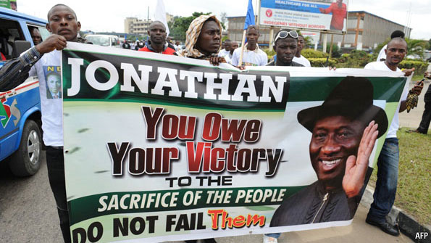
NIGERIANS have taken to watching an old film—one of their own—since the presidential election last month. It shows intrigue and thievery at the court of an ancient king in the Niger Delta. Decked out in glittering costumes on an improvised sound stage, the wicked court at last collapses under the weight of its own sins.
When it was released in 1999, “Saworoide” was seen as a commentary on the regime of Sani Abacha, who ruled (or, as some prefer, “dismembered”) Nigeria between 1993 and 1998. Once again, Nigerians are hoping to see the back of their ruling elite. Goodluck Jonathan, the president, wafts along on a wave of personal goodwill and is mostly seen as benign. It is the men and women around him whom voters blame for Nigeria’s woes.
With Mr Jonathan’s inauguration on May 29th, and the formation of a new government, many expect a turnaround. Two-thirds of Nigerians think the election will change their lives, according to a poll conducted by the International Republican Institute, an American outfit that promotes democracy. “We dream,” says a girl shining shoes. “What else can we do?”
The buoyant mood extends to the boardrooms and watering holes of Lagos, the business capital. There, sleekly suited bankers are licking their fingers. “We are printing extra business cards,” says one. Foreign investors, too, see a chance of good times ahead on the back of reforms promised by Mr Jonathan. They speak of billions held in offshore accounts, ready to be injected into the economy if the political stars align. A senior Western diplomat calls this “a real opportunity for Nigeria to kick itself into a new sphere”.
Though widely shared, that sentiment has not silenced the general dissatisfaction. If anything, it has grown louder as reform plans take shape and the rascal ways of the political class are unmistakably identified as the main reason for the lack of prosperity. The economy may be growing by 7% a year, but this feeds mostly the greedy mouths closest to government troughs. The speaker of the lower house of parliament was investigated this month for “misappropriating” $140m. Meanwhile, about 70% of Nigerians live on less than $2 a day.
The problem is not simply one of embezzlement and bribery. The entire state machinery exists to siphon off cash. Many functions of government have been adapted for personal gain. It starts at the frontier. Access to the fast-track channel at Lagos airport can be bought from touts for $10. Border guards in cahoots with them work extra slowly to make this option more attractive.
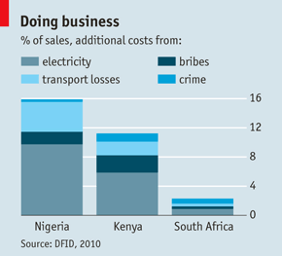
A universe of red tape engulfs the economy. In a survey by the International Finance Corporation, Nigeria ranks 178th out of 183 countries when it comes to transferring property. In some Nigerian states, governors must personally sign off on every property sale; many demand a fee.
Senseless restrictions and arcane procedures abound. Procter & Gamble had to shelve a $120m investment in a factory to make bathroom products because it could not import certain types of specialist paper. An American airline waited a year for officials to sign off on an already agreed route from Atlanta to Lagos.
Massive economic failure is the result. Employment in industry has shrunk by 90% in the past decade, “almost as if by witchcraft”, says one sheepish boss. The few jobs that exist are mostly offered by cartels. These control imports, too. The need for new infrastructure is vast, but the price of a 50kg bag of cement is three times higher than in neighbouring countries. Fighting cartels is hard. Customs officers are bent, hindering foreign competitors. Judges are easily bought. The police are, at best, ill-equipped. One in four cops exists only on paper: chiefs collect the extra pay.
Nigeria is the leading oil producer in Africa, with a revenue stream of about $40 billion a year. The effect of this wealth is mostly corrosive. “Nigerian politics is one big bun-fight over oil money,” says Antony Goldman, a consultant. Three-quarters of the government budget goes toward recurrent expenditure, including salaries. Parliamentarians are paid up to $2m a year—legally. Very little is invested in infrastructure. State governors all receive big slices of the oil pie. This has attracted some very shady characters into politics.
North and south
Where the state gets out of the way, Nigerians can often be hugely successful. Many are capable entrepreneurs. The $800m-a-year film industry is the second-most-prolific in the world and Nigeria’s second-biggest employer, after the government. Parts of the country enjoy remarkable prosperity. Most sweet spots are in the south-west, in or close to Lagos. A growing middle class has sprung up there, hungry for consumer goods. One million Nigerians have BlackBerries.
Most imported goods pass through the remarkable southern city of Onitsha, a thriving commercial hub and the biggest market in Africa. Up to 3m people throng its narrow alleys every day, many of them balancing flat-screen televisions on their heads as if they were buckets filled with water at the village well. The fringes of the city are lined with palatial villas built by successful traders, who decorate them with garish statues of nymphs and angels.
But Onitsha is an exception. More than two-thirds of Nigerians are still subsistence farmers. The majority, many of them Muslims, live far away from the coast. Incomes per head in the north are 50% lower than in the Christian south, and falling. Literacy rates in the north-east are two-thirds lower than in Lagos. A senior official in Kano, the northern capital, says 2m of the 9m residents are beggars. The city’s industrial areas, once centres of garment-making, are now ghost towns. Cowpea vines blow around the empty roads.
The south—with its ports and banks—has found it somewhat easier to escape the state’s poisonous hand. Deindustrialisation has hit hardest in the north, and not just economically. Militancy is on the rise among the young. Overland roads are unsafe. Only the suicidal venture out at night. Attacks on civilians and security forces are increasingly common. Young men without jobs burned down the houses of political leaders after the election last month, enraged that the Poobahs should enjoy another four years of pampering. About 800 people died, some in revenge attacks.
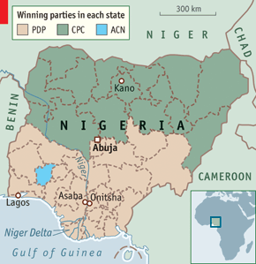
It is no surprise that extremists thrive in this climate. Boko Haram, a local terror group, is roaming ever wider and fine-tuning its methods; a link-up with al-Qaeda may be next. Northern extremism is fuelled by the fear of loss. Unlike his predecessor, President Jonathan is from the south. Many northerners worry that he will neglect them, or even turn off their oil. Nigeria’s electoral map (right) reflects this. All states north of the capital, Abuja, voted against Mr Jonathan; all but one state south of it voted for him.
This deep national rift is all the more reason, as one newspaper put it, “to be frontal in tackling the monster”, meaning the sclerotic state that has destroyed the northern economy. Progressives even blame it for all Nigeria’s ills. “Bad governance is the root cause everywhere,” says Chidi Odinkalu of the Open Society Foundations. When an unstable water tank on the ramshackle roof of a school came crashing down last year, killing six children, it was seen across the country as an example of state failure. Lamido Sanusi, the respected central-bank governor, who spent years in the private sector, says: “We need a civil war in government. We need people who will fight for change.”
What kind of change? Reformers have a long wish-list. Job-creation, however, could be relatively straightforward. Nigeria could funnel its oil revenues into a more efficient financial system that could provide capital to the private sector to build roads and power stations and expand private enterprises, such as farming.
Plans are already on various drawing boards. Parliamentarians have for years been trying to pass a new oil law. The oil companies want it, pining for clarity so that they can safely increase production. But even the new law will not tackle the biggest problem: the fact that Nigeria’s national oil company is both a player in the industry and its (incompetent) regulator. At the least, its functions should be split; and it, too, should be cut free of the state.
Oil pumped in the Gulf of Guinea comes ashore, via the international spot market, in the form of billion-dollar transfers that have made Lagos a regional financial centre. There reforms have already started—and have shown some results. One in five Nigerians has a bank account, with a further 10% increase predicted from mobile-phone banking over the next five years. A professionally managed sovereign-wealth fund will replace the current slush-fund that was used by the government to give away more than $10 billion in the run-up to the election.
The fund will probably adopt standard transparency rules known as the Santiago Principles. Elsewhere, however, opacity mars almost every aspect of the financial sector. The central bank has been so frustrated that it recently banned cash payments of more than a few thousand dollars. Yet black money has its advantages. Because international banks have imposed stricter controls, a lot more of it stays in Nigeria now than was the case a few years ago. Murky funds once bound for Switzerland instead flow into local construction, telecoms and hotel companies.
Power poverty
The two biggest beneficiaries of financial reforms would be agriculture and electricity. Farmers desperately need help. In 1997 they received 17% of total lending; today they get 1.4%. Once West Africa’s breadbasket, Nigeria can no longer feed itself. Last year it spent $1 billion on importing rice—ten-year-old rice from Indian grain reserves—while close to 40% of its own harvest rotted, mostly for lack of roads to markets and processing plants.
Infrastructure is key. And the single biggest impediment to building it is Nigeria’s negligible power supply. The situation is grotesque. MTN, a mobile-phone company, has masts all over the country, as it does in South Africa, where the power supply is better. Operating costs are three times lower there. In Nigeria MTN must equip each mast with a generator, a back-up generator, a fuel tank, guards to protect the fuel and a lorry to deliver it.
It is hard to exaggerate Nigeria’s power-poverty. The seventh-most-populous country in the world, and its seventh-biggest oil exporter, has as much grid power as Bradford, a post-industrial town in the north of England. Nigeria is the world’s biggest market for private generators; many middle-class homes have one, but small businesses can rarely afford them.
Mr Jonathan has said that power reform is his “highest priority” on his Facebook page (which most Nigerians will have trouble accessing without electricity). He has created a new government agency to privatise six generating companies and 11 distributors by the end of the year. More than 300 investors, both domestic and international, are considering bids. Grid transmission will remain in government hands but will be privately managed. The aim is to triple supply by 2013.
That will not be easy. Power-company employees fear their jobs will go. Consumers complain about price increases. Soon-to-be-emasculated industry insiders resent the loss of bribe income. And the mafia that sells fuel to millions of generator-owners is fighting for its market. Bart Nnaji, the president’s power tsar, admits that “there are people who don’t want reform to happen.” He has an armed guard outside his office door, and his employees receive anonymous rape threats.
Nonetheless, privatisation is going ahead, though three to six months behind schedule. Entrepreneurs are also being encouraged by Mr Nnaji to build brand-new power plants. Paul Okpue, who makes bamboo flooring in Asaba, a town near Onitsha, says: “I will have my own plant and feed what I don’t use into the grid and get paid for it.” He is eligible for a low-interest government loan of up to $30m.
Godfathers v radicals
Reform will be worth little, however, if state corruption is not tackled. That needs institutional change. In the view of many Nigerians, high officials should lose their immunity; legislators’ salaries should be cut, so as not to attract cowboys; and the publication of all government accounts would be a good idea. Parliamentarians, of course, disagree. A constitutional convention may be needed to push through the trickiest reforms.
Many frustrated businessmen—some unpaid for years—think the situation is hopeless. Yet Nigeria’s recent past suggests that small changes can bring vast benefits. The appointment of Attahiru Jega as head of the election commission last year produced the first credible poll in a generation. Telecoms privatisation has reduced phone prices by 99%.
Nigeria is reformable, but it needs the right sort of leader. Its presidency is more powerful than its American equivalent. Favours are bestowed and punishments meted out by “the man in the villa”, as some Nigerians call the occupant of the presidential palace. But he must assert himself over advisers, ministers and godfathers—the visiting regional bosses who lobby him. Many supported Mr Jonathan, who was formerly vice-president, during his 12-month interim presidency after his predecessor, Umaru Yar’Adua, died in office. Now they expect payback. IOUs will be cashed. This is the point where every civil-service reform in the past has failed.
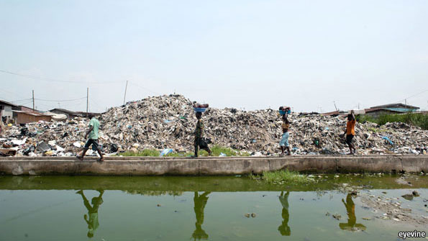So far to go, so much to do
Power in Nigeria is exerted by groups, not individuals. The country is too big for one man to rule. Even military leaders two decades ago chose to share power with a clique. A system of ethnic and regional quotas has developed. Jobs in all institutions are apportioned. Each of Nigeria’s 36 state governments, for example, proposes one cabinet minister. Loyalty in cabinet is rarely to the president, but to the godfather who picked the minister—and now expects a share of the loot.
To change the system, Mr Jonathan would have to break with his backers. That is difficult, perhaps even dangerous. For instance, a mafia that embezzles vast fuel subsidies is said to be a big contributor to his campaign. The government spends more than $4 billion a year to sell fuel at less than half the already low American price. (Since Nigeria has no domestic refining capacity—billions allocated to repair its facilities were squandered—the fuel must be bought on international markets.) The president’s backers routinely falsify bills of lading, inflating the amount of fuel imported fivefold, then collect the government subsidy on all of it, and finally smuggle the fuel to a neighbouring country to sell at double or triple the price. Mr Jonathan, of course, did not personally take their money. But if he goes after them their cronies may stop co-operating.
Political radicalism has a bad name in Nigeria, and not only when it threatens entrenched interests. The bloody Biafran war of the 1960s, when the south-east tried to secede, tainted subsequent attempts at wholesale change. And yet Nigeria has a rich history of radicalism. Half a century ago radical liberals helped drive out their colonial masters. Today’s radicals, surprisingly, tend to look not so much to their own history as to America’s.
Some see Mr Jonathan following in the footsteps of Chester Arthur, the 21st American president. Like him, he is humbly-born and bookish. Arthur was a penny lawyer, Mr Jonathan the first in his family of canoe-makers to earn a PhD (though some doubt he wrote it). Both men fell in with mean political machines—Arthur in New York, Mr Jonathan in the Niger Delta—and were elevated from total obscurity to the vice-presidency by scheming regional bosses. Then the president suddenly died (Garfield in 1881, Yar’Adua in 2010), and the top job was theirs. Arthur deserted the machine that made him and put it out of business. He created the modern American civil service and throttled patronage politics. He was not re-elected.
A cautious reformer
Might Mr Jonathan follow the same path? He has vowed not to run for office again, which should make things easier. But so far he has not shown the necessary ruthlessness. According to his official biography, “He abhors embarrassing situations; he hates failures and he loves peace.” His attention span is short, his public speaking poor. In meetings he sometimes reads from notes and “drifts off”. During the election campaign he refused to debate his challengers unless he could control the rules. Voters may have promoted him beyond his natural abilities. When he was a provincial official in the 1990s, his catchphrase was “Don’t overdo things.”
Nonetheless, there is some evidence that he is a committed reformer. Over the past year he has religiously held a meeting on power reform every Tuesday from 11am to 1pm. That has made a big difference. Some of the advisers he has picked are dyed-in-the-wool reformers: men like Oronto Douglas and Ken Wiwa, who have come up through civil-society organisations. Alas, the man he chose as his vice-president is a patronage merchant with a huge personal fortune.
Which way Mr Jonathan will lean in the next four years should become clear soon. In early June he will unveil his new team. If he is going to defy the godfathers, this is the time to do it. The head of police, the customs chief, the chief justice, the main anti-corruption investigator—will they be partisan stooges, or men who put the country first?

