Mexico's state elections

A motley political alliance scrambles the presidential race
Jul 8th 2010 | Mexico City
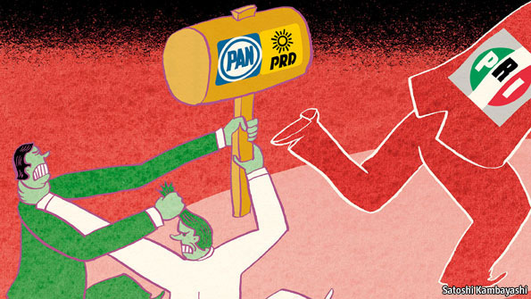
DURING the campaign ahead of Mexico’s state elections on July 4th, many feared that the gruesome run-up to the vote would overshadow the results. Two candidates were murdered, and countless others were intimidated: one would-be mayor found a decapitated corpse deposited outside his home. The atrocities, including four dead bodies hung from bridges on election day, were attributed to drug gangs reminding the country who rules the roost.
Yet the vote itself, in 14 of Mexico’s 31 states, provided a surprise that could redraw the country’s political map. The opposition Institutional Revolutionary Party (PRI), which ruled Mexico from 1929 to 2000, took over the lower house of Congress from Felipe Calderón’s conservative National Action Party (PAN) in 2009. It had been forecast to sweep all 12 of this year’s contests for governorships before winning the presidency after Mr Calderón steps down in 2012. Instead, it took just nine, the same number it held before the vote.
The three states it lost, Oaxaca, Puebla, and Sinaloa, had been ruled by the PRI for 81 years. They are bigger and more important than the three states the PRI snatched back in return: together, they represent 11% of the country’s population and 6.9% of its GDP, against 3% of the population and 2.3% of GDP made up by the PRI’s new acquisitions. Other PRI bastions also looked wobbly: the party clung onto Veracruz, the largest state in contention, by less than 3%, and held the smaller Durango by less than 2%.
The PRI lost its fiefs to an unlikely alliance between the PAN and the leftist Party of the Democratic Revolution (PRD). The pair have been bitter rivals since the PRD’s 2006 presidential candidate accused Mr Calderón of stealing the election. They are ideological opposites. But as Alejandro Poiré, the under-secretary for immigration and a former political-science professor, notes, the two teamed up in the past to end the PRI’s monopoly on power. Jesús Zambrano, a senior PRD leader, sees a marriage of necessity. “Some PRI members are prehistóricos”, he says of their longing for one-party rule. “We can’t just sit there with our arms crossed.”
The parties are likely to repeat the tactic in next July’s race for governor in Mexico state, the country’s most populous. It includes most Mexico City suburbs and is seen (often misleadingly) as a political barometer. In 2005 the PRI’s candidate there, Enrique Peña Nieto, won easily. Thanks to his popularity in the state, able advisers, engagement to a soap-opera star, and wide media exposure, he is now the front-runner for the PRI’s presidential nomination.
But the PAN and PRD’s combined vote in 2005 exceeded Mr Peña Nieto’s. If the two parties can find a candidate who could capture most of the anti-PRI vote next year, they might be able to stop him from installing his chosen successor in the governor’s mansion and sap his momentum. “The main thing he has going for him is his inevitability,” says Jorge Castañeda, a former foreign minister. “If he is knocked down, the PRI has no substitute, because they’ve bet the store on him.”
The new alliance could affect policy as well as the horse race. Almost all of Mr Calderón’s legislative initiatives have been diluted or defeated in Congress. With PRD support, Mr Calderón could almost scrape together a legislative majority. That would let him pass laws that do not entail constitutional amendments by picking off just a few PRI members or their allies.
Most big issues, such as allowing private investment in energy, involve changing the constitution. That requires a two-thirds majority, and thus the PRI’s backing. But Mr Calderón could also use the PRD as a bargaining chip, agreeing not to field alliance candidates in some states in exchange for the PRI’s votes in Congress.
Such a strategy might enable him to pass a political reform that would help prevent legislative gridlock in the future. He has proposed permitting limited re-election for legislators and mayors (currently capped at a single term), letting the president order Congress to vote on at least two of his bills in each session, and adding a run-off vote to presidential elections. The PRI is wary of these ideas: a run-off, for instance, would allow the PAN and PRD to field their own candidates and then unite behind whichever one did best.
That Mr Calderón’s “alliance against nature”, as some priístas term it, has beaten expectations does not mean he is out of the doldrums. As Mr Peña Nieto notes, “It was everyone against the PRI, and despite that the PRI triumphed in nine states [out of 12].” The PRI still holds Congress and 19 of the 31 governorships. But the July 4th vote has opened up new possibilities in a previously paralysed system.

