Germania: Hitler's Dream Capital
By Roger Moorhouse | Published in History Today Volume: 62 Issue: 3
Albert Speer’s plan to transform Berlin into the capital of a 1,000-year Reich would have created a vast monument to misanthropy, as Roger Moorhouse explains.
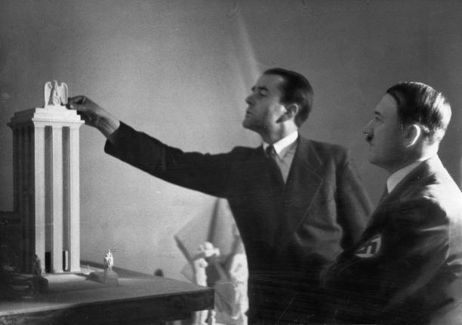Albert Speer presents Hitler with a model of the German Pavilion designed for the World's Fair in Paris, 1937. Mary Evans Picture LibraryIn 1937 Hitler’s architect Albert Speer was given the task of transforming Berlin from the sprawling metropolis that it was into Germania, the gleaming new capital of a Greater German ‘World Empire’, the centrepiece of the civilised world.
It was a vast undertaking. Plans, swiftly drawn up by Speer’s office, were presented to the public on January 28th, 1938. The reaction within Germany was predictably enthusiastic, with newspapers carrying detailed explanations and commentaries. Der Angriff stated that the designs were ‘truly monumental … far exceeding all expectations’, while the Völkischer Beobachter proclaimed grandly that ‘from this desert of stone, shall emerge the capital of a thousand-year Reich’. The foreign press, though less effusive, nonetheless concurred. The New York Times, for instance, described the project as ‘perhaps the most ambitious planning scheme’ of the modern era.
The plans certainly did not want for ambition. In accordance with Hitler’s original sketches they centred on a grand boulevard, which was to run from north to south for around seven kilometres through the heart of the city, linking two proposed new rail termini. Given carte blanche in redesigning this vast swathe of the city centre, Speer and his minions had had a field day and their plans read like a catalogue of comparatives and superlatives. The vast Grand Hall, for instance, close to the Reichstag, would have been the largest enclosed space in the world, with a dome 16 times larger than that of St Peter’s in Rome. Designed to host 180,000 people, there were concerns among the planners that the exhaled breath of the audience might even produce ‘weather’ beneath the cavernous coffered ceiling. The 117-metre tall Arch of Triumph, meanwhile, was designed – on Hitler’s express instruction – to carry the names of Germany’s 1.8 million fallen of the First World War engraved upon its walls. Similarly massive, it would have comfortably accommodated its Parisian namesake beneath its arch. Linking these monuments along the new axis would be a plethora of new buildings, civic and commercial, flanking broad avenues, ornamental obelisks, an artificial lake and a vast ‘circus’ peppered with Nazi statuary.
The image that will be familiar to many is of Hitler inspecting the white scale-model of this main axis, which was presented to him on his 50th birthday in April 1939 and was erected in a side-room of the Reich Chancellery. Though Hitler’s interest in the project was restricted almost exclusively to the north-south axis – and he would often return to muse over the model – the plans were not limited to that one area. Speer had succeeded in incorporating those headline designs into a much more thoroughgoing reorganisation of the city’s infrastructure.
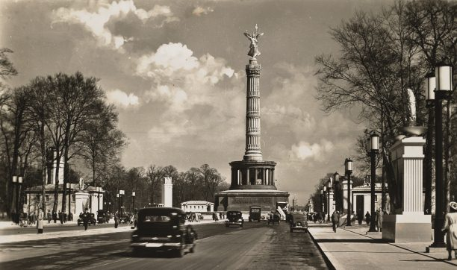Facing east towards the Victory Column on what was to have been Germania's east-west axis, 1939. AKG Images
First of all, Berlin’s rail network was to be overhauled, with the two new stations replacing three old termini and with many miles of sidings being replaced by a new line that would circle the city centre. Roads, too, were to be redrawn. The two new boulevards – the proposed north-south axis and the east-west axis, completed in 1939 – were only the centrepiece of a radical redevelopment. In addition Speer foresaw the city’s formerly organic urban growth being rationalised by the addition of radial thoroughfares and four concentric ring roads, the outermost of which would provide a direct connect-ion to the German autobahn network.
Visions of Germania: How the city might have looked
Entire suburbs were to be constructed to provide modern housing stock, administrative buildings and new commercial developments, which, it was planned would accommodate over 200,000 Berliners, moved out of the slums of the city centre. New airports were foreseen, including one for seaplanes on the lake at Rangsdorf. Even the city’s parks would be revamped, with horticultural studies being commissioned to report on the species that were required to restore the 18th-century flora of the region. Such was the scale of the Germania plans that, when Speer’s father – himself an architect – saw them, he summed up the thoughts of many of his contemporaries, saying: ‘You’ve all gone completely crazy.’
Of course only a tiny fraction of these grandiose designs would ever be realised. The visitor to Berlin today will struggle to see much evidence of Speer’s Germania unless he or she knows where to look. Most obvious is the boulevard west of the Brandenburg Gate, which is the old east-west axis and which is still illuminated by some of Speer’s original – and rather elegant – street lamps. Meanwhile the Victory Column (inaugurated in 1873 following Prussia’s victories over Denmark, Austria and France in the 1860s and 1870s) was moved to its present location to make way for the projected north-south Axis. Most bizarrely, the southern suburb of Tempelhof still contains a huge circular concrete block weighing over 12,000 tonnes – the Schwerbelastungskörper, or ‘heavy load-bearing body’ – which was supposed to help Speer’s engineers gauge the ability of Berlin’s sandy soil to take the vast weight of the proposed Arch of Triumph. Too large and too solid to demolish, the block stands to this day as a silent monument to Nazi megalomania.

More than a pipedream
Given that so little of Germania was ever completed and that only a fraction of it remains, it is easy to underestimate its significance. Speer’s planned rebuilding of Berlin is too readily dismissed as a Nazi pipedream; a still-born manifestation of Hitler’s architectural fantasies thankfully confined to the drawing board. Yet, in spite of the fact that Germania never came into being it would be a mistake if we were to allow ourselves to view it merely as an abstract: a folly, or an architectural curiosity somehow divorced from the odious regime that spawned it. For, as we shall see, Germania was in many ways a rather perfect representation of Nazism.
First, the issue of its feasibility must be assessed. Despite its soaring ambition the plan to re-model Berlin was part of a veritable orgy of building that had gripped the later, peacetime years of the Third Reich. Much of that, certainly, was relatively small-scale – barracks, settlements, schools and so on – but a number of projects showed similarly monumental tendencies and were themselves considerable feats of planning and construction. Most famously, perhaps, there is the example of Hitler’s vast new Reich Chancellery, which stretched the entire 400-metre length of the Voss Strasse in Berlin and was completed in 1939 at a cost of over 90 million Reichsmarks.
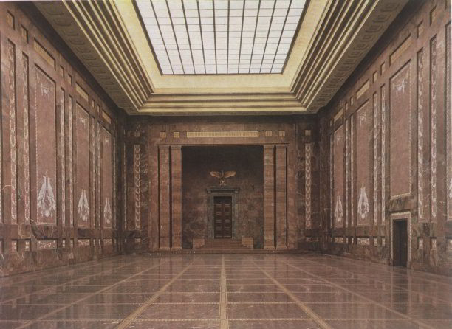The Mosaic Hall of the new Reich Chancellery, 1939. AKG Images.
Other Berlin landmarks were similarly grandiose: the Olympic Stadium, opened in 1936, seated 100,000 spectators and was part of a much larger complex that was intended as much for political as for sporting ends. Göring’s Air Ministry, meanwhile, also completed in 1936, was once the largest office building in the world, offering 2,800 rooms across seven floors with 4,000 windows and nearly seven kilometres of corridors. Today it is home to the German finance ministry.
Elsewhere construction was no more modest. In Nuremberg Speer’s famed tribune on the Zeppelin Field was dwarfed by the nearby Congress Hall, modelled on the Colosseum in Rome, which was built to accommodate 50,000 of the Nazi faithful. Though it only reached a height of 39 metres – as opposed to the 70 metres that was planned – it is still the largest surviving building of the Nazi period; while at Prora, on the Baltic coast, a huge holiday resort was constructed, which, though unfinished at the outbreak of war in 1939, stretched for 4.5km along the seafront and would have housed over 20,000 holidaymakers. Even Hitler’s folly above Berchtesgaden – the Kehlsteinhaus, or ‘Eagle’s Nest’ – was an ambitious project. Completed in 1938, after little over a year in construction, it was sited atop an Alpine ridge at an altitude of over 6,000 feet and was accessed via a purpose-built seven-kilometre mountain road, which had to be blasted into the mountainside.
When considering Hitler’s plans for Berlin, therefore, one must bear in mind the wider context of Nazi construction and the astonishing track record that Hitler’s architects already had in successfully realising his visions. Germania was not mere Nazi ‘pie in the sky’. It was a part of a concerted programme to provide Germany with a portfolio of grand-scale, monumental architecture, which, Hitler believed, would be seen as the defining buildings of the age, rivals to Egypt, Babylon and Rome, inspiring future generations of Germans. It was certainly not merely a dictator’s architectural wish-list.

Quarries and camps
Given its central importance to the Nazi vision, the building frenzy – of which Germania was part – was thoroughly integrated into the Third Reich’s economy and terror networks. Indeed it is not widely understood just how close the relationship was between the building programme and the concentration camps. The vast expansion of the camp system from 1936 onwards had, in fact, been fuelled primarily by the demand for labour and materials from the burgeoning construction sector, with Albert Speer – and Germania – in the vanguard.
Consequently, many of the most infamous concentration camps of the Nazi era – Mauthausen, Gross Rosen and Buchenwald among them – were established close to quarries. The camp at Mauthausen, for instance, was set up in 1938 alongside the granite quarry that had supplied much of the stone used to pave the streets of Vienna, while the camp at Sachsenhausen, outside Berlin, was close to what was intended to be one of the largest brickworks in the world. The camp-quarry at Flossenbürg in northern Bavaria, meanwhile, was the source of much of the white-flecked granite that was going to be used in Berlin, some of which is still stacked inside the Congress Hall in Nuremberg. Thus Germania was not only central to the Nazi aesthetic, it also played a vital role in the establishment and maintenance of the concentration camp network. Nazi architectural planning, it seems, had synchronised perfectly with the interests of the SS.
Germania’s financing was also not as utopian as one might imagine. Speer estimated the total cost of the project, perhaps optimistically, at six billion Reichsmarks, five per cent of Germany’s GDP in 1939. Yet such was the Byzantine nature of economic relationships in the Third Reich that only a fraction of that figure would have to be paid directly by the Reich government. For one thing, the vast majority of the building materials that were prepared for the project came from the concentration camps dotted across Nazi Germany, while the quarries and brickworks themselves were owned or leased by an SS-owned company, DEST (Deutsche Erd-und Steinwerke). So Germania effectively got its materials for free, with the added bonus – in Nazi eyes – that their political opponents were being ‘re-educated by labour’ in the process.
In addition the construction and demolition costs were to be spread across the annual budgets of numerous ministries, organisations and Nazi fiefdoms. And there was no shortage of willing donors, with some, such as the Nazi Labour Front, being deliberately kept at arm’s length for fear that they might wield too great an influence. The city of Berlin was required to shoulder much of the financing, with various appeals for donations and contributions to make up any shortfall. It also would not have escaped Speer’s attention that his projected costs equated exactly with the total estimated value of Jewish property in Nazi Germany. By these measures, Speer recalled, the costs of the project could be divided (and effectively concealed), leaving central government directly liable only for the Great Hall and the Arch of Victory. Hitler, meanwhile, tended to wave away any complaints from his ministers by stressing the large numbers of wealthy tourists that – one day – would visit the new capital of the Greater German Reich.
So, although little of it was actually constructed, Germania was not merely theoretical, it was very real. And it would have felt all the more real to those concentration camp inmates at Mauthausen or Flossenbürg, who had to quarry the granite slabs for Berlin’s new Reich Chancellery or the Soldier’s Hall. Even sites that never saw the light of day were prepared for; stone was cut, bricks were fired and men died. It is reasonable to assume that, of the 100,000 or so concentration camp inmates who perished at Sachsenhausen, Flossenbürg and Mauthausen, a large proportion of them died preparing the stone for the rebuilding of Berlin.
Germania was also very real for ordinary Berliners. From 1939 to 1942 the areas of the city earmarked for the project were being cleared and existing properties demolished. Even the nocturnal visits of the RAF in 1940 were welcomed by Speer’s staff as providing ‘valuable preparatory work’ for the demolition programme. Preparations elsewhere were similarly thorough. The district of the Spree-bend to the west of the Brandenburg Gate, for instance, was criss-crossed with test trenches and foundations, while to the south, by the end of 1939 the project’s first building, the Foreign Travel Office, was already completed in its essentials. Beneath it all, meanwhile, the complex of underpasses that would take through-traffic away from the new centrepiece of the Reich, had already taken shape.

The human cost
In all this demolition and construction countless thousands of people were directly affected in the German capital. Foremost among them were prisoners of war and forced labourers, who were housed in often substandard conditions and made to work around the clock and in all weathers. Despite his later protestations of innocence, Speer was never shy of exploiting PoWs as labour. Indeed in November 1941, after the opening successes of the war against the Soviet Union, he petitioned Hitler with a request for some 30,000 Soviet PoWs specifically for use in the construction of the ‘new Berlin’. Hitler acceded to the request, thereby bringing the total workforce overseen by Speer’s staff and working directly on Germania to around 130,000.
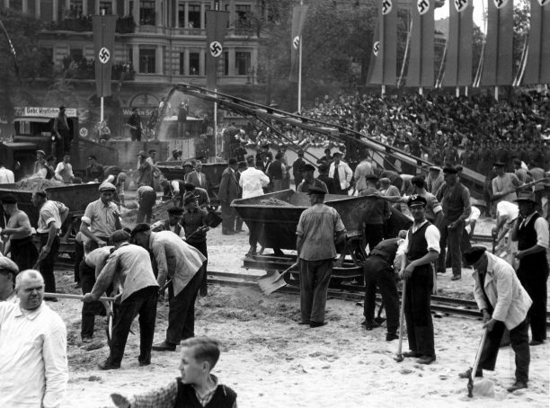
Civilians, too, faced considerable disruption. Those ‘Aryans’ who found themselves living in the way of Speer’s plans were rehoused, either in modern, purpose-built accommodation in the suburbs or else, as was more usual, in properties from which Jewish owners had been evicted. Already in 1938 Speer had suggested that the capital’s Jewish community should be moved into smaller properties, thereby freeing up larger buildings for the use of those Aryan Berliners displaced by the ongoing demolition works. By 1940 this process was well under way and many thousands of Jewish properties were being vacated.
Those displaced Jews, however, often found themselves – perversely – being moved into the path of Speer’s bulldozers. As the housing crisis in the capital worsened, many of them were unable to rent property and were forced into so-called ‘Jew-houses’, which were often those substandard blocks, already slated for demolition, that stood along the route of the construction works. There, amid chronic overcrowding and poor sanitary conditions, with as many as 200 families inhabiting a single block, they were effectively stripped of their few remaining legal rights as tenants. They could have had little inkling that worse was to come, but in October 1941 many of them would be aboard the first transports that would leave Berlin, destined for the ghetto at Łódz.
In this way the Germania project, despite being largely stillborn, had profound consequences, becoming a catalyst not only for the evolution of the concentration camp system but also for the development of Nazi policy against the capital’s Jews.
Speer’s plans for Berlin are fascinating. In an architectural sense, they are – if nothing else – a potent display of the astonishing extremes that can be reached by sycophantic architects. Yet any assessment of the Germania plans must reach beyond the narrow sphere of architecture, even if only a fraction of those designs ever graduated from the drawing board. Speer’s plans cannot simply be viewed from the architectural perspective alone: in examining them one is morally bound to consider not only the designs themselves but also the brutal methods by which they were brought into being.
Germania, though largely unrealised, nonetheless projected its malign influence into many other spheres of life – and death – in the Third Reich. Its contempt for mankind was demonstrated not only in the treatment meted out to those doomed to cut its stone in the concentration camps or those who found themselves living in its path; it also extended to those who might one day have walked those granite-clad boulevards. It is notable, for example, that in all the plans a human dimension is almost completely lacking. Hitler, it appears, had absolutely no interest in the social aspects of the planning that he oversaw; his passion was for the buildings themselves rather than for the human beings who might one day inhabit them. Indeed it has been plausibly suggested by Frederic Spotts that the plans for Berlin’s reconstruction were themselves simply a manifestation of Hitler’s desire to reduce cities and even individuals to the status of mere playthings. When one recalls the images of the Führer stooped like some malevolent deity over his architectural models in the Reich Chancellery this is an interpretation that becomes instantly and chillingly persuasive.
Just as Albert Speer was never just an architect, therefore, Germania was never merely an architectural programme. It was, in fact, a perfect reflection of the dark, misanthropic heart of Nazism.
Roger Moorhouse is the author of Berlin at War: Life and Death in Hitler’s Capital 1939-45 (Bodley Head, 2010).

