China: The debate over universal values

It is not quite true that China is rejecting Western values such as democracy. Rather, it is fighting over them
Sep 30th 2010 | Beijing
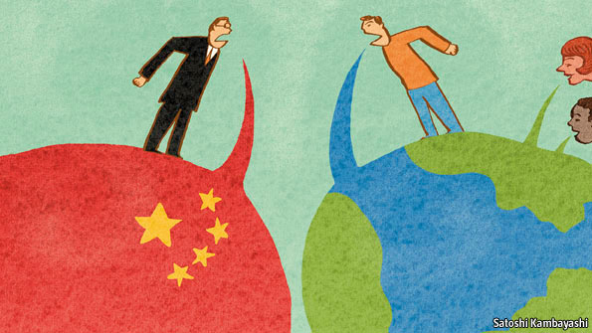
ON JULY 19th the graduates of one of China’s leading business schools settled down in their academic finery to listen to a farewell address by Qin Xiao, the chairman of a state-owned bank. They little expected what they were about to hear. Instead of rallying them to further the cause of China’s socialist modernisation, Mr Qin urged them to resist the lure of worldly things and to pursue “universal values” such as freedom and democracy.
Mr Qin’s speech to an audience of 2,000 people in Tsinghua University’s sports centre fanned the flames of an ideological debate that has been smouldering in China for the past two years. A philosophical question of whether universal values exist has turned into a political fight, dividing scholars, the media and even, some analysts believe, China’s leaders. The schism is likely to become more apparent as the Communist Party prepares for a sweeping change of leadership in 2012. Liberals will try to goad incoming leaders into making their views clear.
Mr Qin, who retired on September 21st after nine years as chairman of China Merchants, the country’s sixth-largest bank, said recognition of universal values was at the heart of big issues facing China’s development, from urbanisation to the provision of public services and the ownership of state assets. “Universal values tell us that government serves the people, that assets belong to the public and that urbanisation is for the sake of people’s happiness,” he said. Supporters of the “China model”, he added, believe the opposite: that people should obey the government, the state should control assets and the interests of individuals are subordinate to those of local development.
The term “universal values”, or pushi jiazhi, is a new one in Chinese political debate—surprising given that concepts commonly associated with it, such as freedom, democracy and human rights, have been bickered over incessantly for 30 years. Many Chinese scholars think the debate really took off in 2008 after an earthquake in Sichuan province that killed around 80,000 people. Ten days after the disaster, a liberal newspaper in the southern province of Guangdong, Southern Weekend, published an editorial that praised the government’s swift response. It said it had “honoured its commitments to its own people and to the whole world with respect to universal values”.
That single mention of the term was enough to enrage hardliners. A flurry of commentary appeared in Beijing newspapers and on conservative websites attacking the idea of universal values as a Western plot to undermine party rule. China was preparing to host the Olympics in August 2008 with the slogan, “one world, one dream”. But conservatives feared that embracing universal values would mean acknowledging the superiority of the West’s political systems. In September, after the games, the party’s own mouthpiece, the People’s Daily, weighed in. A signed article accused supporters of universal values of trying to westernise China and turn it into a laissez-faire economy that would no longer uphold “socialism with Chinese characteristics”.
The debate picked up in December 2008 when hundreds of liberal intellectuals and out-and-out dissidents signed a manifesto in support of universal values, known as Charter 08. China faced a choice, it said, of maintaining its authoritarian system or “recognising universal values, joining the mainstream of civilisation and setting up a democracy”. This was a step too far for the party leadership. Recently, Chinese officials have been issuing warnings about diplomatic trouble if the Nobel Peace Prize, due to be announced on October 8th, goes to the charter’s organiser, Liu Xiaobo. Mr Liu, who is the bookies’ favourite to win the award, is serving an 11-year jail term for his role. On September 28th, a Chinese foreign-ministry spokeswoman said his acts were “completely contrary to the aspirations of the Nobel Peace Prize”.
China’s strong economic performance during the global financial crisis has been a morale booster to conservatives. In a veiled demonstration that China has its own values, the authorities in Beijing this week staged the capital’s first large-scale celebrations of Confucius’s birthday (his 2,561st) since Communist Party rule began. Conservatives like to contrast what they see as a Confucian stress on social harmony and moral rectitude with the West’s emphasis on individual rights.
But the rival camps are still at daggers drawn. Liberals see the prime minister, Wen Jiabao, as a champion of universal values. In November 2008 an article posted on Guangdong newspaper websites named both Mr Wen and President Hu Jintao as supporters of the notion. Neither man has used the term pushi jiazhi publicly, but the liberals’ case for Mr Wen, at least, is a strong one. He wrote in 2007 that “science, democracy, rule of law, freedom and human rights are not unique to capitalism, but are values commonly pursued by mankind over a long period of history.” An appeal by Mr Wen in late August for political reform has prompted a slew of veiled responses in the conservative media, castigating Western-style democracy.
Conservatives claim support from the party’s publicity department, which controls the media in Beijing. They were encouraged by a speech on September 1st by Vice-President Xi Jinping, who is all but certain to take over from Mr Hu as party chief in 2012 and as president a year later. Mr Xi’s speech was peppered with references to values, but did not come close to suggesting that any were universal. He cited the examples of several ordinary party members who, by devoting themselves to its interests, had answered “the basic question of what the main goals and highest values are for a communist”. A Chinese scholar with close ties to conservative officials says there are divisions among top leaders over universality.
They have certainly vacillated. The government’s first white paper on democracy in China, in 2005, began: “Democracy is an outcome of the development of political civilisation of mankind. It is also the common desire of people all over the world”. A drafter says he now believes those words were “inappropriate”.

