Cautiously, Iranians Reclaim Public Spaces and Liberties Long Suppressed
By THOMAS ERDBRINK
NY Times
OCT. 5, 2015
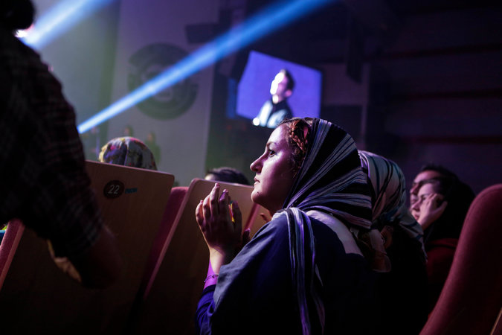
A concert by the pop singer Sina Hejazi at the Milad Tower in Tehran. Public concerts have become more frequent in Iran even though music is still denounced by conservative clerics.

TEHRAN — As the music ended and the crowd rose in a standing ovation, several women in the audience could be seen with heads bared, the obligatory head scarves draped around their necks.

This was no underground concert by an indie band in North Tehran, though. Rather, it was a recital by a classical lute player in Vahdat Hall. As the opera house emptied, the women casually slipped the scarves back on and walked out. No one seemed to care, or even to notice.
Far from a protest or a political gesture, this was a fleeting illustration of a newfound self-confidence, visible across the capital — what Iranians are calling the “lifestyle movement.”
“Nobody batted an eye, because in practice most people are far ahead of the norms set by the government,” said Haleh Anvari, an essayist based in Tehran who was at the concert. “In cars, cinemas and concerts, ordinary people are increasingly taking their space.”
Iranians have always enjoyed rich private lives, some following Western trends and fashions, but behind closed doors. The state tolerated that, but insisted that people adhere to the strict laws on appearance and behavior in public spaces that were laid down after the Islamic revolution in 1979.
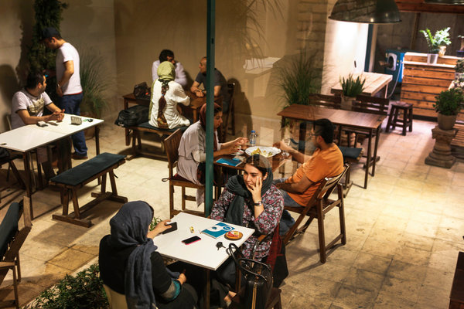
Young people enjoyed their afternoon in a cafe in central Tehran.

This disconnect has led to a perpetual cat-and-mouse game, with public freedoms virtually disappearing after the government’s brutal repression of protest following the widely disputed presidential election in 2009.

But now, following the election of a moderate president, Hassan Rouhani, and the signing of the nuclear agreement this summer, Iranians are increasingly taking to the streets, this time not to challenge the government but to reclaim public spaces. Though there are plenty of skeptics who say the changes are minimal and could be reversed at any time, the lifestyle movement seems to be spreading across the country.
“Few would say it out loud, but we had almost become a police state,” Hamid Reza Jalaeipour, a sociologist at Tehran University, said about the years after 2009, when the morality police were a fixture in every main square, hauling those deemed to be “badly veiled” off in vans. For many, the atmosphere became so suffocating that they started leaving for other countries.
Mr. Jalaeipour said small changes began after Mr. Rouhani unseated Mahmoud Ahmadinejad in 2013, promising a nuclear agreement and an expansion of personal freedoms, but have increased noticeably of late. “Especially after the elections and now the nuclear deal,” he said, “the self-confidence of ordinary people is increasing and that can be seen everywhere.”
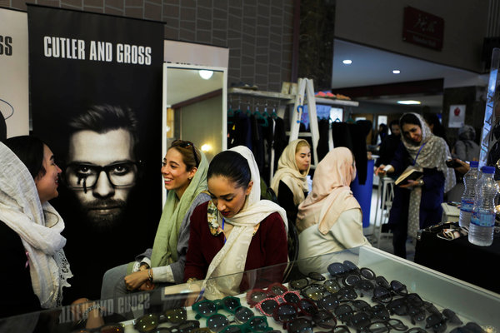
Iranian girls selling sunglasses at a charity event. Activism addressing a range of issues has become more accepted in the country since the election of President Hassan Rouhani in 2013.

But the change is palpable in a country that once posted morality police throughout the city; discouraged dressing in anything but black and most forms of entertainment; and that, in recent years, had begun burying the remains of martyrs of the Iran-Iraq war in the middle of public squares.
In the universities, students have started wearing bright colors. Street musicians line up at busy crossings, even though music is still frequently denounced by conservative clerics as “haram,” or forbidden in Islam. Fashion shows with models and runways, previously banned, are popping up. At night, women can be seen riding in cars without their head scarves, while billboards, long the exclusive domain of political figures, now feature celebrities like the Iranian actor Bahram Radan, who advertises leather coats.
Where previously even joking in public gatherings was considered politically risky, cafes now organize stand-up comedy evenings. Groups of citizens have formed nongovernmental organizations around issues like animal rights and the environment.
In the spring, more than a thousand animal rights activists gathered at the Ministry of Environment, protesting the killing of stray dogs in the city of Shiraz. The protest was fueled by social media, heavily amplified by the introduction of 3G mobile Internet. The killing stopped.
Many of the initiatives are the natural result of long pent-up demand, but also because the state seems to be retreating from many areas.
Analysts say that is the work of officials appointed by Mr. Rouhani, who have taken up high-level positions in the Culture and Interior Ministries. They cannot rewrite Iran’s laws: the Parliament and the judiciary will block any changes. But they have allowed ordinary citizens more space to breathe. Suddenly there are too many concerts to choose from, and public initiatives like campaigns to boycott Iranian carmakers to press them to raise the quality of their offerings or to save stray cats are mushrooming all over town.
The only red line is politics, many here say. Anything with a political tinge will be stopped cold.
Still, that provides a lot of openings for those who, like Ehsan Rasoulof, can see them. The son of a wealthy banker, the 32-year-old looks like a typical aspiring Iranian artist, wearing a checked shirt and ripped jeans and chain-smoking Iranian cigarettes, which are half the size of Western ones. Instead of driving a Maserati, as other children of the elite in Tehran do, he uses taxis.
“I am not left, or right, I couldn’t care less about politics,” he said. “My mission in life is to take back our public space.”
He opened the Mohsen Gallery, now one of Tehran’s most prominent art spaces, in honor of his brother, a photographer who died in a plane crash. He has used his family money to fund rock, pop and alternative bands, publish books and produce movies. In 2013, he opened a cafe, Nazdik, in downtown Tehran that sponsors a variety of cultural events and attracts people to a part of the city most do not usually frequent at night.
He did it, he said, because “we need bases to hang out.”
Mr. Rasoulof described an unending tug of war with the authorities over permits for concerts and other public performances. He said he had planned to hold a rock concert Thursday under the city’s Freedom Tower and had all the permits in place. But the show was canceled after the government announced three days of mourning to commemorate the deaths of Iranian pilgrims in the stampede during the hajj last month in Saudi Arabia.
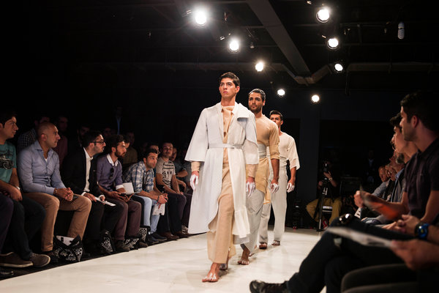
A fashion show in Tehran.

“We will have the concert later,” he said. “As long as we stay away from politics, many things are possible.”
He said many Iranians were intent on reclaiming freedoms seen after the election of Mohammad Khatami, a moderate who was president from 1997 to 2005 — minus the politics. That was like a dam breaking, flooding Iran’s closed society with youthful ambitions. Newspapers opened up, boys and girls started mixing and, at the height of what some called the “Iranian spring,” students battled with security forces for six days after a newspaper was shut down.
But conservative opposition built up, leading to years under Mr. Ahmadinjad devoted to destroying the civil society that had emerged, including imprisoning and exiling its architects.
Nowadays the moderates are also back, but operate cautiously — as they themselves say, like a car driving through the night with its headlights off.
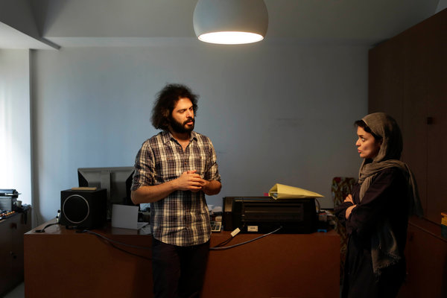
Ehsan Rasoulof is the son of a banker, and is using family money to open up public spaces in Iran.

Sitting in a newly opened party office, Ali Shakorirad, the head of the reformist Islamic Iranian National Union Party, said he had no clear agenda: “For now we are simply trying to survive.”
Most Iranians do not care much about political change these days. Instead, the focus is on social responsibility.
“During the Ahmadinejad era we saw that if we stood on the sidelines we lost out,” said Sohrab Mahdavi, a member of a group prodding the government to clean up Tehran’s notoriously bad air. “If we want to be good citizens, we must first take responsibility ourselves,” he said.
Mr. Jalaeipour, the sociologist, said that he was not sure where the new activism was heading, or how far it would go. It is in the nature of such movements to migrate into the political realm, he said, “It is definitely a challenge for those in power.”
But the inroads in public space are apparent everywhere, he said, and may not be so easy to suppress. “Nowadays you even see women taking out the trash without their head scarves on,” he said. “It seems difficult to send all these people back into their houses.”
Others were more cautious, citing past outbursts of public expression that were followed by crackdowns, but still saw the changes as enduring.
“Naturally, the state will try to control the pace of these changes,” said Ms. Anvari, the essayist. “But, ultimately, their interest in the private space has waned over the years. This led to families changing; now we are witnessing these changes on the streets.”

