The Tory right: Blue on blue

Can David Cameron keep his own party happy?
Oct 7th 2010 | birMingham
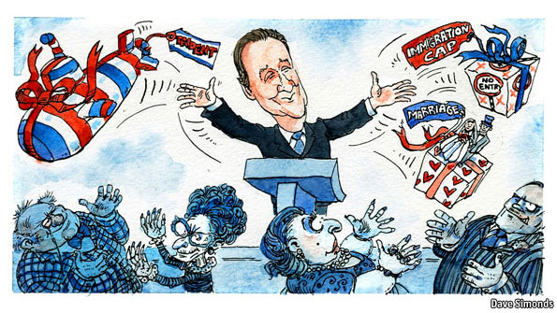
SINCE the Conservative-Liberal Democrat government was formed in May, most observers have looked to the Lib Dems as the main source of disaffection. Yet the big arguments within the cabinet so far have been “blue on blue”, mostly involving causes dear to the Tory right. Liam Fox, the defence secretary, has warned of the threat to the armed forces and national security posed by impending spending cuts. Until an agreement was reached recently, the zeal for welfare reform of Iain Duncan Smith, the work and pensions secretary, received short shrift from a sceptical Treasury. Meanwhile, Ken Clarke’s liberal noises as justice secretary—he has questioned the utility of short prison sentences—have provoked anger among fellow Tories, including very senior ones.
The right’s grievances with David Cameron are not only about policy. They have long regarded the prime minister’s leadership style as aloof and cliquey, and have neither forgotten nor forgiven his failure to win a general election they believed was eminently winnable. He aggravated this anger by retaining almost all the advisers responsible for the election campaign, while asking some Tory frontbenchers to make way for Lib Dems in the cabinet.
For now, the right’s resentment is confined to grumbling. It helps that this wing of the party approves of the government’s main missions: cutting spending and decentralising public services. But, as Mr Cameron knows, the pacifying novelty of being in power after 13 years will wear off.
The Conservatives’ autumn conference in Birmingham had been intended to soothe these disgruntled Tories. Sure enough, most of the policy announcements were popular among the grassroots. As well as his more divisive plan to withdraw child benefit from high-earning families George Osborne, the chancellor of the exchequer, said a limit would be set on the amount a household can claim in benefits. On October 5th Mr Clarke said prisoners should work a 40-hour week on the minimum wage, with some of their earnings going to their victims. That is the kind of prison reform that Tories can live with. The next day, William Hague, the foreign secretary, said a bill would be introduced in Parliament requiring any new transfer of power to the European Union to be put to a referendum.
Perhaps the biggest gift for the Tory base was a hint rather than a clear announcement. Responding to the child-benefit row, Mr Cameron suggested that his old plan to recognise marriage in the tax system may be revived, and perhaps even made more generous. His big speech on October 6th struck other recognisably Tory notes. He lauded wealth creators, confirmed that he would retain Britain’s nuclear deterrent and reiterated his determination to tackle welfare dependency.
This kind of party management is wise, and overdue. Mr Cameron will need friends as his government is buffeted by unpopularity in the coming years. But his dilemma is that pacifying the Tory base may conflict with his simultaneous effort to portray himself as a “one nation” prime minister In quite a smooth division of labour, Mr Osborne has gradually emerged as the de facto Tory party leader, guarding his tribe’s interests within the coalition while Mr Cameron floats above the political fray.
Tories distressed by that pose should be cheered by the fact that it could prove hard to maintain. Gordon Brown played “father of the nation” in his early months as prime minister. It was not long before his mania for partisan calculation was exposed.

