The sacked mayor of Moscow
Medvedev 1, Luzhkov 0

President Dmitry Medvedev’s dismissal of Yuri Luzhkov, the veteran mayor of Moscow, cements the Kremlin’s grip on power in Russia
Sep 30th 2010 | MOSCOW
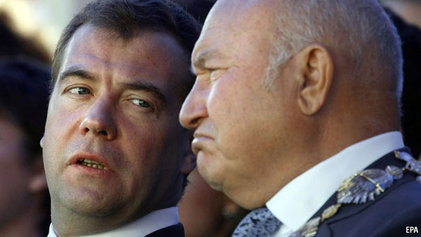
DMITRY MEDVEDEV has been long on talk and short on action ever since he became Russia’s president in 2008. That is why some were surprised on September 28th when he dramatically fired Yuri Luzhkov, the mayor of Moscow since 1992, citing a “loss of confidence”. The 74-year-old Mr Luzhkov was one of Russia’s most powerful politicians and a senior figure in the ruling United Russia party. He is a household name all over the country; his wife, Yelena Baturina, a construction magnate, is Russia’s richest woman.
Mr Luzhkov’s departure was not itself such a shock, after a furious open fight had broken out with the Kremlin some weeks ago. A slew of programmes on state-owned television had raked over longstanding allegations of the mayor’s corruption and mismanagement. Mr Medvedev made it clear that he wanted him to step down. What was a surprise was that, after a short Kremlin-sanctioned holiday, a defiant Mr Luzhkov returned to his office on September 27th, insisting that he would not resign. This left Mr Medvedev with no alternative but to sack him.
The Kremlin has fired or replaced all the most powerful regional leaders in Russia over the past 18 months. It has the power to do this because it changed the law to abolish elections to these posts in 2004. Mr Luzhkov, who in 1999 was briefly a serious candidate for the Russian presidency instead of Vladimir Putin, is by far the biggest name to have gone so far.
He had been at odds with Mr Medvedev for some time. But it is only recently that the mayor seems to have lost the support of Mr Putin, now prime minister. Mr Putin has long been intolerant of alternative centres of power in Russia, but he owed Mr Luzhkov a favour for his backing in 1999. The last straw seems to have been a newspaper article Mr Luzhkov published in early September criticising Mr Medvedev’s decision to suspend construction of a new road between Moscow and St Petersburg. He also wrote of the need for the government to “recover its true authority,” a phrase widely interpreted as a call for Mr Putin to return as president in 2012.
Observers quickly detected a bid by the mayor to drive a wedge between Mr Medvedev and Mr Putin. Mr Medvedev’s decision to sack Mr Luzhkov was similarly hailed by some as a new assertion of independence on the part of the president. Yet the truth is that he could not have acted without Mr Putin’s approval. Mr Putin said this week that he had discussed the matter with Mr Medvedev, adding pointedly that “the mayor is subordinate to the president, not the other way round.” Indeed, that Mr Medvedev took so long to do the deed and proved unable to talk Mr Luzhkov into going quietly will be seen in some quarters as a sign of weakness, not strength.
Mr Luzhkov’s ousting is the end of an era. He oversaw Moscow’s oil-fuelled transformation from the drab capital of the Soviet Union into the glitzy showpiece of modern Russia. He delighted pensioners with handouts and rebuilt the gold-domed Christ the Saviour Cathedral, destroyed by Stalin. But he also cracked down on anti-Kremlin protests and refused to allow gay-pride marches, calling homosexuality “satanic.” He became a hate figure among architectural buffs by bulldozing hundreds of historic buildings and replacing them with hideous replicas.
He may now fear for his future (although he is said to be considering an appeal against his dismissal). To some, his sacking was reminiscent of the arrest of Mikhail Khodorkovsky, a business oligarch, in 2003. The real offence was not the accumulation of vast riches (Mr Khodorkovsky) or the stench of corruption (Mr Luzhkov), neither of which upsets the government. It was rather the challenge to the Kremlin’s “vertical of power”; in Mr Luzhkov’s case a hint that regional elections ought to be revived. Mr Luzhkov may not be pursued by prosecutors (and his wife spends most of her time in Austria). But they have already set their sights on some in his entourage. It would not be a surprise if some of the Luzhkovs’ assets find their way into the hands of Kremlin associates.
The implications of Mr Luzhkov’s sacking for Russia’s political future are less clear. Although Mr Medvedev is seen to have reasserted some of his authority, and may still have an eye on running for president again in 2012, a return by Mr Putin still seems more likely. One of Mr Luzhkov’s offences was to seem to belittle the office of the presidency itself. Whatever he thinks about the performance in the Kremlin of his erstwhile loyal lieutenant, Mr Medvedev, Mr Putin wants to uphold the dignity and power of the office—presumably because he plans to take it back.

