Revisiting the Hoover Dam: A great feat of engineering, but no panacea for modern ills
Oct 22nd 2011 | from the print edition

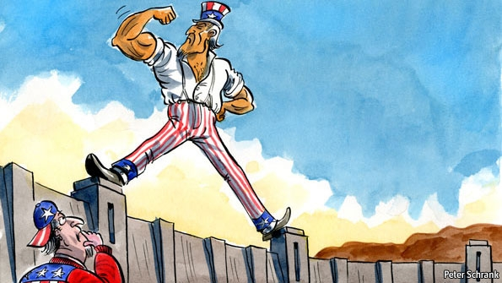
“THAT Used To Be Us” is the title of one of the latest books to lament America’s decline from its former self. With hundreds of western Republicans flocking to Las Vegas this week to hear yet another debate between the presidential candidates vying to take on Barack Obama, this seemed a good moment to pay homage to the Hoover Dam, that monument to America’s ability to think big even in the depths of the Great Depression.
Lexington was not alone. Three-quarters of a century on, visitors from all over America still throng the great dam. Since its completion well over 40m have gaped at the stately arch that stops up the unruly Colorado. A subterranean theatre shows a grainy black-and-white movie, accompanied by a stirring orchestral soundtrack, lauding the ingenuity of the dam’s engineers and the intrepidity of the “high scalers” who dangled fearlessly with drills and hammers above the Black Canyon. Visitors marvel at the deep-groined tunnels that diverted the mighty river, and the vibration from the ocean of water that drives the turbines that generate the electricity that pays back the cost of the project, with interest, to the federal government.
If you are an American looking for the “that” that used to be us, the Hoover Dam is not a bad place to start. Few other federal projects—the race to the moon is one—have captured the imagination this way. But manned space flight in America is now in mothballs, and in these dispirited times even the pride visitors take in the dam is mingled with wistfulness. “We couldn’t do it now,” said one during Lexington’s visit, as if on cue. The Hoover Dam is a monster of cement and steel, but has also become a symbol, conjuring up a time when politicians could react to economic calamity not with paralysis, petty squabbling or apportioning blame but by rolling up their sleeves and doing something big.
As to whether America could build the dam today, Michael Hiltzik, its modern historian, says in his book “Colossus” that it probably could not. It was hard enough back then to overcome the rivalries of the seven states involved, but at least nobody gave a fig for the down-river rights of the south-western Indians, let alone the Mexicans, or the creatures whose habitats were eradicated when the river was dammed. Today a rampart of federal legislation, such as the National Environmental Policy Act and the Endangered Species Act, would block the way.
If not another great dam, why not some equivalent? America today is not in a 1930s-style Depression, but the millions of unemployed are desperate for work. Its roads, railways and airports are crumbling and buckling. A league table of infrastructure this year ranked America at 24th, between Malaysia and Taiwan. The Congressional Budget Office says it could spend up to $80 billion a year more on projects that would give an economic return. Mr Obama is an enthusiast: he has proposed investing in green energy and high-speed trains. But these ideas have left Americans unmoved. And if building dams has gone out of fashion, so has spending on public works with borrowed money. Republicans in Congress have pronounced Mr Obama’s plan for an infrastructure bank “dead on arrival”.
That is a pity. America can and should spend more on infrastructure. But nostalgia is seldom a sound basis for policy. The politicians of the 1930s were no less petty than today’s, nor less ideologically divided. Franklin Roosevelt and his fellow Democrats tried hard to keep Herbert Hoover’s name off the dam that had been started on his watch. And whereas Hoover looked at the project as an engineer, seeing mainly a means to realise the agricultural potential of California and the rest of the south-west, FDR was intent on turning it into a symbol of the New Deal and the superiority of collective action. It became the launching pad for all his other ambitious public undertakings, including the 29 dams built by the Tennessee Valley Authority that were to follow.
And yet the Hoover itself was no great creator of jobs. Ron Klain, who worked on Mr Obama’s Recovery Act, has argued that nostalgia for the dam is misplaced. Even at its peak the project employed only 5,200 people, and it would be harder still for such projects to generate jobs today. At the Hoover a soaring new bridge, five years in the making, now spans the Colorado, giving the lie to the notion that America can no longer perform wonders of engineering when it wants to. But with modern technology no more than 1,000 people worked on this bridge at any time.
Is it really so terrible that America could not build a Hoover Dam today? The America of the 21st century is not only a different America, but a richer America. It has no cause to regret that it can now use machinery to do the work of thousands of men toiling in horrific conditions, many of them succumbing to carbon-monoxide poisoning that was disguised as “pneumonia”. And though some of the Republicans debating this week in Las Vegas would scythe away the regulations that make it so hard to do useful and profitable things, such as drilling for gas and oil, many citizens treasure their environment and want to preserve it. That is a luxury most people in rich countries are glad to be able to afford.
The Hoover Dam changed the human geography of America, luring tens of millions into an arid West that would otherwise have remained a wilderness. In an odd way, the fact that even the Colorado can no longer slake the thirst of metropolises such as Phoenix, Los Angeles and San Diego is testimony to the dam’s success. Indeed, many of America’s difficulties today, such as the drying up of work for unskilled hands, are the problems of success. That does not make them any easier to deal with, but they will not be solved by the methods of a bygone age. Something else—maybe a cellphone, maybe a string of computer code—will have to stand as this century’s emblem of American prowess.

