Putin Personality Disorder

Russia's president may like to look tough, but he's weaker than you think.

BY FIONA HILL, CLIFFORD G. GADDY | FEBRUARY 15, 2013
Russia merited just one mention in President Barack Obama's State of the Union address on Tuesday night, an offhand remark that his administration will continue to "engage Russia to seek further reductions in our nuclear arsenals." Obama's first term did see some thaw with Moscow -- the "reset," a modest relationship with then President Dmitry Medvedev, and the passage of the New START agreement -- but it's clear that things have become frostier since Vladimir Putin returned to power. It's an indication of an impasse in dealing with the Kremlin -- and perhaps one that is fundamentally about personality. No one in Washington really knows what to make of Russia's famously immodest and opaque leader.
Who is the real Vladimir Putin? This question has never been fully answered. Putin has dominated Russian politics for more than 12 years, but in that time almost no new information has surfaced about his background beyond the material in a few early biographies. Even in the biographies, very little information about the Russian president is definitive, confirmable, or reliable. As a result, some observers have said that Putin has no face, no substance, no soul. He is a man from nowhere, who can appear to be anything to anybody.
But Putin is a product of his environment -- a man whose past experiences have clearly informed his present outlook. Indeed, Putin is best understood as a composite of multiple identities that stem from those experiences, and which help explain his improbable rise from KGB operative and deputy mayor of St. Petersburg to the pinnacle of Russian power. Of these multiple identities, six are most prominent: Statist, History Man, Survivalist, Outsider, Free Marketeer, and Case Officer. None of the single-word labels people usually attach to Putin -- KGB thug, kleptocrat, autocrat -- offer a satisfactory explanation for the phenomenon of his rule. It is the combination of all his identities that made Putin an effective behind-the-scenes operator in Russian politics and helped propel him into the Kremlin. Today, however, these identities have become a source of weakness. The country has changed since 1999; Putin has not.
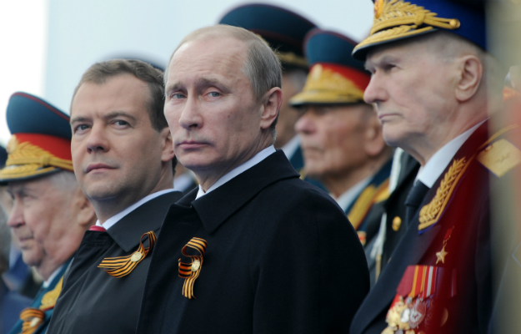
Statist: Putin's rise to the Russian presidency in 1999-2000 was partially the result of an elite consensus about the importance of restoring order to the state after a decade of domestic crisis and international humiliation. Reflecting the national mood, Putin used one of his first major political statements -- his so-called "Millennium Message" of December 29, 1999 -- to present himself as a statist. In Russia, individuals exist to serve the state and their rights are therefore secondary. From his earliest days in the Kremlin, Putin has pursued the goal of restoring and strengthening the state -- by rediscovering and taking back Russia's fundamental values, re-energizing its historical traditions, and abandoning the practice of blindly copying abstract Western models. He has stressed communitarianism over Western individualism, promoted the revival of the Russian Orthodox Church, and drawn direct links between the modern Russian presidency and the pre-Revolutionary Russian tsars.
NATALIA KOLESNIKOVA/AFP/Getty Images
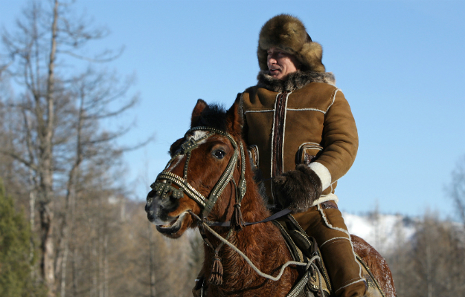
History Man: Putin has flaunted his attachment to Russia's historical traditions. In official biographical materials, he is portrayed as a self-designated student of history. As president, he has tied his personal destiny to that of the Russian state and actively deployed various interpretations of the country's past to reinforce policy positions, frame key events, and cloak himself in the mantle of historical legitimacy. For example, Putin has frequently highlighted parallels with Pyotr Stolypin -- prime minister under Nicholas II, the last tsar of the Romanov dynasty -- who championed far-reaching economic and social reforms. It was not just coincidence that Putin selected the 100th anniversary of Stolypin's death in 1911 to announce his intention to return to the presidency and see his reform program through to completion.
But if history has been a political tool for Putin, it is also very personal. His parents were survivors of the siege of Leningrad, one of the blackest periods of Russian history, when almost one million people died. His family's harrowing tale from World War II fits neatly into the national historical narrative -- one in which Russia constantly battles for survival against a hostile outside world. The critical lesson from centuries of domestic turbulence, invasion, and war, is that the Russian state always survives in one form or another. Every calamity weathered reaffirms Russia's resilience and its special status in history. This has been a rhetorical touchstone for Putin, as well as for many others from his generation.
ALEKSEY DRUZHININ/AFP/Getty Images
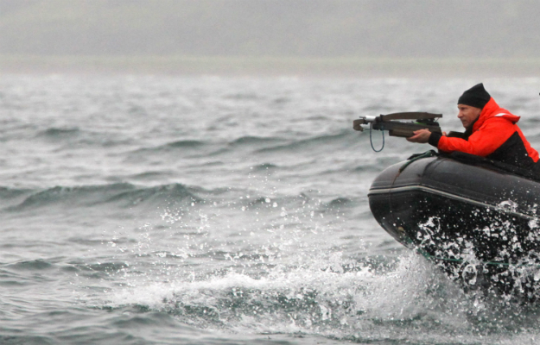
Survivalist: The collective experience of this dark history has turned the Russian population into survivalists -- people who constantly think of and prepare for the worst. Throughout his presidency, Putin has raised survivalism from the personal to the national level. He made it a priority to pay off the colossal state debts his predecessors, Mikhail Gorbachev and Boris Yeltsin, racked up over two decades. Putin concluded that these debts brought down the USSR, and almost brought down the fledgling Russian state in the 1990s. For the state to survive, Russia's debts had to be paid off. He also proceeded to build up massive national reserves -- everything from oil, gas, and refined petroleum products, to livestock feed, military uniforms, tents, medications, and generators -- so that Russia would have the resources to withstand any natural disaster or war. Finally, he created huge financial reserves in anticipation of future economic crises (most recently converting some of Russia's substantial but volatile currency reserves into gold bullion).
ALEXEY DRUZHININ/AFP/Getty Images
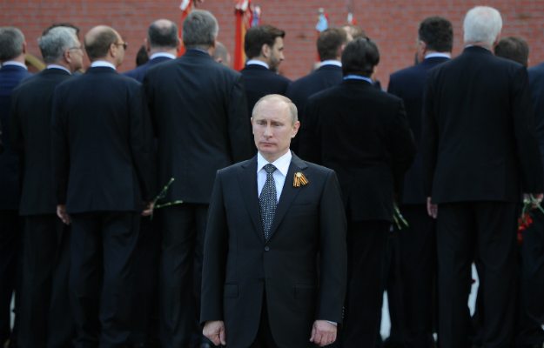
Outsider: Putin has cultivated an image of himself as an outsider since he was a young man. He was born and raised in Russia's second city of Leningrad (now St. Petersburg), the child of a factory worker and sometime janitor, with earlier humble roots in Russia's Ryazan province. In many respects, Putin was even an outsider within the KGB. He was recruited into the institution in the 1970s as part of an effort by KGB Director Yury Andropov to bring in a new generation of operatives from outside normal channels. But Putin did not rise rapidly through the ranks of the KGB, nor did he secure plum postings.
Putin was never part of the leadership structures of the Communist Party of the Soviet Union (CPSU) and remained an outsider throughout the 1980s. During the critical reform period of perestroika, the KGB posted Putin to the provincial city of Dresden in East Germany, where he would remain until after the fall of the Berlin Wall. After his tenure as deputy mayor of St. Petersburg, in summer 1996, Putin was specifically brought to Moscow as an outsider to help root out entrenched interests in the capital's political and business circles. Putin has made a virtue of this outsider status throughout his presidency, stressing his connections to "ordinary" Russians and distancing himself from Moscow's resented elites.
NATALIA KOLESNIKOVA/AFP/GettyImages
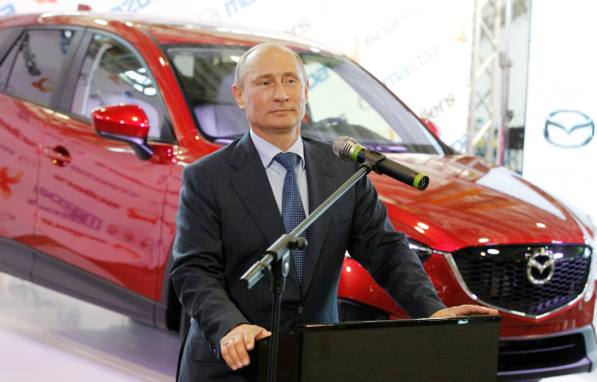
Free Marketeer: Putin's outsider status and his pragmatism enabled him to reject two of the central tenets of Communism: state ownership and central planning. History taught him that the Soviet economic system failed. Private property, free enterprise, and the market were superior. But Putin's understanding of capitalism was limited. The business practices he was exposed to during his time as deputy mayor of St. Petersburg did not have a primary emphasis on entrepreneurship, production, management, or marketing. In the 1990s, capitalism in St. Petersburg was more about personal connections to the city government than relations with workers and customers. As such, Putin seems to have emerged from his St. Petersburg experience with the view that winners in the market system are those who are best able to exploit the vulnerabilities of others, not necessarily those who provide the best goods and services at the most favorable prices. This perspective set him up to exploit the vulnerabilities of others, including Russian businessmen, to manipulate them and ensure that they followed the directives of the Kremlin.
MIKHAIL KLIMENTYEV/AFP/GettyImages
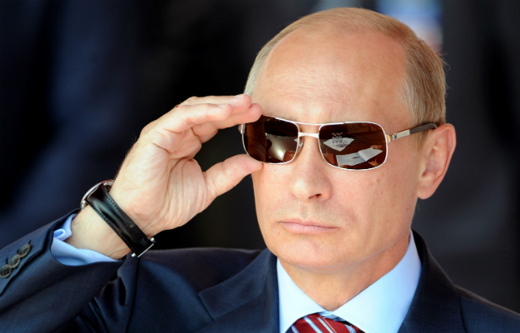
Case Officer: As much as Putin appreciated the virtues of private ownership, when he became president he faced an important dilemma: how to reconcile private ownership of key sectors of the economy with meeting the statist goals he had set for Russia's development. How could he control and direct industry without reverting back to the total state ownership of the Soviet period? Putin found the answer through his most important identity -- the case officer. During his time in St. Petersburg as deputy mayor -- a position he was initially encouraged to take by the KGB -- businessmen were Putin's targets, not his partners. In order to ensure that they delivered on their promises to the city government, he collected compromising financial and personal information and leveraged it against them. When he got to Moscow in 1996, he used these same tactics against another set of businessmen -- Russian oligarchs --who were preying on each other and the Russian state.
As a case officer in the KGB, Putin had learned how to identify, recruit, and run agents, and acquired the patience to cultivate sources. He also learned how to collect, synthesize and use information. These tools proved invaluable in bringing Russia's oligarchs to heel. In a televised roundtable meeting with Russia's oligarchs in July 2000, for example, Putin deployed textbook KGB tactics. He explained that the businessmen would retain their extensive assets, but they would have to agree to a new tax regime that would give the federal government more resources. He told them that they must also actively consider Russian national interests, as defined by Putin and the state, when engaging in economic activities abroad. This was private enterprise with strings attached. The property rights of business magnates were ultimately dependent on the goodwill of the Kremlin.
DMITRY KOSTYUKOV/AFP/Getty Images
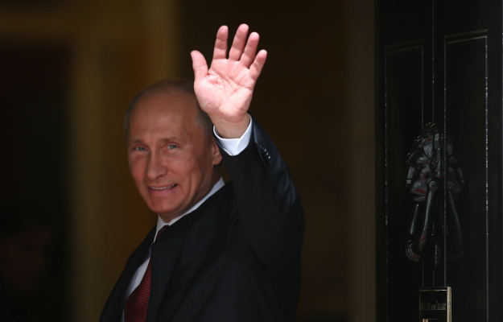
* * *
These six identities form the man Putin is today. They help us better understand his conception of the Russian state and the way he rules it. But the same strengths that enabled Putin to climb the rungs of power and rein in Russia's oligarchs have now become sources of vulnerability. The country's rapid development has exposed the tensions between Putin's different identities. Putin the Survivalist, for instance, is in conflict with Putin the Free Marketeer. Policies oriented toward Russia's survival -- constantly building up reserves and preparing for worst-case scenarios -- are costly, diverting resources and reducing economic efficiency. Putin the Free Marketeer also runs afoul of Putin the Case Officer. Manipulation and blackmail do not help to create a new generation of good entrepreneurs. Putin knows the free market economy is superior to a centrally planned economy, but he does not fully understand how to move beyond deal-making and cronyism toward full liberalization.
Simply put, Putin is the operative in the Kremlin who was suddenly asked to be its master. His unique experiences, born of a specific place and time in Russian history, have not prepared him to be the national political leader of an advanced, developed country -- a politician who is accountable to his electorate. When Putin first became president he had no prior experience with direct responsibility, having always been the No. 2 man in St. Petersburg. In 2000, when Putin was made acting president and anointed as Boris Yeltsin's successor, the resources of the Kremlin were deployed in full-force to secure his formal election. He did not campaign for the position himself. Although his identities combined to put him in a position to be selected by Yeltsin's team, nothing in his history and identities especially suited Putin for his new role of president.
As a result, Putin is now on the defensive. His primary concern is domestic politics and ensuring regime survival. When he made the announcement in September 2011 that he was returning to the presidency, Putin did not anticipate election protests and the rise of a new opposition movement among Russia's urban elite. In many respects, Putin is the victim of his own success. The long period of prosperity and stability he has presided over in Russia helped create the new urban middle class, which consumes at Western levels and now wants Western-style political rights.
Putin is trapped in a dilemma that will persist throughout his current presidency. His long-term goal is to rebuild and restore Russia. To succeed, he needs human capital -- including the members of what is often called the "creative class," many of whom have joined the opposition. But he does not understand this new urban middle class and he lacks the ability to connect with its members. His base of support comes from Russia's "silent majority" of industrial workers, public sector employees, pensioners, and rural residents, all of whom are heavily dependent on state subsidies. As such, Putin remains distrustful of the very people he needs to power Russia's revival.
Domestic dissent and Putin's efforts to counter it will be a permanent feature of his current presidential term. Paradoxically, the more progress he makes toward modernizing Russia, the more people will demand greater political openness and, ultimately, Putin's removal from power. The rise of Russia's middle class, then, will continue to pit Putin against himself in the years ahead.

