One Nation Indivisible?
A Thematic Overview of Nationalism and Sectionalism in the Antebellum Era (1789-1861)

Operational Definitions:
Nationalism refers to an ideology, a sentiment, a social movement, and an approach to governance that focuses on the nation. It fosters a collective identity. In the specific case of the U.S., nationalism refers to devoting primary loyalty to the United States as opposed to a region or a state. As a corollary to this, the U.S. government, according to nationalists, should reign supreme over state and local governments.

Sectionalism refers to an ideology, a sentiment, a social movement and an approach to governance that focuses on the sovereignty of one section of a country. In the specific case of the U.S., sectionalism refers to devoting primary loyalty to one’s state or region as opposed to the “United” States. As a corollary to this, state governments, according to sectionalists, should wield considerable powers vis-à-vis the national government.

Directions:
Throughout the Antebellum Era (1789-1861) numerous events took place which led to struggles between advocates of nationalism and advocates of sectionalism. In most cases these are complex issues which can only be properly understood in the context of the antebellum milieu.

Your task is to, describe and analyze each issue:

- Describe the issue: tell the story. Describe the basic facts: who, what, when, where, and why.

- Analyze the impact of this issue: thoughtfully explain how this event contributed to nationalism, sectionalism, or both. Your explanation requires an argument about whether this event contributed primarily to nationalism or sectionalism.

You may bullet point your responses to the summary in part A; you must explain your analysis in part B in full sentences.

You may use your textbook and/or the internet.

This will be a time consuming endeavor which, if done carefully and methodically and thoughtfully, will give you a nuanced understanding of the challenges faced by the new nation and the causes of the Civil War.

Section One: The Early Years of the Republic (1798-1815)
- The Alien & Sedition Acts (1798) - a sample response
- Summary: Four bills passed by Federalists in Congress, signed into law by President Adams, in the context of an undeclared war with France (the “Quasi-War”). The Acts were largely aimed to stifle dissent towards the Adams administration and, thus, targeted Republicans. The Acts were:
  - Naturalization Act - extended duration of residence required for citizenship to 14 years. Exp. 1802.
  - Alien Friends Act - authorized president to deport any resident alien considered "dangerous to the peace and safety of the United States." Created in fear of French sympathizers.
  - Alien Enemies Act - authorized president to apprehend and deport resident aliens if their home countries were at war with USA (with an upcoming war with France in mind). Remains in effect today as 50 U.S.C. § 21-24.
  - Sedition Act - made it a crime to publish "false, scandalous, and malicious writing" with the "intent to defame" or to bring Congress or the President into "contempt or disrepute." Exp. March 3, 1801.
- Analysis: The A & S Acts hoped to forge a sense of nationalism by
  - Eliminating the Republican Party
  - Proclaiming a national enemy in the French
  - Protecting President Adams from an enemy Republican press
However, as evidenced by the Virginia and Kentucky Resolutions, the end result of the A & S Acts forged sectionalism as Republican strongholds throughout the country declared the Acts null and void.

- The Virginia & Kentucky Resolutions (1798) - a sample response
- Summary:
  - Legislatures of VA and KY passed resolutions declaring A & S Acts unconstitutional.
  - Argued for states’ rights – each state has power to declare federal laws null and void
  - Secretly written by Jefferson and Madison
- Analysis: In retaliating so brazenly to the A &S Acts, the VA & KY Resolutions clearly fostered sectionalism. The Resolutions argued that state and local authority can supersede national authority. Their influence led right up to the Civil War and even to the present day.

- Marshall Cases (1801-1835)

- The War or 1812

Section Two: The “Era of Good Feelings” (1816-24)

- The Era of Good Feelings (1816-1824)

- Henry Clay’s America System (1815)

- The Tariff of 1816

- The Bank Wars of 1816 & 1836
Note: Focus here on the 1816 debates over the Bank of the United States. But also research and describe Andrew Jackson’s war on the Bank in 1836, when it was to be re-chartered for the third time.

- The Panics of 1819 & 1837
Note: Focus on the Panic of 1819 here. But note that a second economic panic—which was a deeper, longer, and more painful economic crisis—in 1837 had very similar causes and effects.

- The Missouri Crisis and the Missouri Compromise (1820)

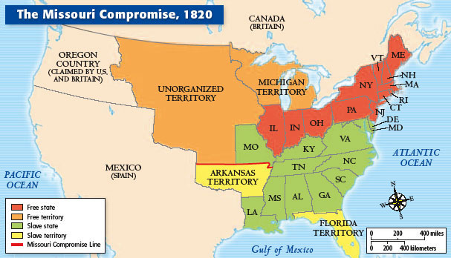

- The Completion of the National Road (Cumberland Road) (1818)

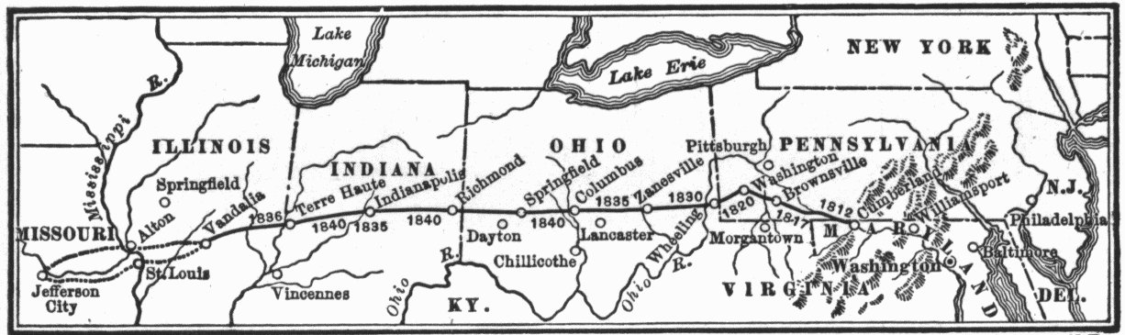
- The Completion of the Erie Canal (1825)

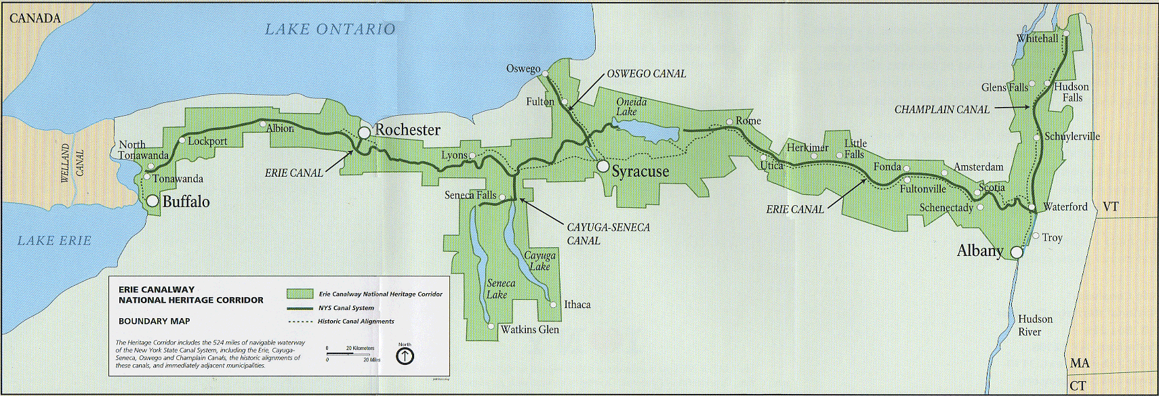

- The Beginning of the American Industrial Revolution (1820’s)

- The Monroe Doctrine (1823)

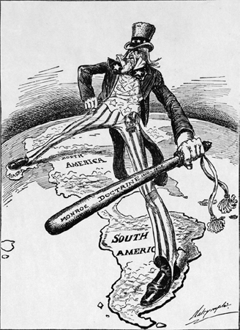

- The Election of 1824 and the “Corrupt Bargain”
Presidential Candidate | Party | Home State | Popular Vote |  | Electoral Vote
Presidential Candidate | Party | Home State | Count | Percentage | Electoral Vote
Andrew Jackson | Democratic-Republican | Tennessee | 151,271 | 41.3% | 99
John Quincy Adams | Democratic-Republican | Massachusetts | 113,122 | 30.9% | 84
William Harris Crawford | Democratic-Republican | Georgia | 40,856 | 11.2% | 41
Henry Clay | Democratic-Republican | Kentucky | 47,531 | 13.0% | 37
(Massachusetts unpledged electors) | (n/a) | (n/a) | 6,616 | 1.8% | 0
Other |  |  | 6,437 | 1.8% | 0
Total |  |  | 365,833 | 100.0% | 261
Needed to win |  |  |  |  | 131

Section Three: Cultural & Economic Divisions Re-emerge (1828-48)

- The “Tariff of Abominations” & The Nullification Crisis (1828)

- The Indian Removal Act (1832)

- The Second Great Awakening (1820s - 1840s)

- Mass Immigration to the U.S. (1820s - 1840s)

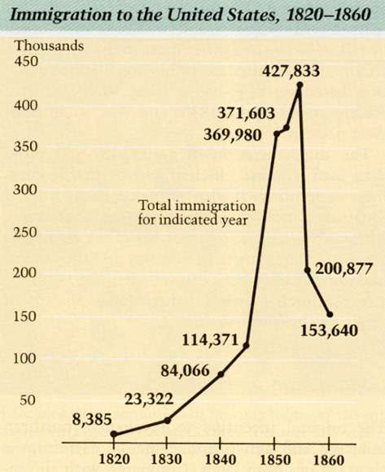
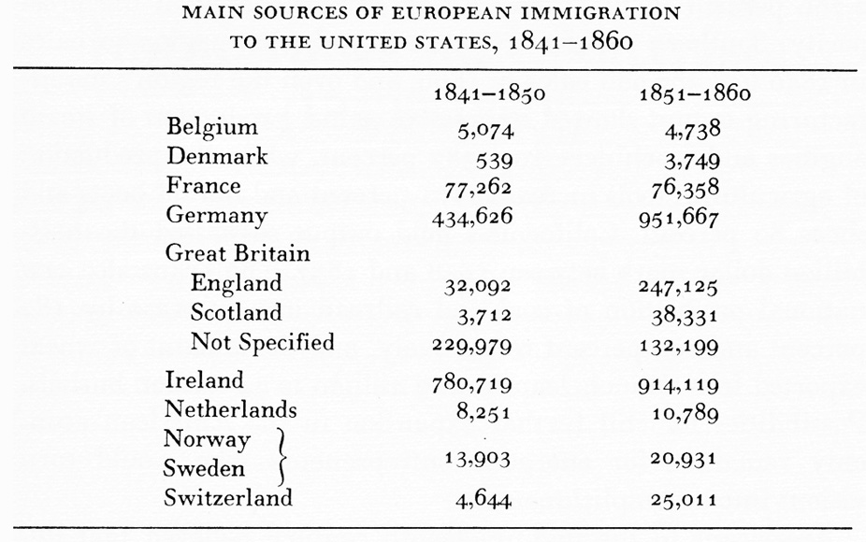

- Horace Mann’s Case for the Public Schools (1848)

Section Four: Westward Expansion Tests Bonds of Union (1803-48)

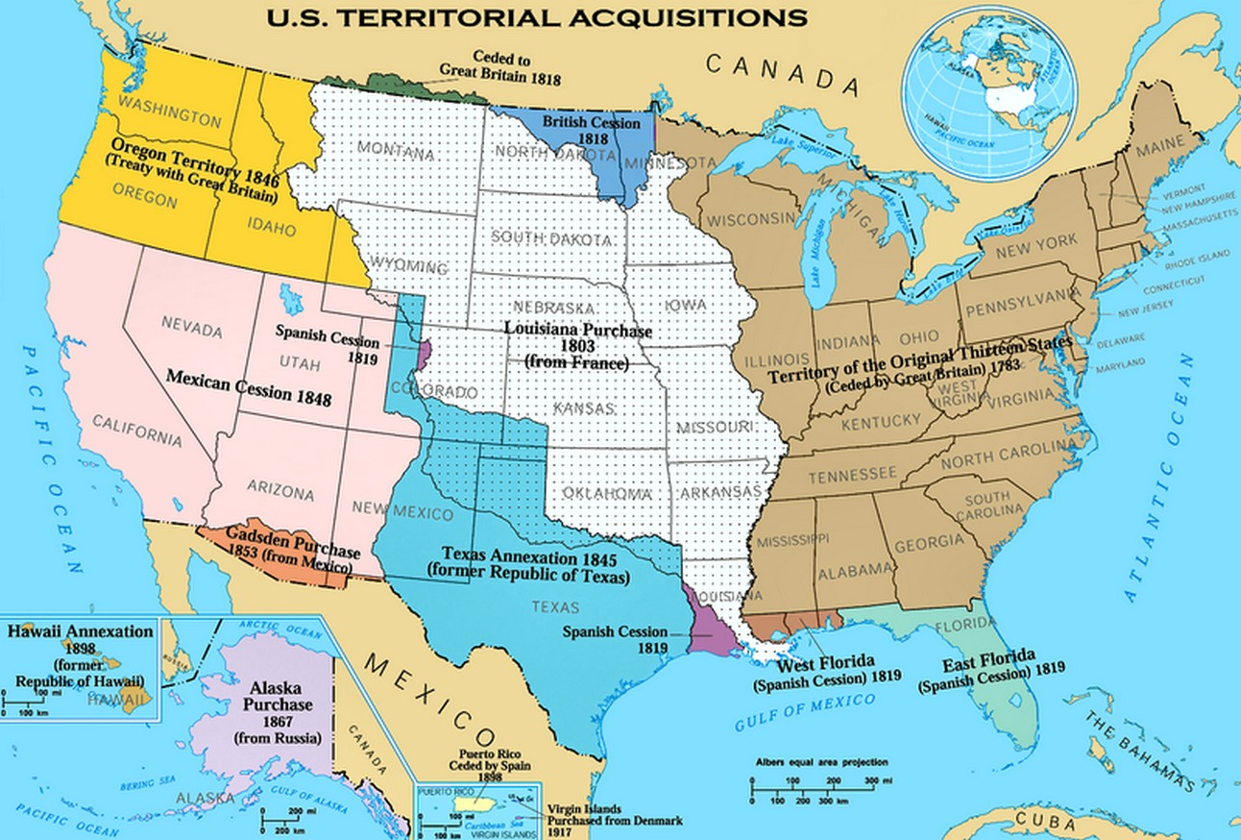

- The Louisiana Purchase (1803)

- The Texas Crisis (1836)

- The Mexican-American War (1846-1848)

- The Wilmot Proviso (1848)

Section Five: The Divisiveness of the “Peculiar Institution”
- The Gag Rule (1835 – 1840s )

- George Fitzhugh’s Slavery Justified (1849) & Sociology for the South (1854)

- Dred Scott v. Sanford (1857)

- Rebellion Against the “Peculiar Institution”
  - The Underground Railroad

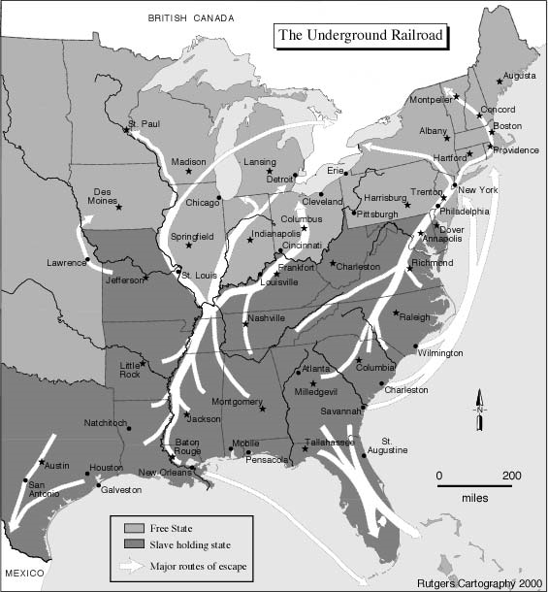

  - Nat Turner’s Rebellion (1831)

  - William Lloyd Garrison’s Liberator (1831-1865)

  - John Brown’s Raid at Harper’s Ferry (1859)

Section Six: The Failures of Compromise Politics and the Demise of Union (1850-1861)

- The Crisis of 1850 & The Compromise of 1850

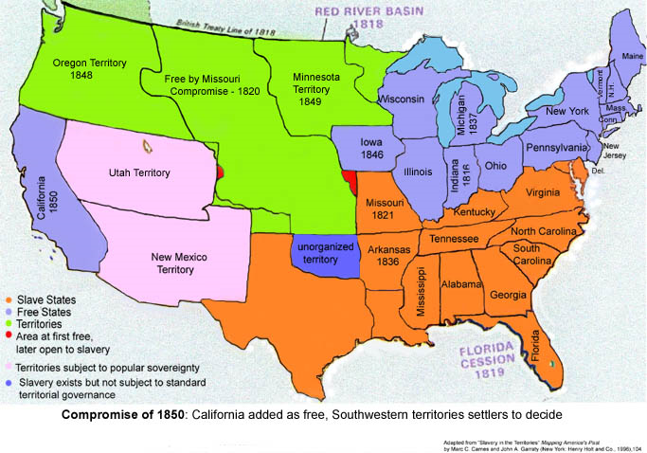

- The Kansas-Nebraska Act (1854) & Bleeding Kansas (1856)

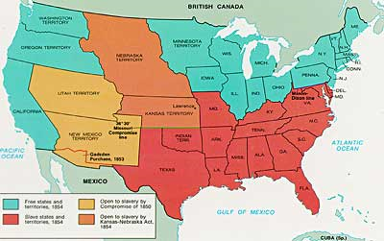

- The Third Political Party System (1854-1896)
Note: Describe the basic platforms of each party then analyze how this contributed to sectional discord in the box on the right. .
  - Republicans
Analysis of national-sectional impact:

  - Free Soilers

  - Know Nothings

- The Election of 1856
Presidential candidate | Party | Home state | Popular vote |  | Electoral  vote
Presidential candidate | Party | Home state | Count | Pct | Electoral  vote
James Buchanan | Democratic | Pennsylvania | 1,836,072 | 45.3% | 174
John Charles Frémont | Republican | California | 1,342,345 | 33.1% | 114
Millard Fillmore | American/Whig | New York | 873,053 | 21.6% | 8
Other |  |  | 3,177 | 0.1% | –
Total |  |  | 4,054,647 | 100% | 296
Needed to win |  |  |  |  | 149

- The Election of 1860
Presidential candidate | Party | Home state | Popular vote |  | Electoral  vote
Presidential candidate | Party | Home state | Count | Pct | Electoral  vote
Abraham Lincoln | Republican | Illinois | 1,865,908 | 39.8% | 180
John C. Breckinridge | Southern Democratic | Kentucky | 848,019 | 18.1% | 72
John Bell | Constitutional Union/Whig | Tennessee | 590,901 | 12.6% | 39
Stephen A. Douglas | Northern Democratic | Illinois | 1,380,202 | 29.5% | 12
Other |  |  | 531 | 0.0% | –
Total |  |  | 4,685,561 | 100% | 303
Needed to win |  |  |  |  | 152

- The Failure of Crittenden’s Compromise (18 December 1860)

- The Secession of South Carolina (21 December 1860)

- The Confederate States of America (formed from Dec 1860- May 1861)

The Civil War began with the Battle of Fort Sumter on 11 April 1861…
620,000 men died.

