United States History Klausur
The John F. Kennedy School
Livia, Zachary, Quin, Antony, Matilde
Theme: Was the Civil War Inevitable After the Kansas Crisis?
Directions: Write one unified essay, which evaluates two opposing visions for America embodied in the first political parties. The documents provided must be integrated into the body of your essay. You may paraphrase or quote the documents, but in either case you must cite the source (document, line number). When analyzing the material, provide specific historical references—utilizing both the documents provided and previous historical knowledge—to support your thesis.
Provide an appropriate title for your essay. Write on both sides of the paper, number the pages, leave five lines between paragraphs and underline your thesis statement.
1. Identify and describe four pivotal events that contributed to sectionalism during the antebellum era in America
2. Carefully analyze the document to help illustrate whether or not the Civil War was avoidable.
3. Based on your knowledge and assessment of America's situation between 1820 and 1861, develop a thesis-driven evaluation the following statement:
After decades of tensions, compromises, and violence, the Civil War became inevitable after the 1856 Crisis in Kansas.

Document A: Map of the Kansas-Nebraska Act
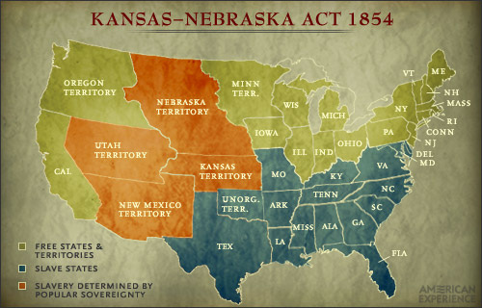

Source B: The Crime Against Kansas: The Apologies for the Crime; The True Remedy. Delivered to the United States Senate, 19-20 May 1856 by Charles Sumner. Sumner was a Radical Republican from Massachusetts.
Mr. President—
Take down your map, Sir, and you will find that the Territory of Kansas, more than any other region, occupies the middle spot of North America…
Against this Territory, thus fortunate in position and population, a Crime has been committed which is without example in the records of the Past. Not in plundered provinces or in the cruelties of selfish governors will you find its parallel....
The wickedness which I now begin to expose is immeasurably aggravated by the motive which prompted it. Not in any common lust for power did this uncommon tragedy have its origin. It is the rape of a virgin Territory, compelling it to the hateful embrace of Slavery; and it may be clearly traced to a depraved desire for a new Slave State, hideous offspring of such a crime, in the hope of adding to the power of Slavery in the National Government. Yes, Sir, when the whole world, alike Christian and Turk, is rising up to condemn this wrong, making it a hissing to the nations, here in our Republic, force -- ay, Sir, FORCE -- is openly employed in compelling Kansas to this pollution, and all for the sake of political power. There is the simple fact, which you will vainly attempt to deny, but which in itself presents an essential wickedness that makes other public crimes seem like public virtues.
…To the charge of fanaticism I also reply. Sir, fanaticism is found in an enthusiasm or exaggeration of opinion, particularly on religious subjects; but there may be fanaticism for evil as well as for good. Now I will not deny that there are persons among us loving Liberty too well for personal good in a selfish generation. Such there may be; and, for the sake of their example, would that there were more! In calling them "fanatics," you cast contumely [rudeness]upon the noble army of martyrs, from the earliest day down to this hour, -- upon the great tribunes of human rights, by whom life, liberty, and happiness on earth have been secured, -- upon the long line of devoted patriots, who, throughout history have truly loved their country, -- and upon all who, in noble aspiration for the general good, and in forgetfulness of self, have stood out before their age, and gathered into their generous bosoms the shafts of tyranny and wrong, in order to make a pathway for Truth; -- you discredit Luther, when alone he nailed his articles to the door of the church at Wittenberg, and then to the imperial demand that he should retract firmly replied, "Here I stand; I cannot do otherwise, so help me God!"...
And in this same dreary catalogue faithful History must record all who now, in an enlightened age, and in a land of boasted Freedom, stand up, in perversion of the Constitution, and in denial of immortal truth, to fasten a new shackle upon their fellow-man.

In response to this speech, Democratic Representative Preston Brooks entered the Senate on May 22, 1856 and severely beat Charles Sumner with a cane. Brooks claimed that in the speech Sumner attacked Brooks' sick and elderly uncle, Senator Andrew Butler (Democrat from SC)

