Devolution in England: Reaching a dead end
The whole process of devolving more powers to local authorities in England seems to have stalled

Mar 4th 2017 | KING’S LYNN
THE town of King’s Lynn is not the most obvious place to learn lessons about the governance of England. It occupies a twilight zone, not big enough to attract large investment as Cambridge has, but not so cut off as to be hopeless like some places farther east. The town, which has a population of 46,000, has a medieval centre that dates to the 14th century when it was a port trading with German Hanseatic cities. Brian Long, leader of King’s Lynn and West Norfolk council, wants to restore its glory. Though shops lie empty, a paper plant opened four years ago, and factories and a business park have sprung up in the outskirts. “We appreciate we are not the most desirable place to invest, but we do have some merit,” says Mr Long.
Yet in November the council voted to reject a plan for the 16 boroughs of Norfolk and Suffolk to join up in a “combined authority”, and accept a mayor for the region, known as East Anglia, in exchange for a slice of £25m funding a year for 30 years to support economic growth and the development of local infrastructure, as well as £130m for housing. Mr Long supported the move but, with three other councils already against, the deal failed.
In May, Liverpool, Greater Manchester and four other combined authorities (see map) will elect a metro mayor for the first time. They are the poster children of the “devolution revolution” launched by the then chancellor, George Osborne, in 2015. The hope was that more joined-up decision-making at local level would boost regional economies and raise productivity. But many rural areas did not even submit a devolution proposal. Elsewhere local councillors rejected the notion. There are fears that, beyond the six deals concluded, it will be hard to do more. Lord Porter, head of the Local Government Association, said last month that he believes “devolution is dead”.
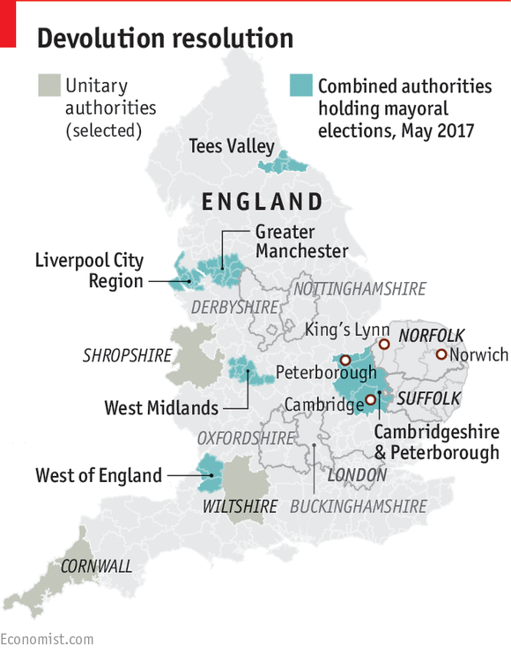
This comes as the prime minister, Theresa May, launches a new industrial strategy, with a declared aim to “drive growth up and down the country from rural areas to our great cities”. Jack Hunter of IPPR North, a think-tank, says that “trying to do industrial strategy from Whitehall simply will not work”. Yet Mrs May and her chancellor, Philip Hammond, seem less keen than their predecessors on devolution.
King’s Lynn ought to be a good candidate. Struggling to develop on its own, it would benefit from closer integration with cities like Peterborough, Norwich and, especially, Cambridge, with its booming high-tech industry, says Mr Long. Extra funding could upgrade rail links, to increase the number of trains to and from Cambridge from one an hour. As it is, King’s Lynn will lose the chance to play a part in a devolved transport policy. Observers call the rejection of devolution suicidal, and believe a compromise could have been found over a regional mayor.
Concern over the size of the combined authority was one reason the deal failed. Many felt that Norfolk and Suffolk, together covering 3,540 square miles (9,170 square km) was too big an area to be joined (Greater London covers 600 square miles). “The combined authority devolution model is made in Manchester and refined in Birmingham,” says Will Rossiter of Nottingham Trent university. That, he says, does not always suit the complex “two-tier” layering of political power in the shires: a county council, in charge of transport and social care, and below it, a district council, in charge of rubbish collection and other local services.
Advertisement
Local politics is another issue. Labour-led Norwich rejected the devolution deal partly out of fear of being dominated by rural Tory councils. In Manchester, most of the councils in the new authority are Labour-run. Yet central government is also to blame. Norfolk wanted a deal on its own, but Whitehall urged it to join with Suffolk, partly because the Local Enterprise Partnership, a regional body promoting business, covers both. The government also moved the goalposts, at one point suggesting Cambridge be included, then switching to link it with Peterborough. “If Cambridge had been part of our deal,” says Mr Long, “I think we would have gone for it.”
Identity is another factor. Whitehall encouraged Derbyshire and Nottinghamshire to combine in a devolved deal, yet local politicians found it hard to relate to a regional authority to which they held no natural allegiance. “Few people who know the economic and political geography of the area believed it could work,” says Mr Rossiter. Sure enough, five district councils rejected the process.
Devolve no more
In Westminster, the excitement that accompanied Mr Osborne’s devolution plans in 2015 has gone. In September Lord O’Neill, who championed the “northern powerhouse” of English cities, quit as a Treasury minister. In December the new transport secretary, Chris Grayling, stopped the devolution of control of London trains to the capital’s mayor. The local government secretary, Sajid Javid, claims to be open to proposals. But to kick-start devolution again “is going to take more than Sajid saying his door is open,” says Jonathan Carr-West of the Local Government Information Unit, a think-tank.
Some counties are restructuring anyway. Oxfordshire and Buckinghamshire each plan to abolish their county, district and city councils and form a “unitary” one. Cornwall, Wiltshire and Shropshire have already done so. But district councils often align with parliamentary constituencies and, as district councillors act as ground troops in general elections, many MPs do not want unitaries.
The biggest problem is persuading the people in places like King’s Lynn to support change. “If you asked all my friends in the town,” says one lifelong resident out shopping with his wife, “I doubt any of them have even heard of devolution.”
This article appeared in the Britain section of the print edition under the headline "All politics is loco"

