Who isn’t coming for dinner

A bit of cross-party parliamentary civility might go a long way in America’s divided polity
Aug 13th 2011 | from the print edition
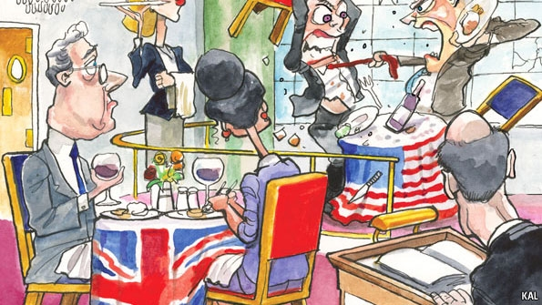
A BRITON in America notices something about comparative politics. Britain’s House of Commons reeks of conflict. The rival parties glare at one another from opposite benches. Debates are barbed and sometimes vicious—especially during the gladiatorial spectacle of prime minister’s questions. America’s Congress is different. Members of the House of Representatives sit shoulder-to-shoulder in the shape of a horseshoe. Debates, such as they are, are marked by an exaggerated decorum. The casual observer might easily conclude that America has the more consensual form of politics and Britain the more adversarial.
As the bitter fights that have scarred the first half of Barack Obama’s presidency show, nothing could be further from the truth. Compared with the total war that is American politics, the British version is sport (amateur sport at that: the $1 billion that Mr Obama is said to be seeking for his re-election campaign would pay for an entire British general election 20 times over).
After they heap scorn and vitriol upon one another in the debating chamber, members of the British Parliament retire companionably together to the bars and tea rooms of the Palace of Westminster. Friendships across party lines are easy, because the next election is generally years away (Parliament sits now for a fixed term of five years) and most politicians spend plenty of time in their taxpayer-subsidised homes in London. Besides, the present ideological quarrels between Tories, Labourites and Liberal Democrats pale into insignificance next to America’s. No party dares to threaten the National Health Service, for example, or propose dramatic changes in tax rates. Above all, British politicians accept the rules of a simple game: the ruling party governs (occasionally in coalition) while the opposition bides its time.
The life of the modern congressman could not be more different. Every member of the House is up for re-election every two years. That requires perpetual fund-raising and, thanks to the system of primary elections, assiduous cultivation of local activists. Many congressmen invest so much time in their districts that they do not bother to rent apartments in Washington, DC, let alone bring their families to the capital. Some sleep instead on sofas in their offices, in some cases expressly to avoid being seduced by the pernicious amity of Washington. Less time in Washington means fewer opportunities for them to befriend members of the other party, even if they wanted to. Increasingly, however, they don’t. Friendships might be all very well if, as in Britain, the opposition were merely biding its time. In America’s system the battle never pauses. Even before the Republicans captured the House in November’s mid-terms, they were fully and often successfully engaged in seeking to thwart the will of the Democrats.
As for ideological differences, the gap between America’s parties is growing. The most conservative Democrat on Capitol Hill is to the left of the most liberal Republican, and vice versa. The Democrats have become the defenders of social-transfer payments, the Republicans zealous champions of small government and low taxation. Many of the 87 freshmen Republicans entering the House in November do not believe that they were sent there to conduct business as usual or—witness their willingness to risk default by refusing to raise the federal debt ceiling—observe the customary rules of the game. “A lot of us”, Tim Griffin, a freshman from Arkansas, told the New York Times, “feel that we’re here on a mission, and the mission is now, and we’re not that concerned about the political consequences.” British politicians of all hues tune into the BBC’s “Today” programme, the morning radio show that sets the nation’s political agenda and referees the facts. America’s listen to their separate echo-chambers.
The addition of inexperienced legislators, burning with missionary zeal, to an already complex system of divided government and separated powers has cast even veteran observers of Congress into a despond. Norman Ornstein, the author with Thomas Mann of a book on Congress called “The Broken Branch”, declared recently that the 112th Congress was the worst ever, but that the next would be nastier still. Next year’s elections, he says, are sure to produce very close margins in both houses, and even more polarisation as redistricting enhances the role of primaries on the Republican side, pulling candidates further to the right. Nobody in a country that reveres its constitution likes to blame the fundamental design of the system. The problem, says Mr Ornstein, is that the newcomers have forgotten the framers’ belief in “deliberation, institutional loyalty and compromise”.
Notes from a small island
As they ponder the scale of their debt and the deadlock between the parties, Americans are entitled to feel frustrated. A record eight out of ten of them said after the recent debt-ceiling deal that they disapprove of the way Congress is doing its job. Given the impasse on the Hill, the occasional Anglophile will ask, could not America borrow something from a system that seems somehow to combine civility with the ability to get hard things done?
Probably not. As they made unmannerly plain a couple of centuries ago, most Americans do not admire Britain’s parliamentary democracy, which is, after all, no panacea. In 1976 Lord Hailsham, a Conservative politician, called its strong centralisation of decision-making an “elective dictatorship”. That might be a boon when strong government is needed: during war, say, or when rioters are burning London, or when, as during the Thatcher period, the times call for a wrenching change. America needs to make big changes if it is to live within its means. But this will not be done by tinkering with its system of government. It is the people who work the system who need to change, primarily by meeting their opponents half way. They could make a start by asking a member of the other party over for dinner.

